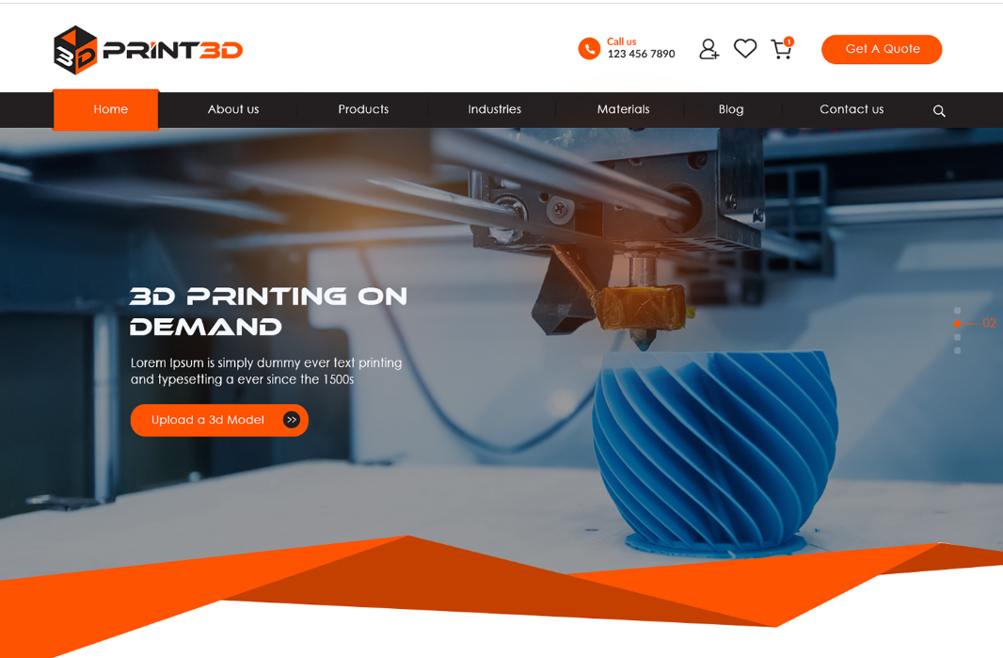
EMAIL Address LINK

If possible and can look as good, we could use one of our printer pictures to make it a little more personal… Any thoughts

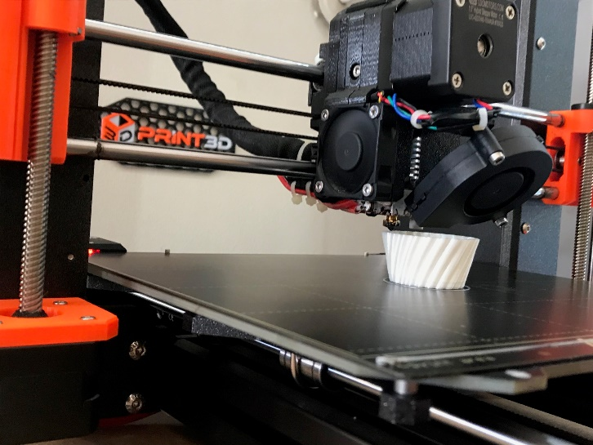

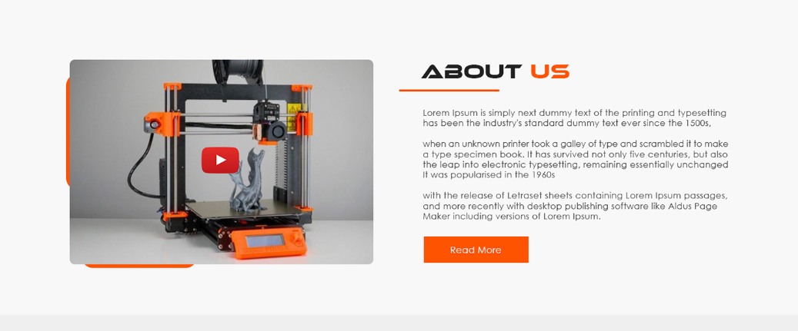

Text TBA

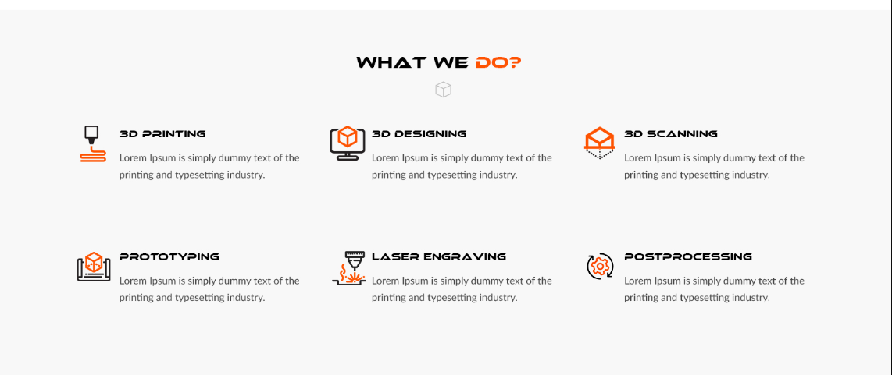

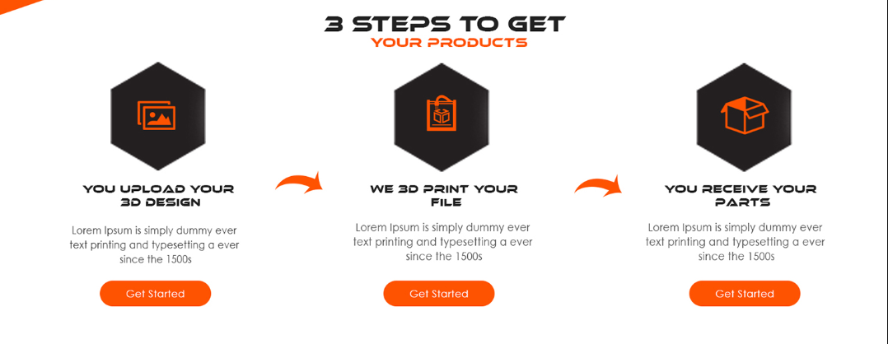
3D Printing

Contact us now

3D Designing and Prototyping
3D Printing allows for ideas and designs to come to life quicker than ever before. It allows for quicker prototypes and small batch manufacturing at lower cost than many other processes. It also allows for the re-creation of parts that are no longer in production, e.g., consumer goods and automotive parts.

We are happy to assist in any stage of the of the industrial design process from the initial design through to small batch production.

3D Scanning

We also replicate parts and items that can no longer be sourced or are no longer being manufactured. These items can be re-created from sketches, drawings or from the broken parts themselves. We also offer 3D scanning from our Highly accurate 3D scanner for items that are difficult to Re-design.

Laser Engraving

We also have our own Fibre MOPA laser engraving machine. This allows us to Mark our prints as well as create custom labels for you. Our laser is also capable of producing different colours on both stainless steel and titanium.

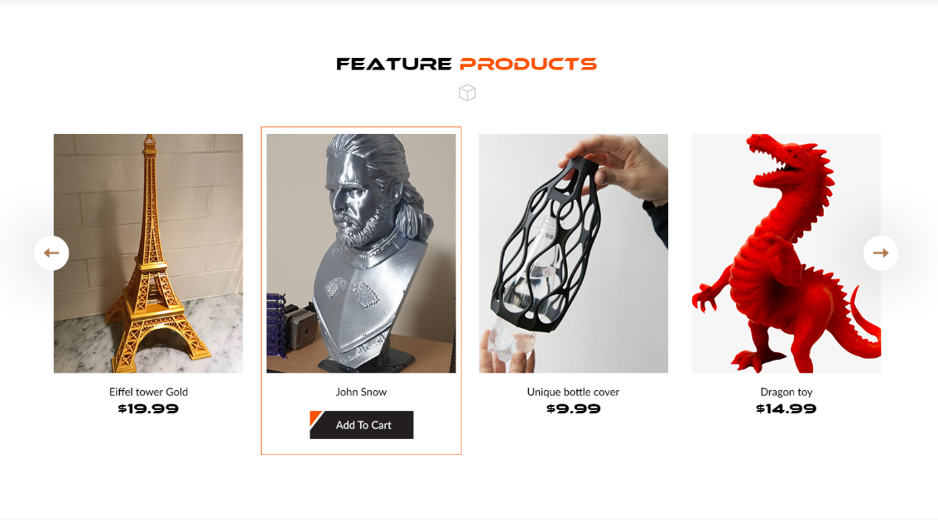

View all products Button

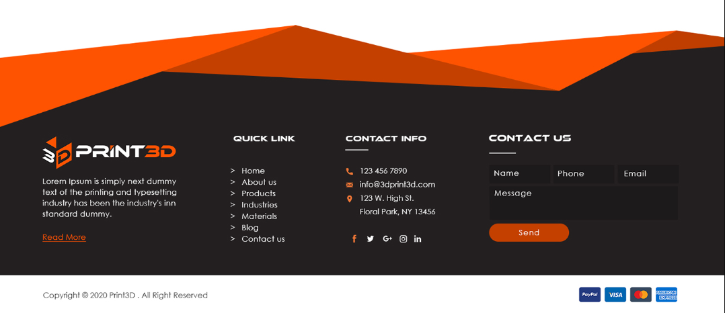

Colour scheme of logo that works well on black

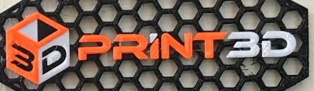

Sales@3dprint3d.com.au
Brisbane & Moranbah QLD, Australia.

Contact us page
(contact us linked page)
