Facial Recognition with Thermal Imaging

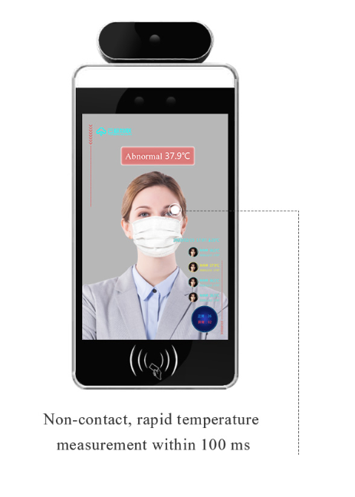
Protection made simple detecting Elevated Body Temperatures
COVID – GASTRO – Flu symptoms plus more

SUITABLE FOR AGED CARE, HOSPITALS, HOTELS, OFFICES, SCHOOLS, WORKPLACES

INTREGRATES WITH DOOR ACCESS CONTROL SYSTEMS
NON CONTACT AUTOMATIC TEMPERATURE MEASUREMENT
STRANGER WARNING AND BLACKLIST MANAGEMENT
PROOF OF IDENTITIY FOR STAFF
Product Description
The new AI (artificial intelligence) technology deployed in our technology allows thermal imaging capturing face temperature whether the identifying person is wearing a face mask or not. Detection via this intelligent terminal integrates face detection and temperature measurement integrating facial contrast recognition, heating imaging via our contactless temperature measurement module. When the person to be identified engages the face recognition terminal, the human body surface temperature can be measured by the thermal imaging technology. The whole face recognition process is a non-contact experience, and is accurate, reliable, efficient and adds an enormous level of safety to your facility. If the temperature of the detected person exceeds a certain threshold, the signal light of the terminal will send out an abnormal warning and carry out a voice warning. Images are captured successful or non-successful and stored in a secure managed onsite database if chosen by the customer deploying the product.

Key Features
- Measurement Distance: 50 – 150cm
- Camera: 2 Mega Pixels Binocular wide dynamic
- Tablet Screen: 8.0 Inch LCD Screen
- Network: WiFi and Ethernet
- 20,000 Photo Database
- Manage Contractors, Staff and log visitors as strangers
- Integrate to existing Access Control, Fingerprint Scanners and other devices for management
- Wall Mount, Desk Mount and Tripod Mounts available
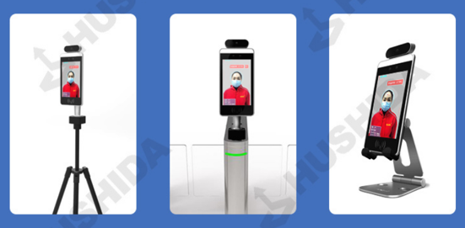

Manage Staff at access points or work login and log off
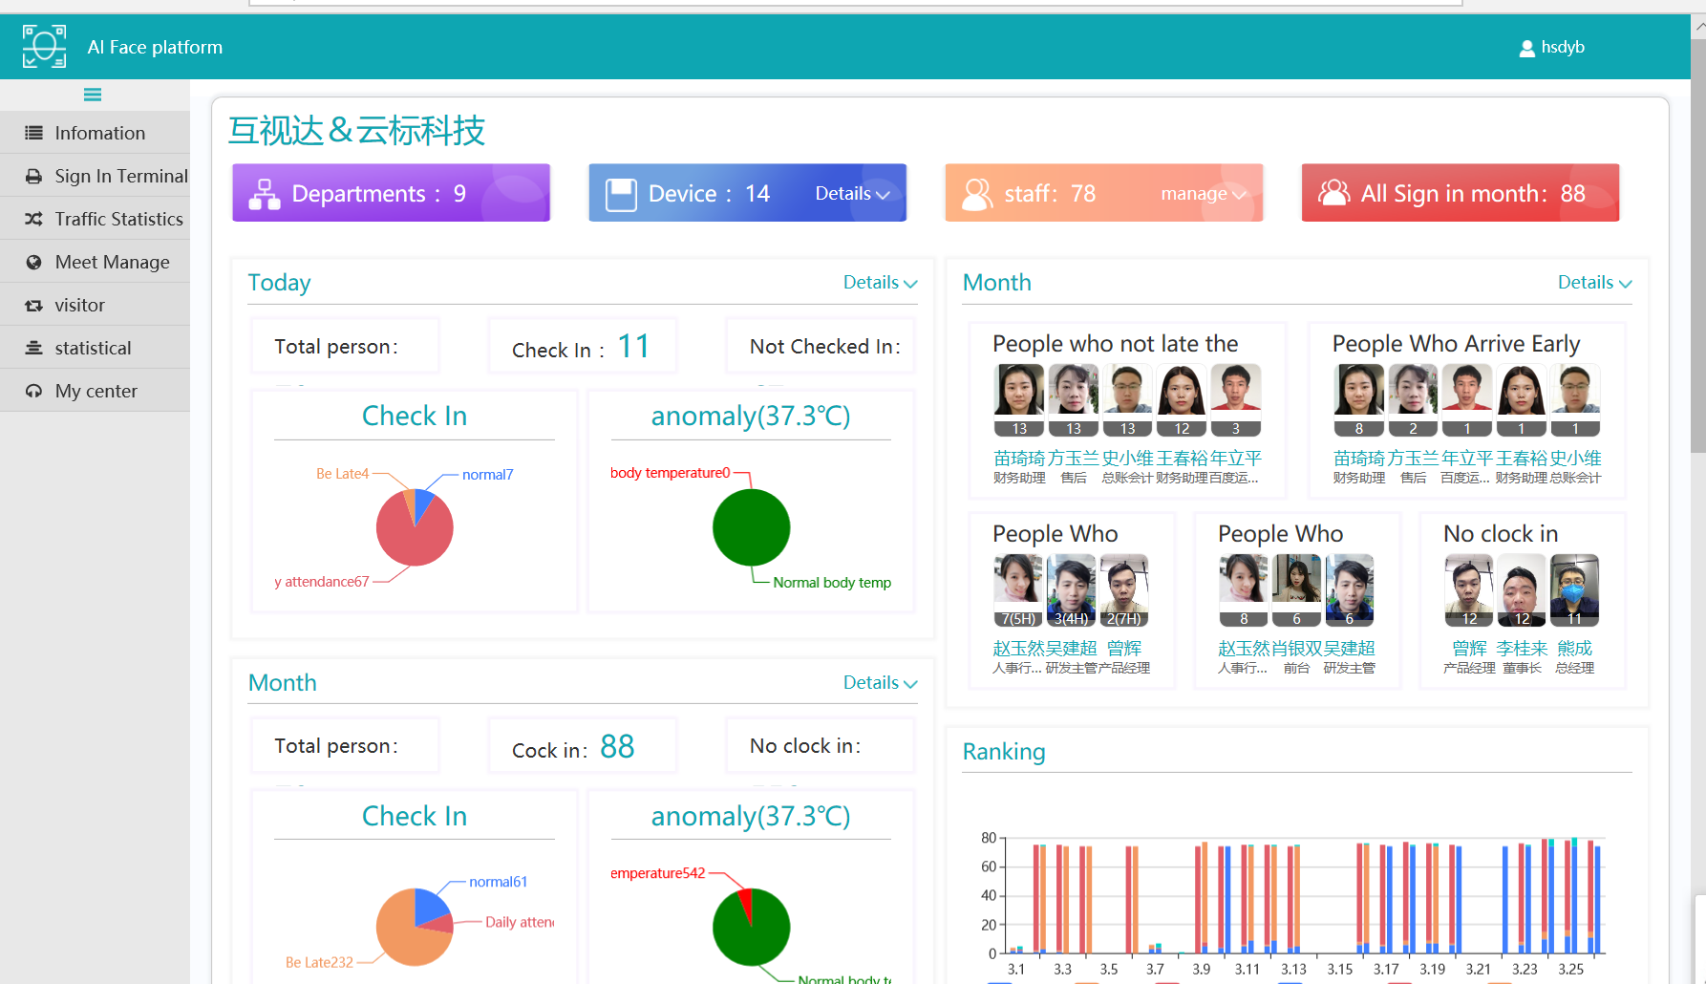

Connect to Existing Security Systems
