I need a design for a protective mask on a doypackbag.
The Background is very important, please be creative, I like the pastel color.Here is an example of material and pastel colour (Can be diffrente I trust you creativity)
Example of the material of the bag:
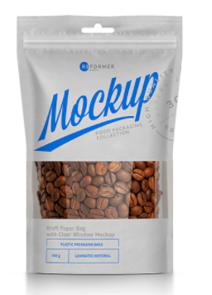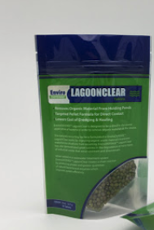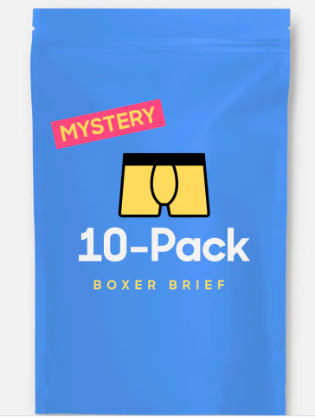

- The dimensions of the bag is 19cm X 25CM + the top part to hang the product
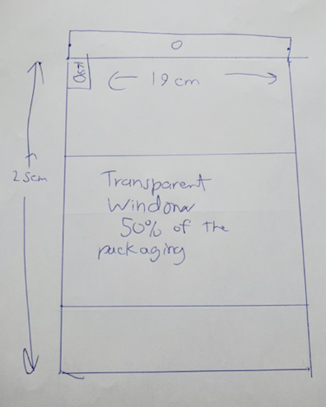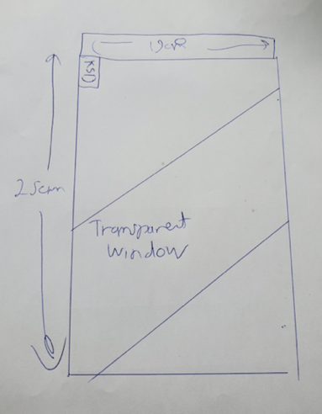
- It needs to have a transparent window so we can see the product trought the packaging.

The transparent window need to be around 50% of the space of the front packaging. Feel free to put the window where you think will have the best look.
( SO apply your design and background and text outside the transparent window)

- At the front of the packaging use this text(he is in English in French)

MASQUE PROTECTEUR AJUSTABLE RÉUTILISABLE

ADJUSTABLE PROTECTIVE MASK REUSABLE

- At the front: I need to have this picture but with an effect: At the right here is an exemple by what I mean with a effect. At the left original picture
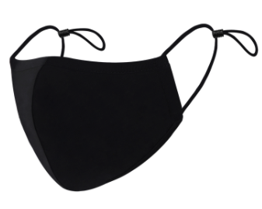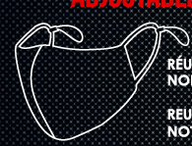

- At the back This information needs to be at the back of the packaging:

ADJUSTABLE PROTECTIVE MASK
REUSABLE/WASHABLE
100% COTTON
NOT CERTIFIED FOR MEDICAL USE

MASQUE PROTECTEUR AJUSTABLE
RÉUTILISABLE/LAVABLE
100% COTON
NON CERTIFIÉ POUR USAGE MÉDICAL

- At the back : this information but with this UPC and item number:KSD965
UPC: 840071000321

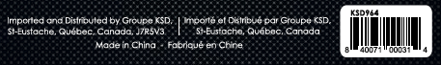

- At the back
I need to have this picture but with a effect: At the right here is an exemple by what I mean with a effect. At the left original picture (same effect than the front but bigger)

- At the top left : Put our KSD Logo top left front, change the color so it fits with your design
