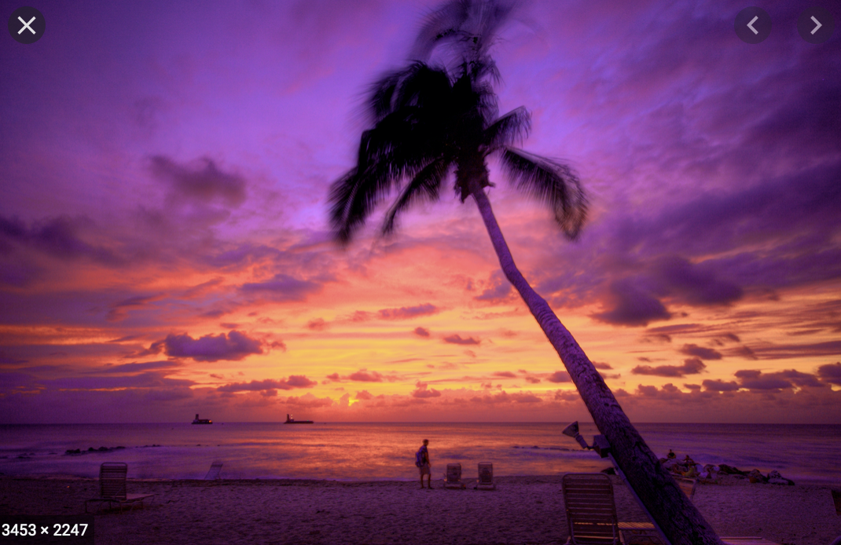
Nouveau
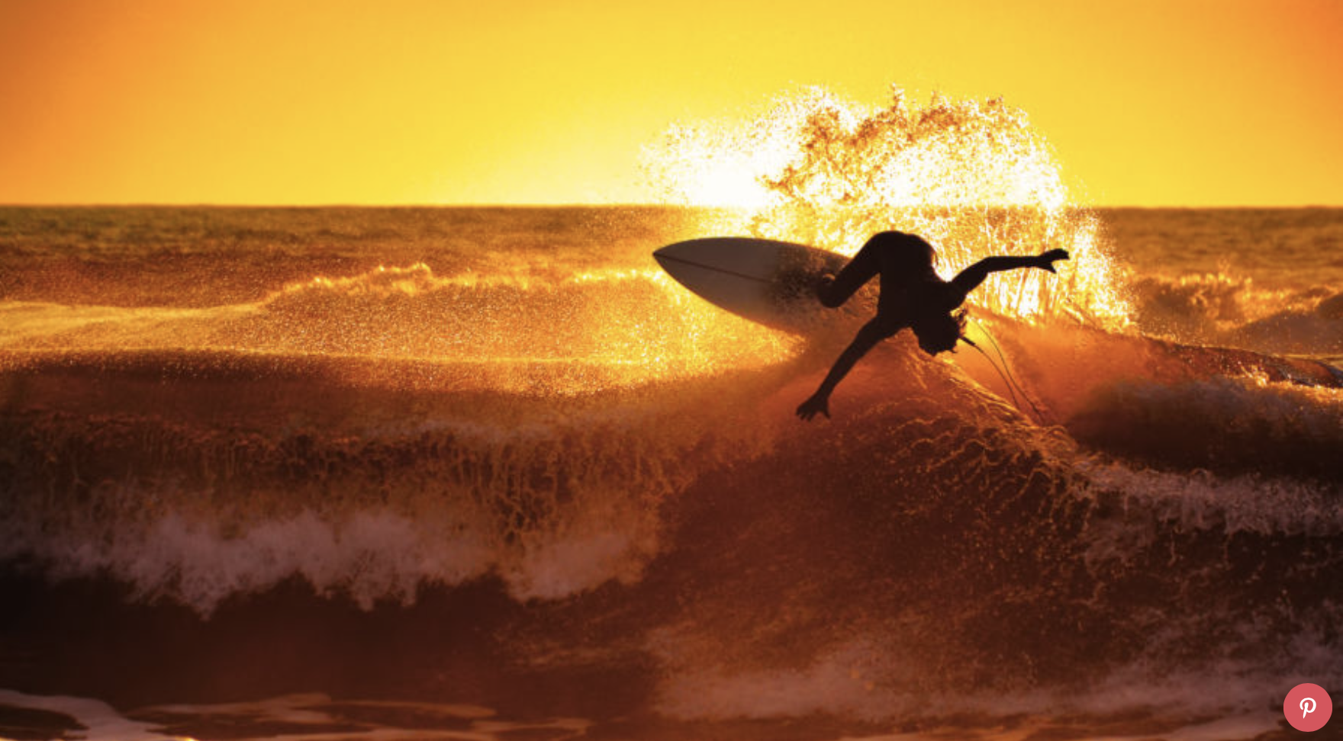
Royalty
Four years to build a life above royalty
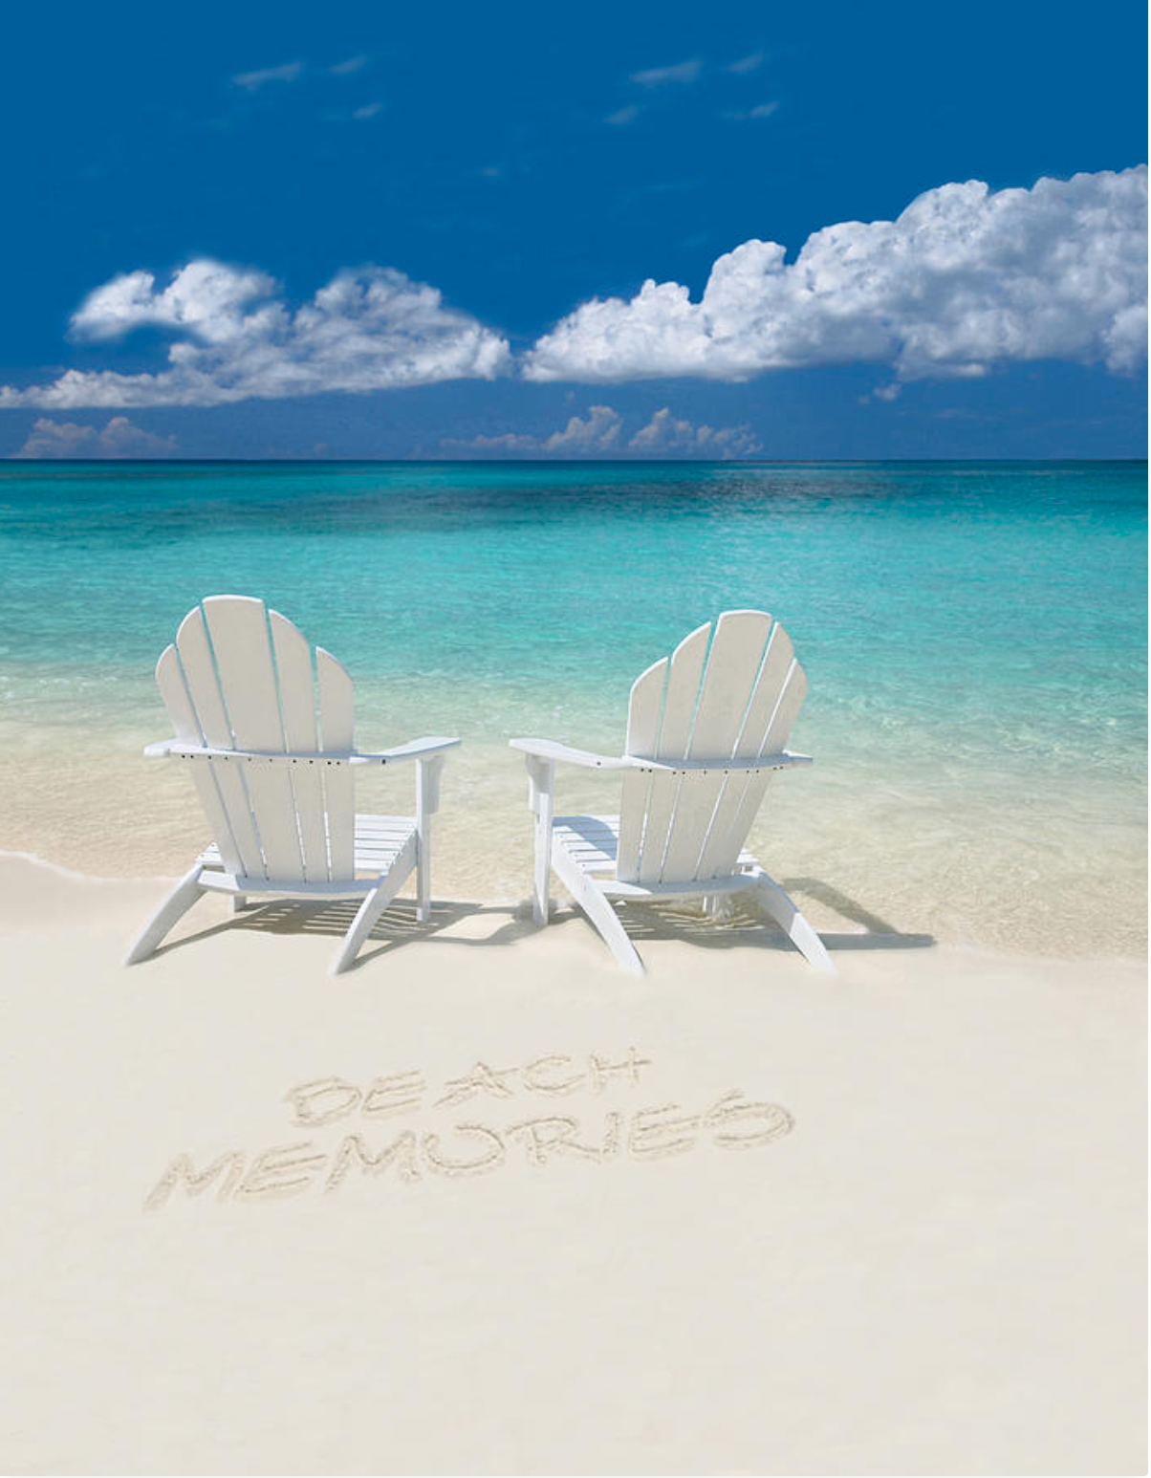

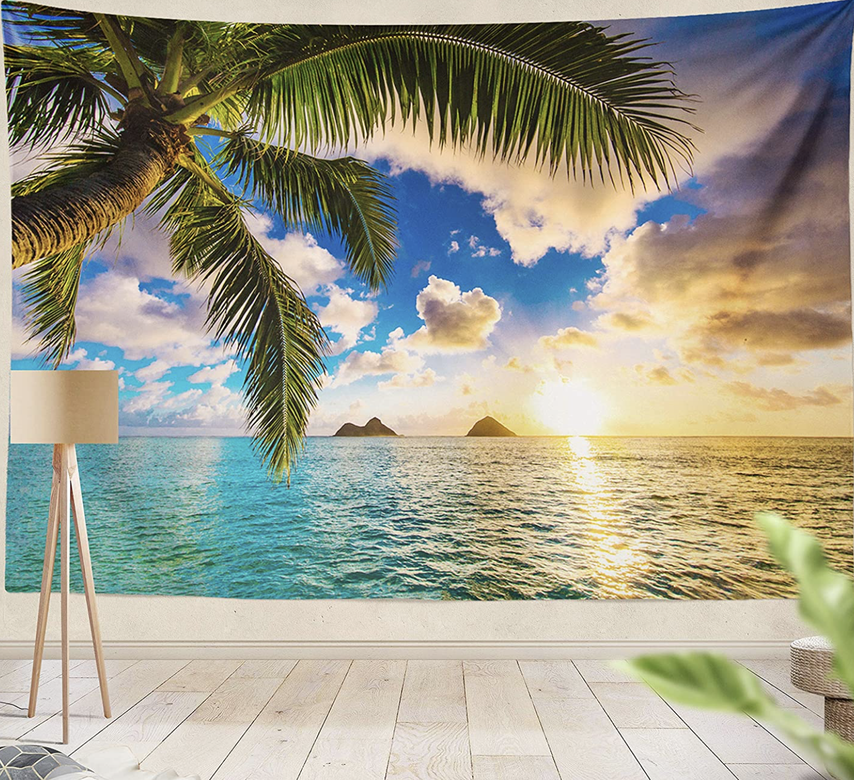
The following tree would be a good style for top right corner of image. Would have to be smaller.

The color of this water is cool, but I’m not sure if it will work with the sky that must be a sunset that fades from orange up to purple higher in the sky.
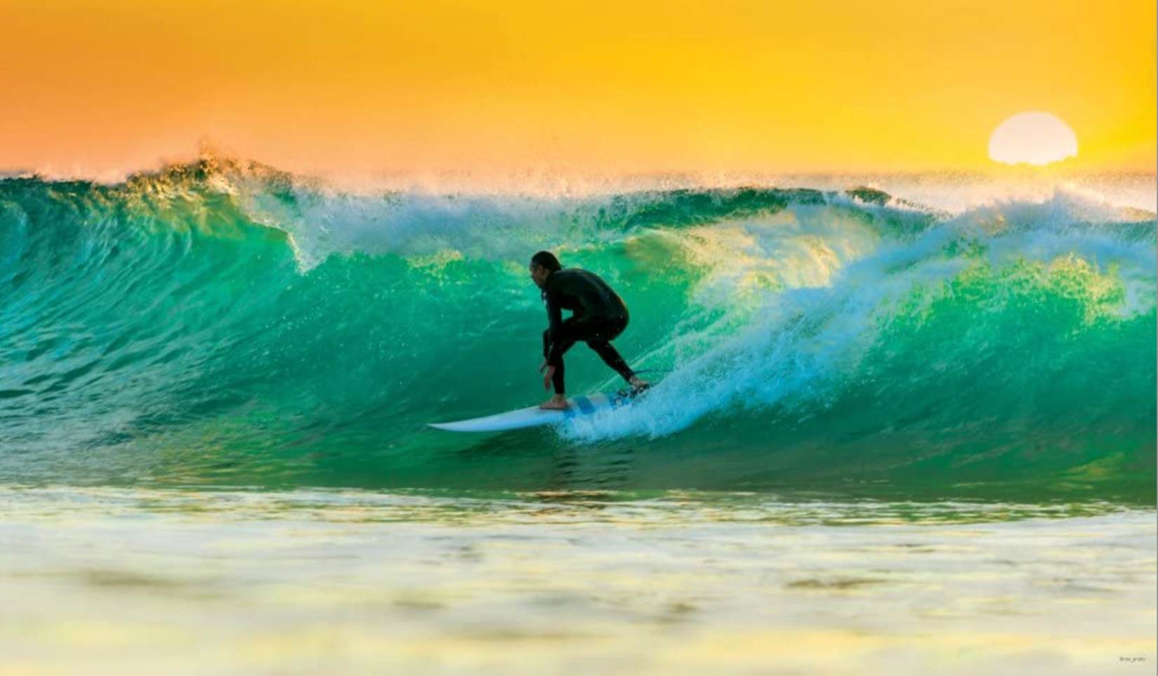

Cool colors for the sunset possibly

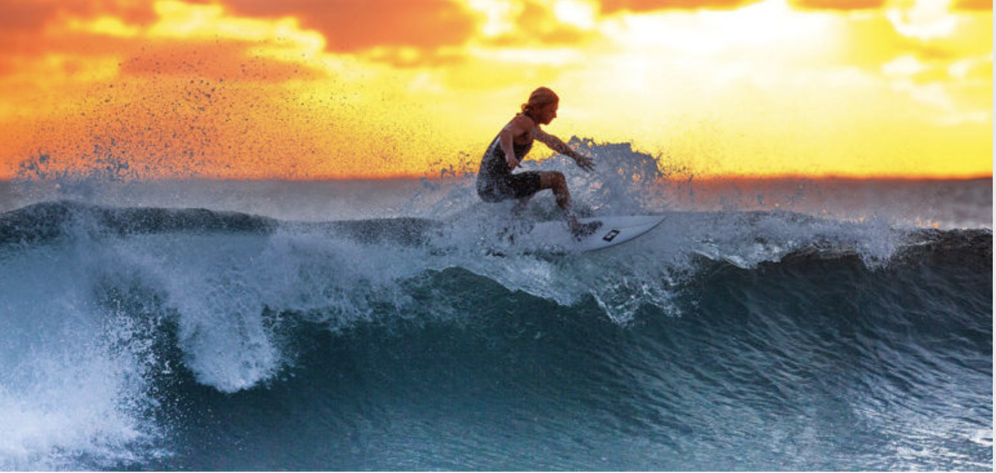

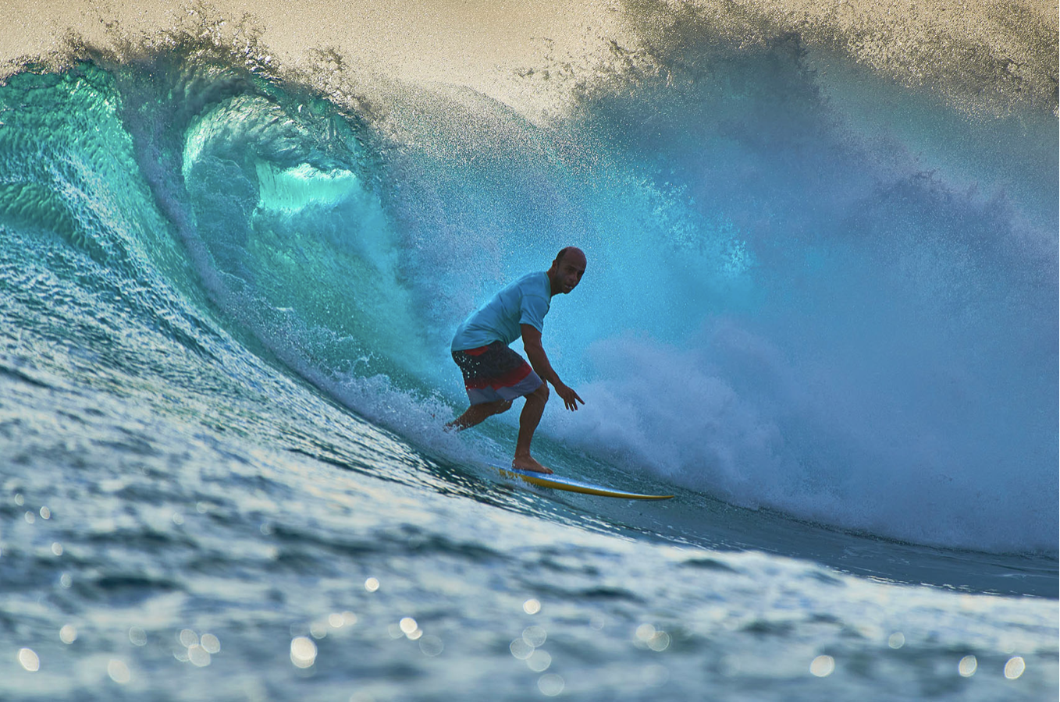
Another possibility for water color:

One of the chairs will have somebody sitting in it with arms up similar to this image:
