FARM DATA SYSTEMS WEBSITE
GENERAL REQUIREMENTS:
- One continuous webpage that you can scroll through on a desktop and mobile interface seamlessly
- FDS logo (fdslogo.jpg) in top left corner of page
- Menu bar remains visible at all times

Layout
Menu Bar: across the top, horizontal
Home About Us Why FDS? Products Partners Contact Us

1st TITLE @ top of page:
Farm Data Systems
Subtext: Bringing industrial automation to the farm

2nd 5 boxes, all next to each other horizontally (NOT SCROLLING):
Box One:

Title: CROP MONITORING
Subtitle: Ensuring that you have real-time information to optimize irrigation management
Button: Learn More (should link to Crop Monitoring Product)
Box Two:

Title: PUMP MONITORING AND CONTROL
Subtitle: Scalable and cost-effective pump monitoring with built-in remote control
Button: Learn More (should link to Pump Monitoring Product)
Box Three:

Title: IRRIGATION AUTOMATION
Subtitle: Upgrade your irrigation system: from retrofit to ranch-wide automation
Button: Learn More (should link to Irrigation Automation Product)
Box Four:

Title: CONTROL PANEL DESIGN AND BUILD
Subtitle: Leverage FDS design and build expertise to meet your exact needs and specifications
Button: Learn More (should link ??? Product)
Box Five:
Title: CONTACT US
Subtitle: For immediate support call (888 277 - 4035)
Button: Get in Touch (should link to Contact form)

3rd About Us:
Header: FDS is a Systems Integrator
Text: Our focus is on helping California growers design, build and adopt effective irrigation management solutions. Our team has worked together for over 15 years, providing monitoring and control systems for 60+ crops that have successfully helped over 500 farms significantly improve irrigation management. We also farm our own 200 acre technology lab to help ensure we deliver reliable monitoring and automation to your farm.
Subtitle: OUR GOAL: to be your trusted partner for technology adoption
Button: Products (should link to top of products page)
IMAGE: almondtrees.jpg

4th Why FDS?:

Header: Why FDS?
Text: We are experts at deploying Information Technology for irrigation management.
We partner with our customers to deliver the right solutions.
Everything we sell is off-the-shelf, cost-effective and reliable.
Subtitle: We're your local farm data team.
Button: Get in Touch (should link to contact us)
IMAGE: vineyard stock photo

5th Products
General Requirements:
- Water Informatics blurb at very top of products section
- Then, Water Informatics logo next to each product section heading
  - Logo: waterinformatics.jpg or waterinformatics.png

Header: Water Informatics
Sub-header: Water Informatics is a cost-effective suite of tools built by Farm Data Systems for irrigation management, providing farmers access to state-of-the-art industrial monitoring and control tools already widely adopted in other industries.
IMAGE: waterinformatics.jpg or waterinformatics.png

REMOTE CROP MONITORING

Section 1: What is Remote Crop Monitoring?
Water Informatics crop performance toolset starts with weather and soil moisture sensors that help farmers better manage crop health and irrigation efficiency. Water Informatics gathers continuous, real-time data to provide insight on plant stress, infiltration, distribution uniformity, temperature, humidity, wind, rain and ET, making it the most valuable solution in the industry.

IMAGE: rcm1.jpg

Section 2: Crop Monitoring System Components
1. Monitor root zone moisture levels up to 60” depth
2. Track irrigation system pressure to ensure good uniformity
3. Track irrigation durations to confirm applied water
4. Refine irrigation decisions with an on-ranch weather station
5. Radio network >98% reliable for reduced maintenance requirements

IMAGE: grouped together in a square rcm2.jpg, rcm3.jpg, rcm4.jpg, and rcm5.jpg

Section 3: Software Overview
1. Dashboard: quick overview of current conditions
2. Health monitoring: to confirm reliable data capture
3. Full profile: for optimal plant health and irrigation efficiency
4. Pressure Tracking: to ensure distribution uniformity
5. Detailed activity: as record of effective irrigation management
6. Full climate: tracking for precise field conditions

IMAGE: please group together rcms1-2.png, rcms3-4.png, rcms5.png, and rcms6.png together and number them with the corresponding numbers above, an example is shown in rcmsexample.jpg

REMOTE PUMP MONITORING & CONTROL

Section 1: What is Remote Pump Monitoring & Control?
Water Informatics is a cost effective, easy-to-use pump monitoring solution that also provides remote access to turn your pump on and off. It is a tool that helps farmers and irrigation districts better monitor pump flows and manage well health and pump performance. Water Informatics gathers continuous, real-time data to provide insight on pump energy use, critical pumping water level, flow and pressure, making it the most complete solution for pump management in the industry.

IMAGE: rpmpump.jpg

Section 2: 5 Tips for Higher Yield
1. Add remote pump start and stop for labor savings
2. Use 24/7 real-time monitoring to prevent over-pumping and avoid costly pump repairs
3. Precisely control the amount of water delivered to optimize production
4. Receive alerts when you approach critical water pumping levels
5. Confirm that actual pump flows (GPM) match your irrigation system design

IMAGE: rpmbox1.jpg and rpmbox2.jpg

Section 3: Software Overview
1. Remote on/off – remote control of the pump for convenience and labor saving
2. Energy monitoring – to confirm reliable power supply and closely track energy costs
3. Well level monitoring - for well health and yield monitoring
4. Filter pressure monitoring - to ensure distribution uniformity
​5. Flow rate and total monitoring - as primary input to pump performance and health

IMAGE: rpmsoftware.png

IRRIGATION AUTOMATION

Section 1: What is Irrigation Automation?
Water Informatics Irrigation Automation includes both valve and pump control systems that brings best-in-class industrial control technology to agriculture to provide farmers with cost-effective, easy-to-use solutions. Water Informatics provides the flexibility and remote control to support precise delivery of plant-water needs with a significant reduction in irrigation labor requirements, making it the most powerful solution in the industry.

IMAGE: iapumpstation.jpg

Section 2: Irrigation Automation System Components

- Industrial strength wide area radio network
- Pump/Valve control & monitoring
- Soil moisture monitoring
- Weather monitoring
- User defined valve selection
- Gateway panel with local control
- Cloud data storage
- Frost alerts
- Desktop/Mobile user interface

IMAGE: Please create an image for this one similar to the one seen below. You must include all 9 things listed above with icons for all 9 (numbered on the image) on a cartoon/drawing of a field of trees, use your creativity to design this and make it similar to the feel of the rest of the website please
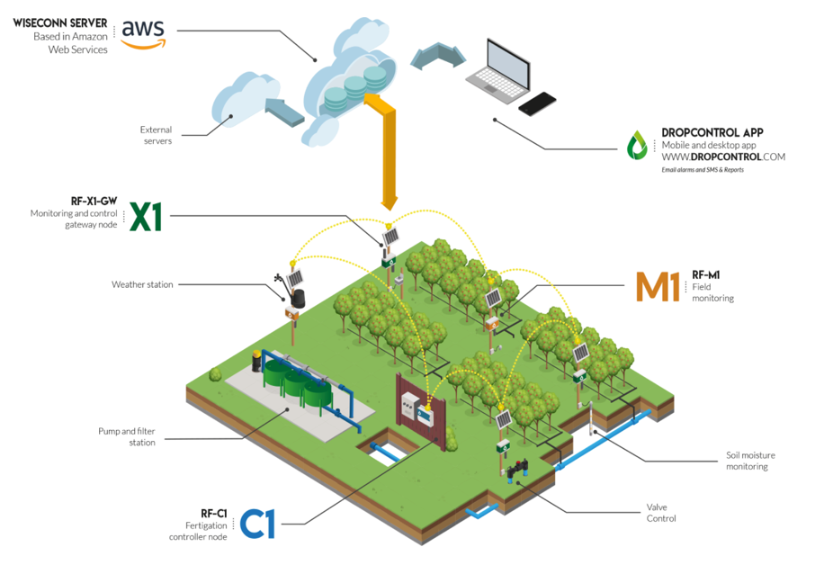

Section 3: Software Overview
1. Pump monitoring: for efficient and reliable operation
2. Irrigation scheduling: for maximum flexibility in irrigation timing
3. Irrigation map: for real-time tracking or irrigation events
4. Advanced device monitoring and control: to ensure correct operation
5. Integration with Crop Monitoring: to optimize irrigation decisions

IMAGE: please group together ias1.png, ias2.png, ias3.png, and ias4.png to the corresponding numbers above, an example is shown in iasexample.jpg

6th Partners
General requirements – display logos grouped into sections:
- Wireless Radios
- Banner.png
- Davis.png
- Ubiquiti.png
- Cradlepoint.png
- Ayrstone.png
- Programmable Logic Controllers (PLCs)
  - Opto22.png
  - Clickkoyo.png
  - Samsara.png
- Software
- Inductiveautomation.png
- Samsara.png
- Probescheulde.png
- Soil Moisture Sensors
  - Sentek.png
  - Decagondevices.png
  - Hsti.png
- Flow Meters
  - Mccrometer.png
  - Seametrics.png
  - Sierra.png
- Other Partners
  - Turck.png
  - Westernweather.png
  - Keller.png
  - Yaskawa.png
