Pothole Repair – Avoiding Costly Liabilities
Moisture intrusion is the leading cause of pavement deterioration. When left alone and when cracks are not repaired, potholes become evident and a safety problem. Potholes represent an annoyance to vehicle traffic and a serious tripping hazard to pedestrians.

To Properly Maintain a Driveway or Parking Lot, It’s Important to Prepare the Asphalt Surface Prior to Sealcoating.
Cracks in your pavement along with pot holes and raveling not only reduce the value of your property and are un-appealing, they are also a safety issue and cause problems for visitors.

How Do Potholes Form?

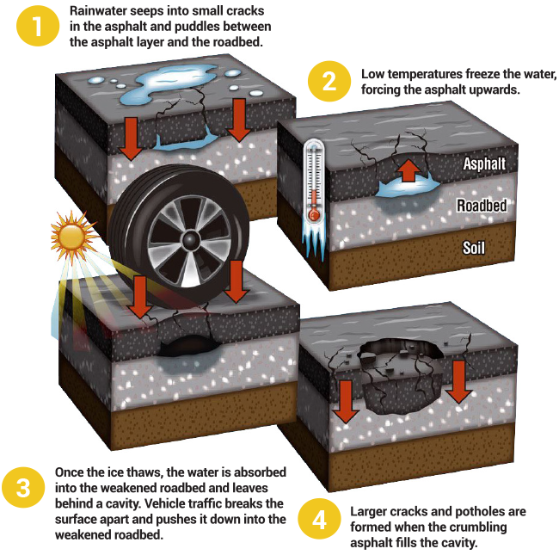

Moisture Intrusion into Cracks is One of the Leading Causes of Potholes
Pavement deterioration occurs when melted snow or rainwater seep through cracks in the pavement and can’t get absorbed into the frozen ground. When the water freezes, it expands and can “pop” or weaken the asphalt. The weight of autos rolling over the weakened pavement causes chunks to break away

