Brand: Florozone | Date:16/04/2020

- What is the task at hand and resulting marketing objective?

Task at hand:

Design new artwork of packaging for Florozone Hand Cleanser
The product will be packed below bottle

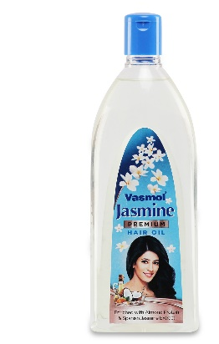

Marketing objective:
To create an attractive packaging for the Florozone Hand cleanser
It will sell in retail shop and Ecommerce portals
USP

- It instantly sanitized your hands
- Washes out 99.9% commonly occurring bacteria , virus & fungus

Ensure that the packaging needs to stand out of the clutter of sanitizer packs in the market.

About the product:

It is a hand sanitizer which will help you to fight viruses like Corona & other bacterial infections

- What is the role of communication & thus the measurable communication objective for this task

The role of the artwork is communicate basis usage of product

- What insight drives this brief?

Due to ongoing COVID-19 pandemic it is imperative to be at home & maintain social distancing. Use of hand sanitizers are become essential parts of our daily routine. There is surge in demand of hand sanitizers infect government are making all the efforts to ensure that there is no shortages of sanitizers and face mask in fight against the COVID-19.
Florozone hand cleanser is again a sanitizer which will help us to fight against COVID-19

Consumer profile:

- Who is our target audience?

TG: 10 to 65 years both men & women

- Mandatories:
  - Good colour combination
  - Please highlight if any printing related requirements like foiling, embossing , SPOT UV/Matt look etc..

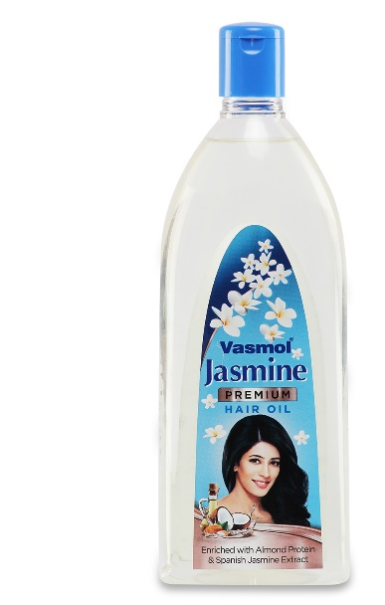
Florozone brand logo

Hand cleanser

Instantly sanitized your hands

99.9% washes out commonly occurring bacteria, virus & fungus

