- HOMEPAGE WIREFRAME AND TEXT
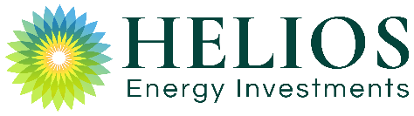 | ABOUT STRATEGY PORTFOLIO CONTACT
[grey background color here refers to the placement of a fullwidth background video
like http://bioenergyinfrastructure.co.uk/]

ILLUMINATING THE FUTURE
Investing in clean energy to generate sustainable returns for our investors and planet

10  Years of Operation | 6  Countries of Investments | 600  MW under Management | €500,000,000  Assets under Management

EXPERTISE. RESOURCEFULNESS. INTEGRITY.  Funding clean energy projects that maximise value to  our investors and contribute to a more sustainable world  > ABOUT US |  |  | HANDS-ON INVESTMENT MANAGEMENT  Utilising our multi-disciplinary knowledge, sector expertise, extensive experience and collaborative spirit  > OUR TEAM
PROVEN INVESTMENT STRATEGY
Achieving consistently high annualized returns and capital gains by leveraging our energy sector experience, broad geographic footprint, dedicated local networks, value creation and implementation of platform structures
> OUR APPROACH

Helios’ energy funds provide a diversified portfolio of assets
- in operation and under construction, in multiple markets -
that drive high investment returns and a balanced risk profile.
Map (focused on UK, Italy, Spain, Israel, Poland and the Netherlands)
with links to individual portfolio items
Helios Energy Investments, Precede Building, Hakfar Hayarok, Ramat Hasharon 47800 Israel
info@heliosfund.com Israel: ​ +972-3-716-7773 Europe: +44 (0) 20 3983 7800
LiveSites |  | Copyright | Terms of Use |  | To Top

WEBSITE DESIGN NOTES
- 3 PDFs need to differ (perhaps 1 without descriptive text, just headers. Another with google map)
- Interactive Map with links to portfolio items
- nav bar – light animation like https://armentavet.com/ and https://www.hi-immigrationlaw.com/
- innovative, unique design with welcoming, appealing, modern feel
- engaging content display by using parallax and subtle movement
- clean, intuitive, easy to navigation layout
- quality, exciting banner images with overlay slogan text ​
- ABOUT PAGE TEXT
- Banner Image with Overlay Text
INVESTING IN EUROPEAN AND ISRAELI CLEAN ENERGY INFRASTRUCTURE
- Helios Energy Investments
Founded in 2010, Helios Energy Investments currently manages four funds and co-investment vehicles, with over €500 million worth of investments in over 600 MW of income-generating renewable energy projects in the Solar PV, Wind, Biogas, Energy from Waste, and Battery Storage sectors in the UK, Italy, Israel, the Netherlands, Spain and Poland.
As a result of its proven track record, Helios has become a leading gateway for Israeli institutional and corporate investors into the European and Israeli energy markets.
Helios continues to expand its activities into new geographies and sectors, capitalising on the growing opportunities in the burgeoning energy sector.
- Milestones in Our History (displayed in succinct Timeline Format)
2010 – Founding of Helios Energy Investments
2012 – Helios Fund I, targeting investments in Solar PV in Israel, Italy, and Biomass in the UK
2014 – Helios Fund II, expanding substantially the Solar portfolio in Israel, establishing Helios as a leading market player in primary and secondary market
2015 – Helios Fund III, growing Helios’ European portfolio
2014 – Helios Fund IV, doubling the group’s committed capital for Israeli projects
2015 – Co-founding of Bioenergy Infrastructure Group (BIG), a UK-based investment platform for Energy from Waste assets
2016 – Entry to the Waste-to-Energy market in Italy
2018 – Co-founding of Bio Capital, a UK-based investment platform in the Anaerobic Digestion sector
2019 – Entry to the Spanish Solar PV, Dutch Biogas and Polish onshore wind markets with substantial investments
- Our Core Competencies
Professionalism and Dedication  Our management team has led the company since its inception in 2010. | Expertise and Experience  Our multi-disciplinary team – with experience in development, construction, financing, operations and exiting projects - holds more than 80 years of combined energy sector expertise across our target geographies. | Reach and Resourcefulness  With offices in Tel Aviv and London and strong partner networks in target countries, we provide a unique platform for active sourcing and management of energy investments.

- Our Team
Helios is managed by a dynamic, growing team of investment and asset management professionals. Our core management team remains unchanged since founded in 2010, and the wider team holds more than 80 years of experience in development, construction, financing, operations and divestment of power generation projects. In addition to its Tel Aviv office, Helios set up an office in London in 2019 to manage and expand the company’s activities in Europe.
Nimrod Goor – Managing Partner |  |  | Erez Gissin – Managing Partner
Nathalie Oz Partner | Boaz Sokol  CFO & Partner | Amon Schneider  COO & Partner |  | Itai Raanan  Partner | Ron Rappaport  Director, Europe Office Head

Nimrod Goor
Founding Managing Partner
Nimrod co-founded and has served as Managing Partner at Helios since 2010.
Prior to Helios, Nimrod was Chairman of the Board of Solar Power, Israel’s leading Solar PV EPC firm. He was also a Partner at Precede Technologies, a seed stage technology investment firm investing in the cleantech sector. Nimrod holds a BSc in Engineering from Tel Aviv and California Coast University and an MBA from the Harvard School of Business Administration.
Erez Gissin
Founding Managing Partner
Erez co-founded and has served as Managing Partner at Helios since 2010.
Prior to Helios, Erez was Chairman of the Board of Brack Capital China, a developer of water and energy infrastructure projects in China. He was also the Founder and CEO at IP Planet Network, Israel, which provides international satellite broadband services in developing markets. Erez holds a BSc in Industrial Engineering from Tel Aviv University and an MBA from Stanford University.
Boaz Sokol
Partner and CFO
Boaz has served as Partner and CFO at Helios since 2011.
Prior to Helios, Boaz was CFO and Investment Manager at Markstone, Israel, an $800 million private equity fund. In addition, he served as Corporate Finance Manager at Eden Springs Ltd. and Manager in the Finance Department of PricewaterhouseCoopers. Boaz (CPA) holds an LLB in Law and Accounting and an MBA in Finance, both from Tel Aviv University.
Nathalie Oz
Partner
Nathalie has served as a Partner at Helios its founding in 2010.
Prior to joining Helios, she was VP Corporate Finance at Citigroup, Israel and Assistant VP and Portfolio Manager at Deutsche Bank Capital. Nathalie holds a BA in Business from Hebrew University and an MBA from Cass Business School, London.
Amon Schneider
Partner and COO
Amon joined Helios as a Partner and COO in 2019.
Amon has over 25 years of extensive management and consulting experience in all business activities and regulatory issues in various foreign territories. He founded and managed companies in Europe and Israel, executing projects in the environment, real estate, and communications industries for international players such as Flextronics, Siemens, Nokia, Nortel and others. Amon was CEO of WIND Technologies, Tal Technologies and Giltek Telecomunications. He also served as the Director of Marketing and Sales at ARAM. Amon studied Communication (Cinema and Television) at the City University of NY and Tel Aviv University.

Itai Raanan
Venture Partner
Itai has led investments in energy and infrastructure projects across the globe for more than 15 years. In the last few years, he managed investments and raised debt as a JV partner and advisor to more than 800MW of renewable energy projects. Prior to that, Itai worked as an Investment Manager at NOY Infrastructure and Energy Fund, served as Commercial Director at Siemens' Thermo Solar, and advised on asset financing in EPF, London. Itai holds a BA in Economics and Business from the Hebrew University of Jerusalem and an MBA from London Business School.

Ron Rappaport
Director, Europe Office Head
Ron has served as Director and Europe Office Head at Helios since 2019.
Prior to Helios, Ron was a Senior Consultant, specialising in power generation. at Baringa Partners. As a Research Assistant at Cambridge University, Ron focused on battery storage and electric vehicles. Ron holds a BA (cum laude) in Management from Ben Gurion University and a MPhil (distinction) in Engineering from Cambridge University.
- Investors
Pheonix | Ayalon | Menorah Mivtachim | Clal | Gilad | Meitav Dash
Amitim | Kupa Handesaim  Keren Handesaim | Hachshara | Karnot Hishtalmut Le Morim Ve Gananot + Le Morim Tichonim | Migdal | Profimexersity of Jerusalem

- News
3 News Items (links needed)
3. STRATEGY PAGE TEXT
- Banner Image with Overlay Text
ACTUALIZING GLOBAL REACH WITH PROVEN PARTNERS
- Investment Strategy
Helios Funds provides consistently high annualized returns while creating the foundations for maximising the capital gains upon exiting the investment.

Helios’ investment strategy is based on:
  - SECTOR EXPERTISE
We focus on the energy sector. Our sector focus, enables us to leverage our expertise and increase overall returns through economies of scale
  - BROAD GEOGRAPHIC FOOTPRINT
We target countries for investment that provide an optimal combination of a positive regulatory environment (assuring multiple years of investment opportunities, solid and stable legal system and property ownership rights mitigating long term ownership risks), and a developed financial system (enabling non-recourse debt financing for power plants). Our geographic spread enables us to transfer knowhow between sectors within a country and between countries within a sector.
  - DEDICATED NETWORK
We build long-term partnerships with key, local developers and industry players in each target market. By leveraging our dedicated network of partners and experts across countries and sectors, we get preferred access to deals and a sharing of risks and upside returns.
  - VALUE CREATION
We invest ahead of yield curve compression. By identifying and capitalizing on new emerging sectors which have yet to become commoditized, we establish a portfolio of projects positioned to benefit from the expected future reduction in purchasers’ target IRR and maximize possible returns on exits.
  - PLATFORM STRUCTURE
We create a critical mass of projects through platform structures. By accumulating projects in a platform structure, we 1) allow for economies of scale, 2) provide for sophisticated, multi-layered, efficient debt financing, and 3) achieve a critical mass of diverse assets ideally positioned for a high value acquisition by a large-scale buyer such as a financial institution, yield-co, utility or an IPO .

- PORTFOLIO PAGE WIREFRAME AND TEXT
 | ABOUT STRATEGY PORTFOLIO CONTACT
Banner Image
DELIVERING ANNUAL RETURNS AND CAPITAL APPRECIATION
Renewable energy, distributed generation and emerging technologies such as battery storage and electric vehicles are part of the accelerating global energy transformation. Over the past few decades, the adverse effects of climate change have become common knowledge, raising the matter to the forefront of the global public agenda. As a result, governments have set ambitious targets for emissions reduction, underpinned by various forms of subsidies for clean power generation. Today, cost reductions are making new energy technologies competitive with traditional fossil-based generation, and the energy transformation is driving significant economic engines. Thus, this fast-growing energy market now contains promising economic opportunities across different technologies, with limited risks in well established markets.

Filter with links  to portfolio items  by sector  - Energy from Waste  - Anaerobic Digestion  - Wind  - Solar PV | Map with links  to portfolio items by country  - UK  - Poland  - Italy  - Spain  - Israel  - Netherlands

This area will populate here with assets (see below) according to what is clicked on above (sector or country)

Helios Energy Investments, Precede Building, Hakfar Hayarok, Ramat Hasharon 47800 Israel
info@heliosfund.com Israel: ​ +972-3-716-7773 Europe: +44 (0) 20 3983 7800
LiveSites |  | Copyright | Terms of Use | To Top

- Portfolio Items
Each asset will have its own page (pages 1-12 as organized below, with BIG and Bio Capital as 2 of 12 pages).
Then website visitors can link to:
- individual assets (from map on homepage)
- pages with all items in a sector (from key next to map on portfolio page)
- pages with all items in a country (from map on homepage)

1. Bioenergy infrastructure group (BIG) - Energy from Waste, UK
Bioenergy Infrastructure Group Limited (BIG) was co-founded in 2015 by Helios, Infracapital, Foresight and Aurium. BIG, which operates as a platform for investments in the waste to energy sector in the UK, has grown to manage one of the largest portfolios in the sector.
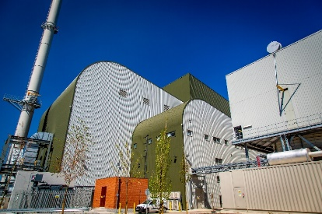  Ince, England  22MW  170 kt / wood  Operating | 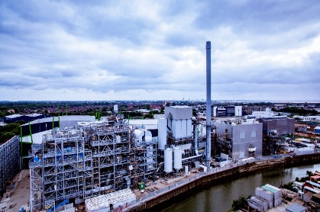  Hull, England  24MW  240 kt / RDF  Operating | 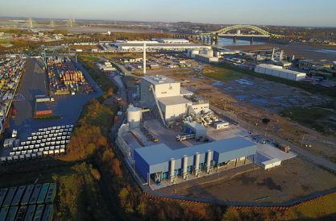  Widnes, England  20MW  140 kt / wood  Operating | 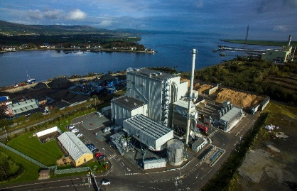  Evermore, N. Ireland  16MW  110 kt / wood  Operating
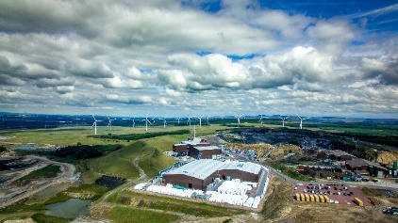  Levenseat, Scotland  12MW  215 kt / RDF  Operating | 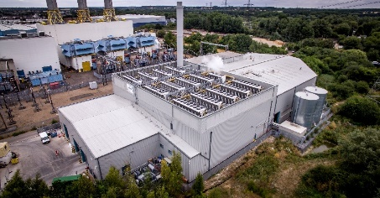  Hoddesdon, England  10MW  105 kt / RDF  Operating | 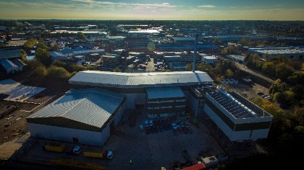  Birmingham, England  9MW  60 kt / wood  Operating

2. Bio Capital - Anaerobic Digestion, UK
Helios, in a joint venture with Aurium and Equitix, co-founded Bio Capital Limited in 2018 as a platform company for investments in the anaerobic digestion sector in the UK. Bio Capital’s portfolio, which targets operational and greenfield assets, includes AD plants for gas-to-grid and electricity generation facilities that utilise food-waste and agri-feedstock fuel sources, as well as waste collection businesses to promote group synergies and economies of scale
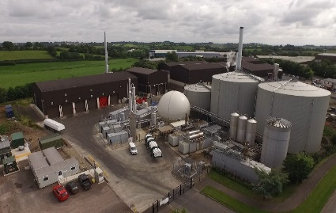  Granville, N. Ireland  8.3MW  110 kton pa  Operating | 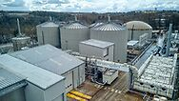  Energen, Scotland  5.6MW  215 kton pa  Operating | 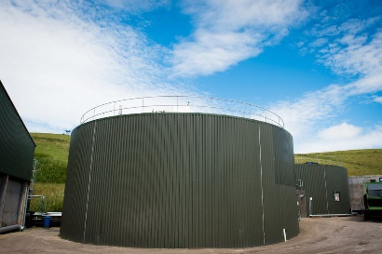  Earnside, Scotland  2.4MW  105 kton pa  Operating
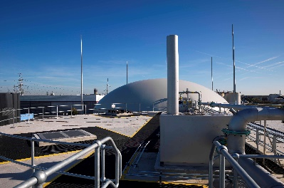  East London, England  3.5MW  60 kton pa  Operating | 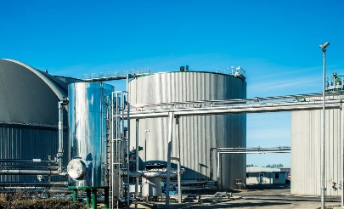  Warrens Emerald Biogas, England | 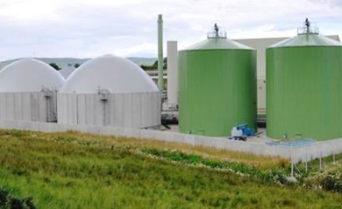  Barkip, Scotland

- Potegowo Project – Wind, Poland
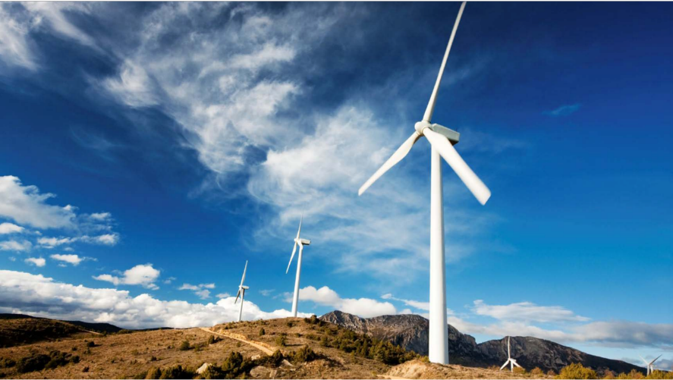
Potegowo Project is the largest wind project in Poland.
Gdansk, Poland
225MW
81 GE turbines
COD Q3/2020

- Domrel Project - Wind, Poland - UNDER CONSTRUCTION
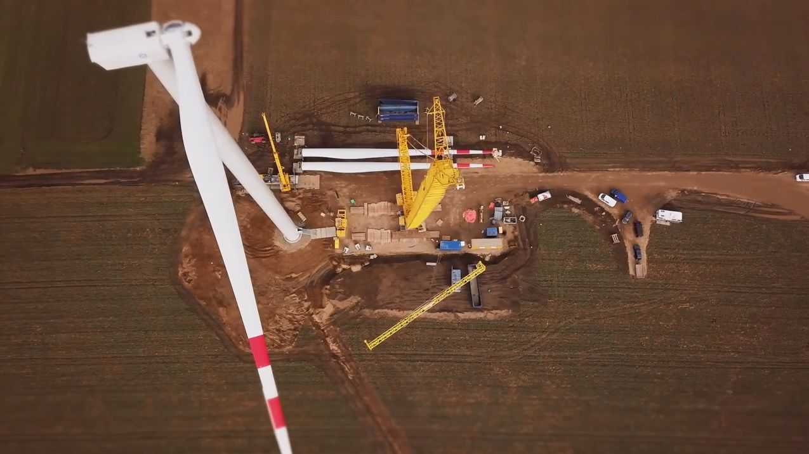
Wielkopolska, Poland
26 MW
13 Siemens Gamesa turbines
COD Q1/2022

5. Six 1MW AD Plants – Anaerobic Digestion, Italy
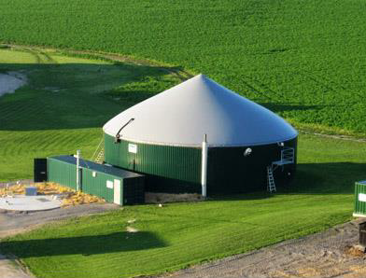
Helios’ waste-to-energy assets in Italy consist of six 1MW AD plants that are operational.
Four plants are fed by energy crop, one by vegetable oil and one by animal waste.
6. Bonete – Solar PV, Spain
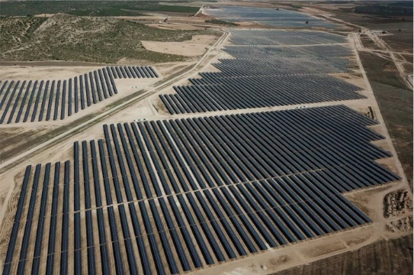
Bonete is Helios’ first investment in Spain.
Albacete, Spain
146MW
COD Q1/2020
7. Ashalim - Solar PV, Israel (additional detail on Israeli projects – MW/COD etc)
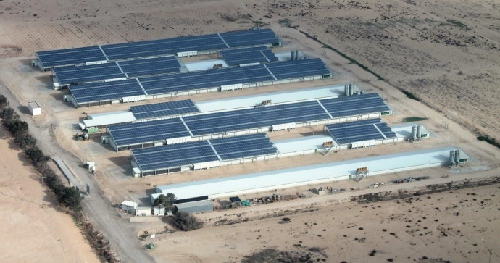
8. Ein Evrona -– Solar PV, Israel
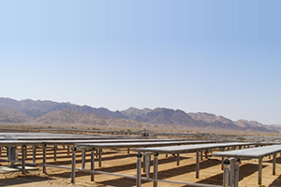
9. Mitzpe Ramon – Solar PV, Israel
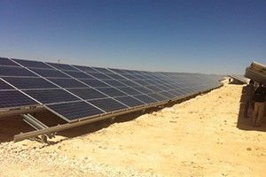
10. Yerucham – Solar PV, Israel
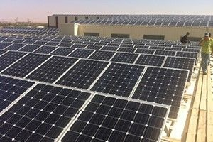
11. Telamim – Solar PV, Israel
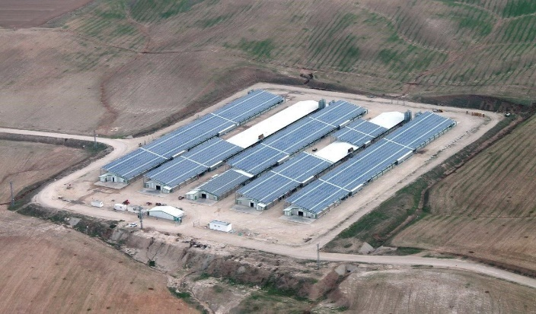
12. Sterksel - Anaerobic Digestion, Netherlands
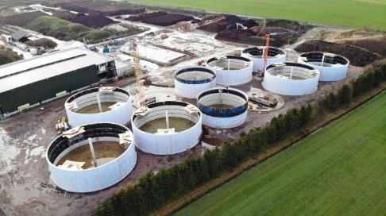
The Sterksel Anaerobic Digestion (AD) project is part of Bio Tech Park Brabant (BTPB) Eco park located in Brabant, Netherlands. The project is currently under construction and is expected to be commissioned by Q4/2020
- CONTACT PAGE TEXT
- Banner Image with Overlay Text
FUNDING CLEAN ENERGY FOR A BETTER WORLD
- Contact Form on left
Fields: Name*, Email*, Phone, Message
Button: SEND
- Contact Details on right
Helios Energy Investments
Precede Building, Hakfar Hayarok
Ramat Hasharon 47800 Israel
info@heliosfund.com
Israel:​ +972-3-716-7773
Europe: +44 (0) 20 3983 7800
Fax: ​+972-77-555-8351​

