Design Crowd Specs
FunSchway is a fun, creative and positive business geared toward a balanced harmonious environment. It centers on positive impact through humor. Communication is key. Innovative techniques improve communication and presentation skills to the next level.

- I am looking for a design that can be used across 3 book covers. They all are related however, might need minor adjustments for each.
  - The main book is called:
FunSchway
Defending Your Happy Place

A personal guide to Clarity, Harmony & Inspiration
By
Pat Gacutan

  - The second book cover is for a workbook that goes with the main book

FunSchway
Defending Your Happy Place
Workbook
Enter the Mojo Dojo
By Pat Gacutan

  - The third book cover is for a small book
FunSchway
Defending Your Happy Place
Funfucious Say…
By Pat Gacutan

- All of the covers need to incorporate my logo (provided)
- I will also provide some items of inspiration to me for the designers to consider.
- I am also including a draft cover that I like, however they did not use my logo, but I somewhat like the Asian design.

- I need all of these covers to be for E books and also for printing purposes.

- The back of the books will have my picture and bio, plus 2 testimonials on the main book. The workbook will have the same. The small book will only have my contact info.

***********************
Inspirations I like:



I like Asian designs. Elegant, professional and Fun.

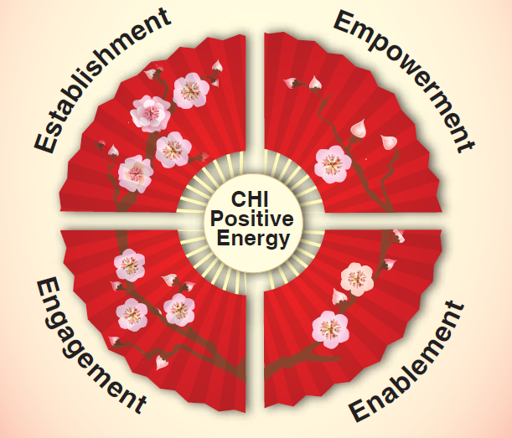

- I like the fans and they need to have exact number of large flowers
- The center CHI which stands for Clarity, Harmony, Inspiration (I need this to be a better design) Maybe something like a ying yang. But Must have CHI in the design
- But I would also like the fan associated with the words except for the CHI. Need CHI designed to reflect positive energy. It does not have to say positive energy but be a powerful drawing to reflect that
- This can possibly be part of the Cover as long as it does not make the cover too busy.

