Projet: Bee Api logo revap
A. Goals:
Create a new image for honey farm business. New logo has to bee more compatible with new mission statement of company; offer natural bee products that promote wellness, sustainable beekeeping and sense of community.
B. Old design :
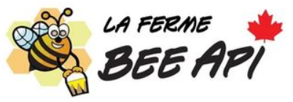
C. Critics of old design:
- Childish look instead of professional look.
- Old design does not match new mission of company.
- Too much complex, too many elements and colors.
- Hard to recognize and to remember.
- Not scalable, loss of resolution when minimizing.
- Bad calligraphy.
D. Characteristics for new design :
- Simple and clear; easy to recognize, simple shapes, less details.
- Scalable: good resolution when enlarged or reduced since logo will be used on mutliple platforms (Instagram, Facebook, shopify website).
- Memorable: easy to recognize and memorized.
- Pass 5 seconds test; leaves association to bee products.
- Logo can be used alone or with typography.

E. Direction of design:
- Use of honeycomb shape (hexagon)
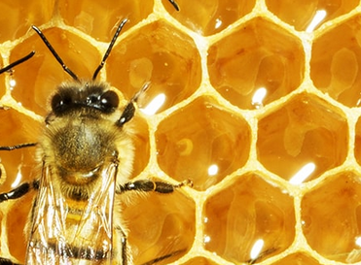
- Create bee with honeycomb, incorporate morphological features ( yellow and black stripes on abdomen and sting).
- 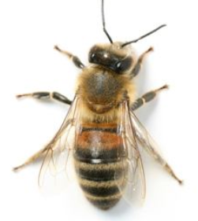
F. Quick Illustrator sketches :


