Geoscience BC PowerPoint Template – Feedback and Next Steps
Updated RT May 6, 2020
- Landscape 8.5 x 11 as well as 16:9

- Add Option for photo in b/g on these: 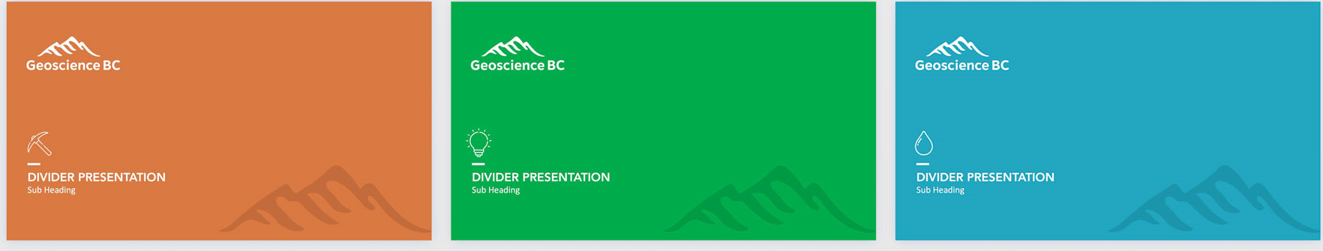

- Colour code to minerals, energy, water:


- Add a slide like this (taken from a different provider) as an overview slide:
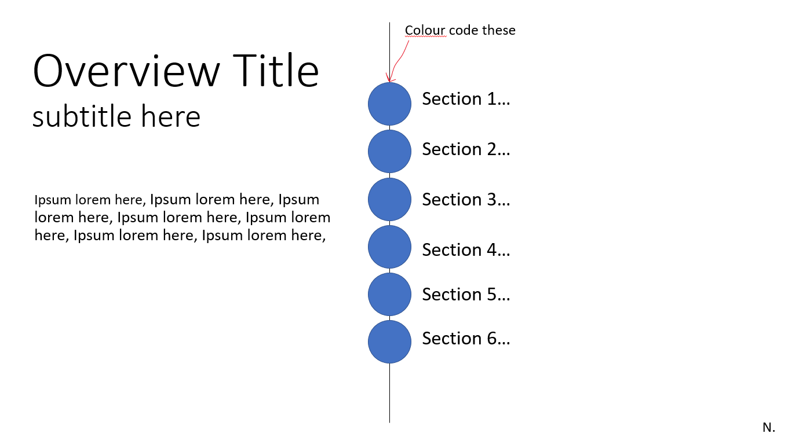

- Remove World Maps Sample (19)

