R3 Infographic – Creative Brief

Global industrial is an industrial distributor of products that are essential for the operation of businesses such as distribution centers, medical facilities, manufacturing facilities, multi-family units, and much more.
Due to the COVID-19 Pandemic, many of these businesses are shut down or operating with essential staff while the remaining personnel are working from home.
As we are reaching the peak of the pandemic, many businesses are starting to think about what they need to do in their facilities to retrofit them and make them safe for their employees and customers in a post COVID-19 world.
This assignment is about developing an infographic that will provide our current and potential customers with information about the old world, and the new world. This needs to be interesting, informational, and viral (i.e.- content is so compelling folks will share with friends, colleagues and other businesses.
The infographic will be shared online, available via PDF. No specific size requirements but keep in mind we want to put online, on a pdf, and potentially add to a PDF guide that will be 8.5x11. May be center section that will be 17x11
While we do not want to highlight specific products, we do want folks to know that Global Industrial has all those products available and we should direct them to our R3 landing Page.
R3 Stands for Restore, Return and Rebound
- Restore your facility – be ready to meet employee and customer expectations in a post COVID-19 world
- Return – have all the safety measures in place for when your employees return
- Rebound – accelerate your rebound because you were prepared ahead of time
Infographic elements – before and after (along with some illustrative products we sell to support the new world – to assist designer)
- Not all examples need to be used. Use your creativity
- Additional products can be found at https://www.globalindustrial.com/coldFlu
Old World | New World | Illustrative product or imagery
Handshakes | Waves
High Touch | Touch Free | Touchfree faucets, toilets, etc.
Show your face | Hide your face (facemasks) | Personal Protective Equipment
Togetherness | Social Distancing | Partitions, crowd control
Work at Work | Work at Home | Home office furniture, office supplies, etc.
Open Floor Plans | Separated floor plans | Panels, rolling white boards, plexiglass separators, etc.
2 Weeks of sanitation supplies on hand | 3 months of sanitation supplies on hand
Common areas built for function | Common areas built for safety | Crowd control, stanchions, separators, signage
Unmanaged people traffic | Defined pedestrian paths – 1 way aisles at retail | Floor signage
Limited hand sanitation | Sanitation stations at every touchpoint | Sanitation stations, sanitizing wipe stations
Self-service buffets | Full service buffets | Plexiglass separators, etc.
Manual doors | Automatic doors
Birthday cake candles blown out | Birthday cake candles banned or put out with fans
Face to face customer service | Plexiglass separated customer service | Plexiglass separators
Facilities cleaned once a day | Facilities cleaned many times a day | Additional sanitation equipment such as carts, brooms, mops, non slip signs, etc.
In Person Meetings | Virtual Meetings | Retrofit conference rooms for virtual meetings

Other assets.

Our Logo:

R3 Logo:
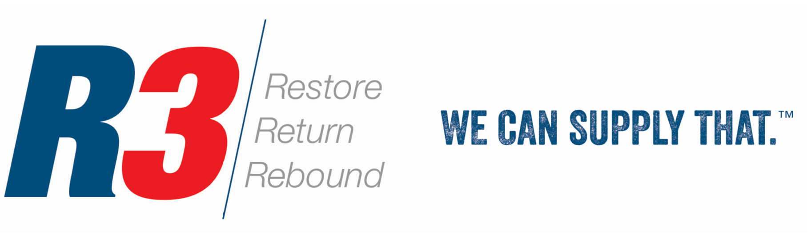
Our website: www.globalindustrial.com

