What is Exercise Physiologist (EP)?

Accredited Exercise Physiologist (AEP) are university qualified allied health professionals. They specialise in designing and delivering safe and effective exercise interventions for people with chronic medical conditions, injuries or disabilities. When it comes to prescription of exercise, they are the most qualified professionals in Australia.

Why would you be referred to see FitTech’s Exercise Physiologist:
- To have a professional work with you to improve your quality of care
- Be the missing link in your health care cycle alongside other Allied Health Professions (your personalised team of specialists)
- To have someone focusing on improving your quality life on a personal level
- To increase your physical activity at your level in a safe and supported way

Contact FITTECH Today

WHERE ARE WE?
G6/132 Corrimal Street Oxford on Crown Wollongong
www.fittechstudios.com.au

HOW CAN WE GET STARTED?
- Come and meet us for an obligation free chat.
- Tell us your goals and lets make a plan.
- Complete an assessment with our EP
- We will put together a personalised training program.
- Book your sessions.
- Lets train and get those goals.
- Review and track your progress with other allied health professions.

Send us an email at daniel@fittechstudios.com.au or call Daniel on 0433 177 993

FB/INSTA @Fittech Studios

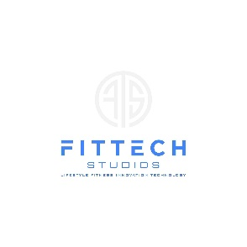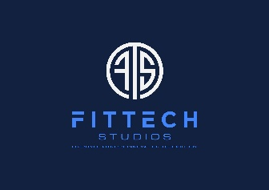
FitTech Studios
Lifestyle Fitness Innovation Technology
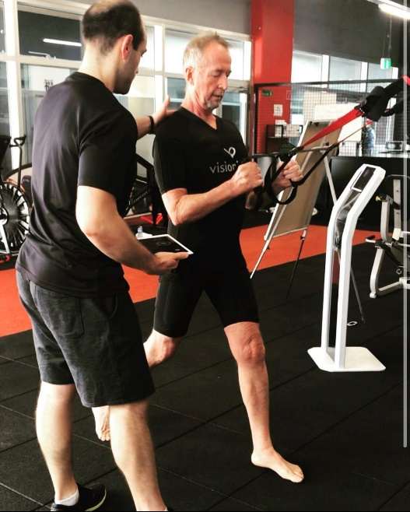
Train smarter not harder”

Here at FitTech we believe in exercise as a medicine to help prevent a range of chronic conditions and at the same time we believe it doesn't have to be hard or time consuming.
We achieve this by utilising our innovative EMS technology and modifying the conventional ways we train.
All of that while being in a supportive environment that will make you feel welcomed and apart of the family.

Claim your EP Sessions


Services delivered by an AEP are also claimable under compensable schemes such as medicare and covered by most private health insurers. FitTech’s in-house EP specialise uses exercise as a medicine to help to prevent and manage a wide range of chronic conditions, including diabetes and some cancers. Qualified to work with NDIS participants, DVA claims, Workers Compensation Cases and Team Care Arrangements with GPs.
Contact FitTech to find out how to apply TODAY!

Enhancing your Exercise Physiology results with the benefits of EMS
Advanced Electro Muscular Stimulation (EMS) technology

Muscle Re-Education

Low impact on joints

Reduced back ache
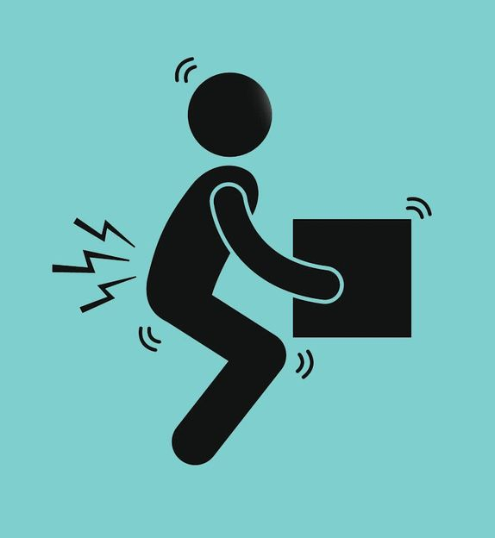

Improved blood circulation
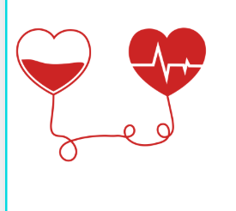
Boosts immune system

Wireless connectivity enables a full body workout


Conditions that can benefit from Exercise Physiology
If you’re living with a chronic condition, injury or illness, an Exercise Physiologist is the best person to help you get moving again. They understand the challenges and will work with you (and your doctor) to prescribe safe and effective exercise interventions.
We can help with:
- Back & Chronic pain
- Cerebral palsy, Autism and other developmental difficulties
- Diabetes & other Metabolic conditions
- Heart health
- Injury recovery (including rehab from operations such as ACL, knee, and hip replacement
- Mental health (Depression and Anxiety)
- Musculoskeletal disorders
- Obesity and related illness
- Osteoarthritis and inflammatory arthritis
- Pre and Post-surgical rehabilitation
- Stroke & other Neurological conditions
- Women’s Health

And many more

