Logo Design Project

Logo Design Brief
We are looking for a logo design for our new company, a municipal advisory and consulting service. The company name is "California Municipal Advisors, LLC". On the logo, our name can be shown as “CalMuni Advisors”. The company is based in the State of California, USA. The company will provide financial consulting services to cities, water districts, school districts, and other types of local public agencies. A lot of our services are aimed at helping public agencies figure out how to pay for infrastructure projects (water treatment facilities, water lines, city halls, school campuses, parks, police and fire equipment, etc.).

Our customers are executives of public agencies (finance directors, city managers, district general managers, etc.), which tend to be more conservative. Things that are important to them are professionalism, fiscal prudence, trust, longevity. At the same time the logo should not feel overbearing or stuffy. Our vision is to bring new ideas and creative approach into a traditional and conservative industry.

Target Market(s)
Public agencies (cities, water districts, school districts, etc.) in the State of California, USA

Industry
Government finance

Logo Text
N/A

Logo styles of interest

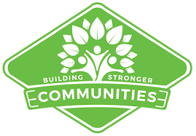

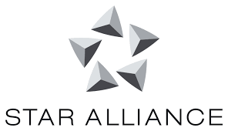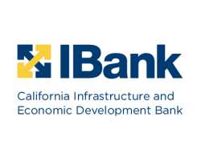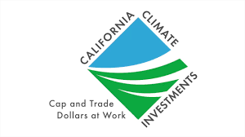



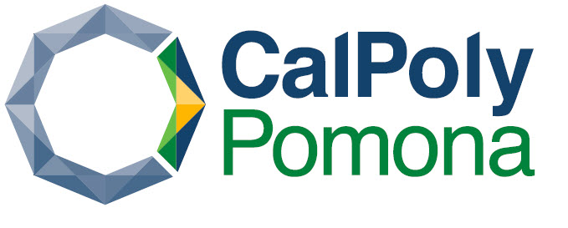

Colors
We like CalPoly Pomona color scheme – sharp and not overbearing. Variations are acceptable.

Look and feel
Elegant / Bold – 50/50
Playful / Serious – 100/0
Traditional / Modern – 50/50
Personable / Professional – 100/0
Feminine / Masculine – 50/50
Colorful / Conservative – 75/25
Economical / Upmarket – 50/50

Requirements
The logo should NOT have a bear (California symbol).
The strong preference is for a crisp, professional logo.

