Coffee Shop, Store Front & Online - Shoptimized theme

***Important*** Credentials to complete the gig will only be shared via Lastpass or a similar password share application. Please ensure you will be able to do this before proceeding.

Please show me any shoptimized themes that you have created/customized.

Job Description
Set up and customize all products to Shopify for my Coffee Shop and customize to my colours and brand - using the current installed shoptimized theme.

Hi there, I have a "Physical retail Cafe" I am looking for someone to upload the attached menu for me in the products section of my Shopify store and make the store look and display awesome. Need expert who has a good understanding of the shopify and shoptimized system as I need a quick turn around.

Existing Old site - www.cupajoes.com.au
New shopify site to be set up with shoptimized theme - https://cupajoes.myshopify.com/

Attached in these excel spreadsheets are the menus:
1.Cupa Joes Insotre Menu - Cupa Joes Online Shop Menu
2. Cupa Joes Online Shop Menu

1. In Store Menu - where customers can only purchase the items in the store - however they will be able to view all items online. So a visually appealing display of products and ease of viewing of the menu is important.
Currently customers can order this menu here - http://onelink.to/b66tqx using phone app, computer or any device and pick up only from store.

2. Online Shop Menu - They can purchase these items online and we can ship.

Examples provided below of how I would like the sites I like - and would like similar design using our products and items. Please feel free to use your expertise to solve and issues or improve.
Also I am happy to discuss any ideas or questions you have.

We do not have many images of our products at the moment so please free to use any of the images from below sites as a temporary pic - unless you can source some better original ones or have some ideas...

https://gloriajeanscoffees.com.au/
https://gloriajeanscoffees.com.au/menu/ - fantastic display of menu items.
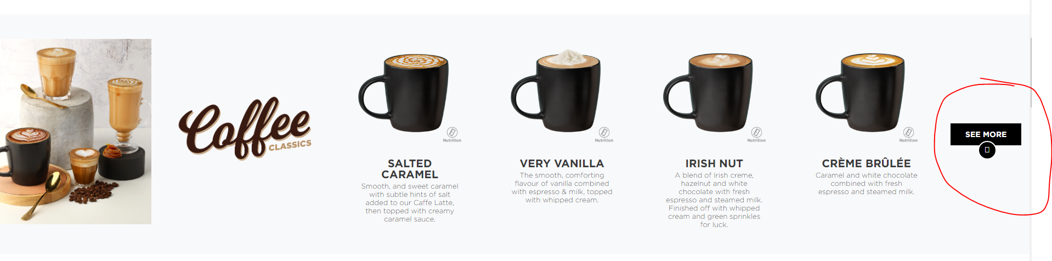

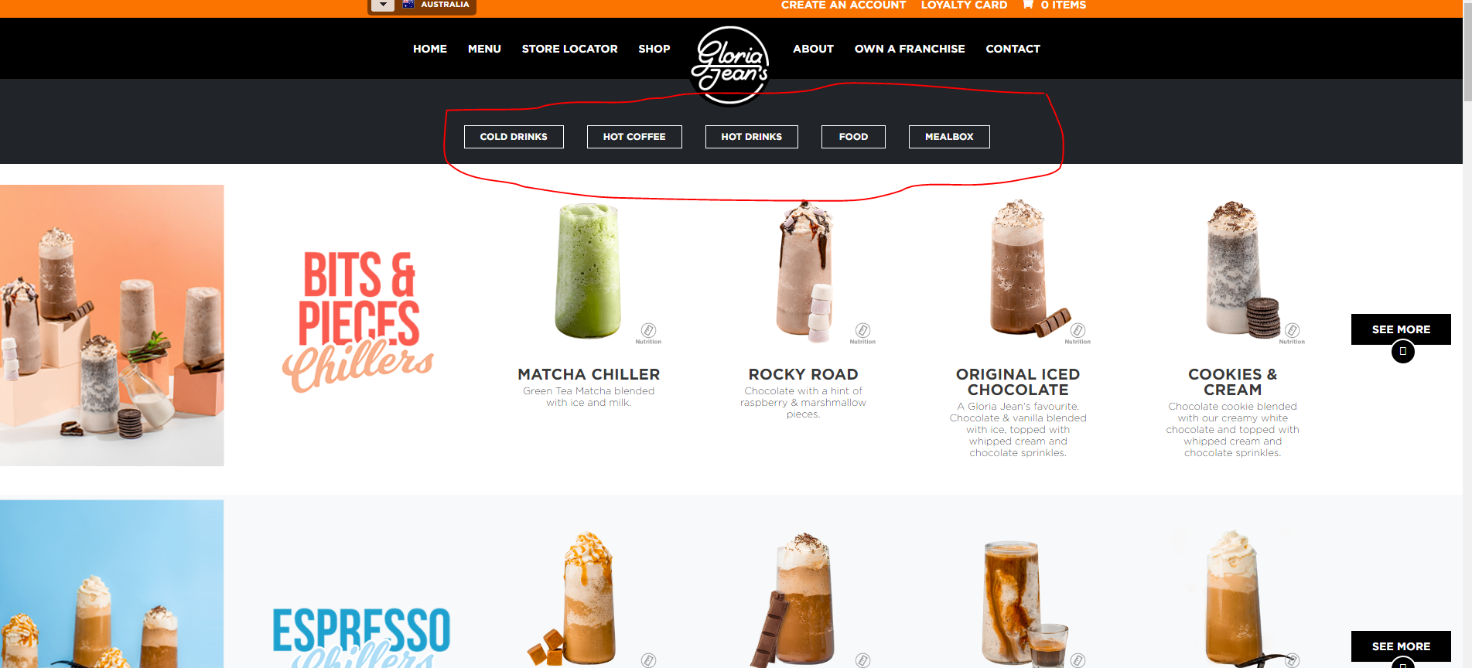

https://www.lacolombe.com/collections/medium - excellent categorization, layout and display of images.

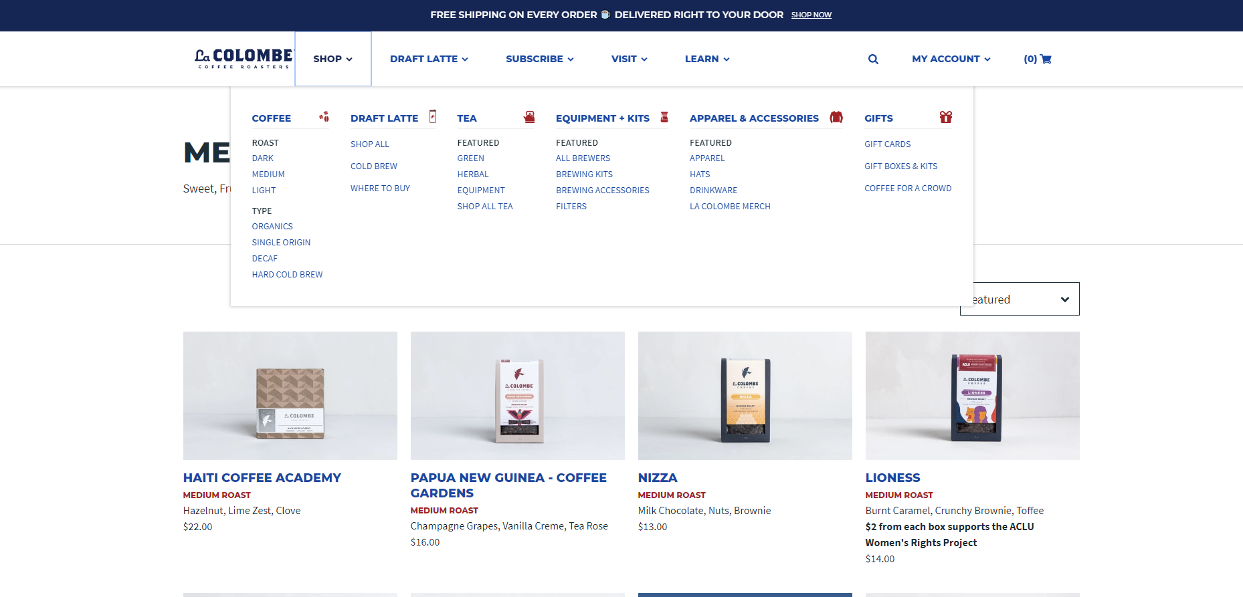

https://dripkit.coffee/collections/gifts - subscription concept is great
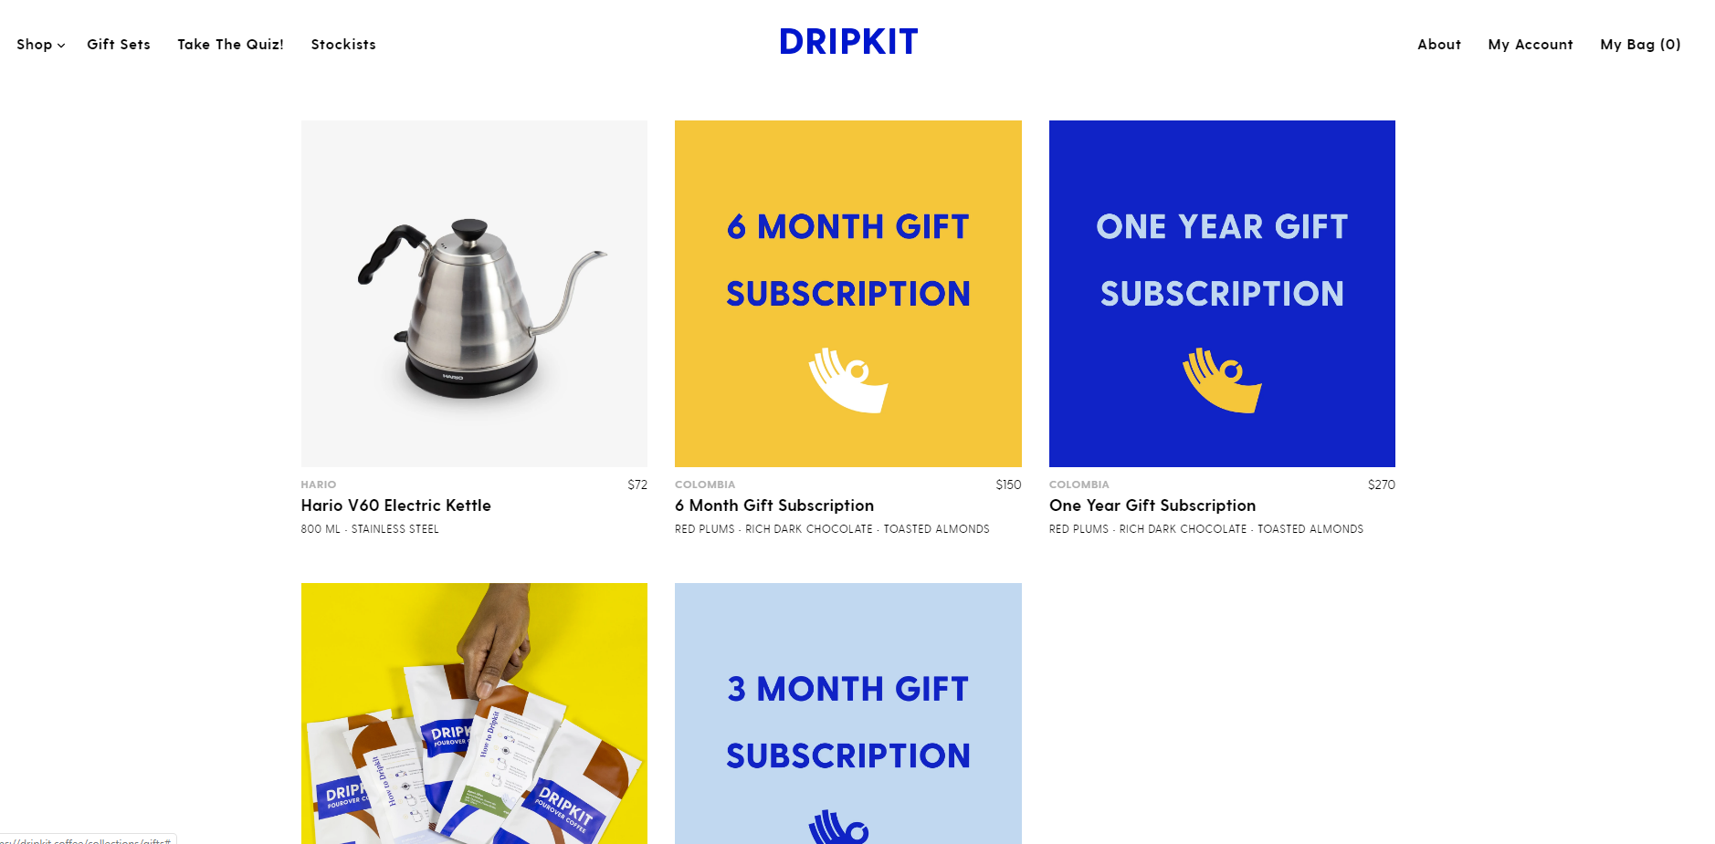

https://demo.shoptimized.net/ - Menu and mega menu display in shoptimized
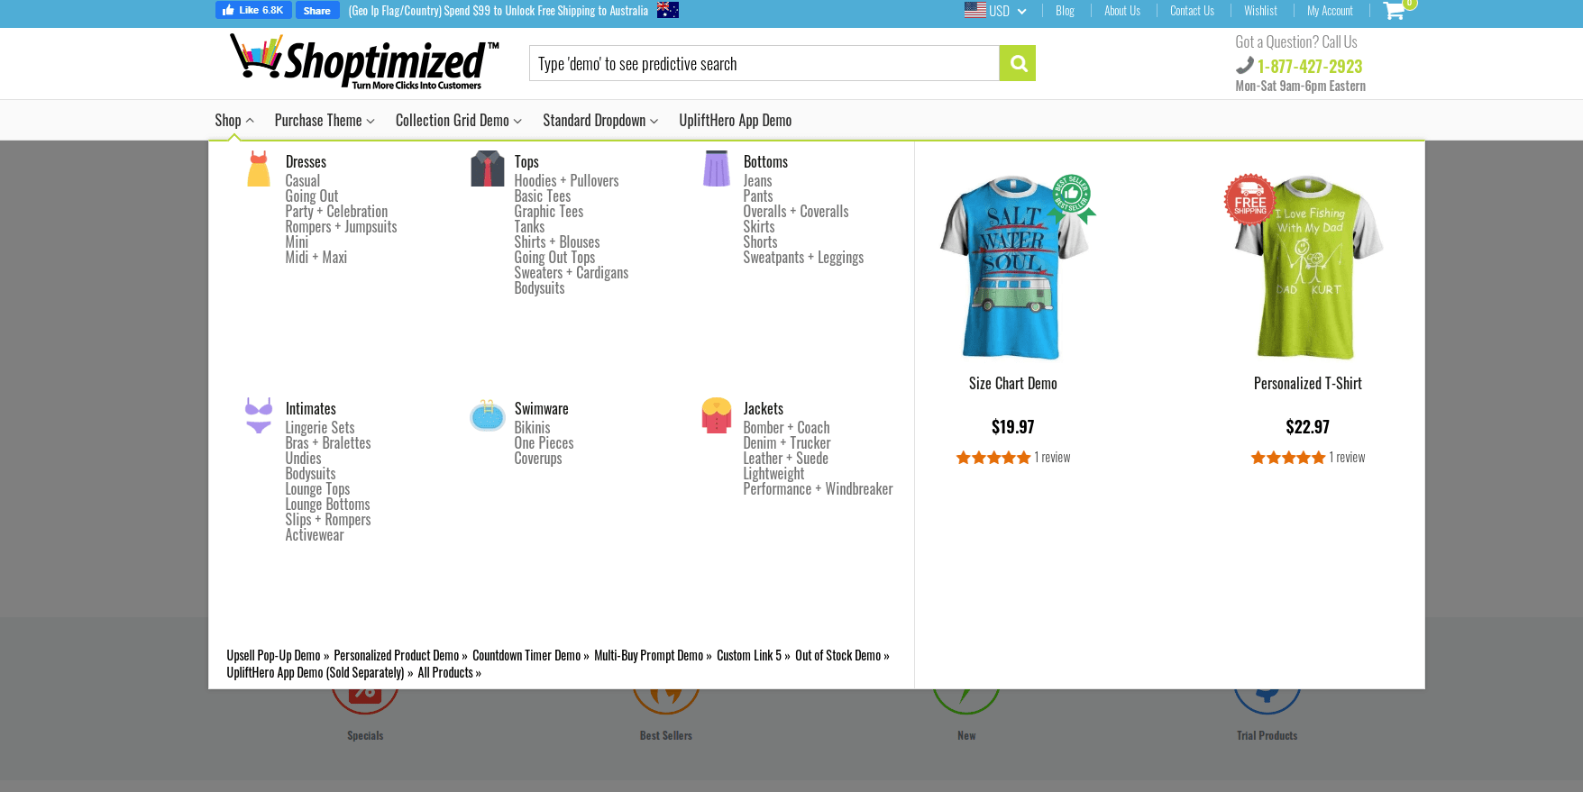

Additional resources I can share with you via last pass to help complete the Job Quickly and smoothly.

- Canva
- Shopify
- Shoptimized resource centre (if required)

