Web Site: dataoasis.com
Wordpress site for Advertising Agency type business called Data Oasis.
Site will be maintained by owner so just need initial wordpress design – you can choose what theme to use.
Logo
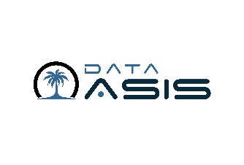
Main Page
Video background – link:
https://dataoasis.net/Clients/DataOasis/DataOasisIntro2.webm
Logo at top left corner
Menu
WHO WE ARE
WHAT WE DO
OUR WORK
CONTACT US
Tag Line: Data Optimized Advertising Systems Information & Solutions
Key words:
data
marketing
analytics
advertising marketing media
“database management”
“digital marketing”
“email marketing”
“direct mail”

Menu
HOME
WHO WE ARE
DATA OASIS is an acronym for Data Optimized Advertising Systems Information & Solutions. Our team of experts are focused on leveraging data to improve the performance of your advertising efforts. We accomplish this by collecting and managing critical data that is needed to drive business decisions, profiling and analyzing that data to implement highly targeted marketing efforts and installing solutions that continuously improve advertising performance moving forward.
Our philosophy:
“Early to bed, Early to rise, Work like He!l!l and Advertise!!!” Ted Turner
“It is a capital mistake to theorize before one has data” Sherlock Holmes
“Without data, you’re just another person with an opinion” Edwards Deming
WHAT WE DO
Data Collection
We use state of the art technology to help you collect the data that you need to make data-driven marketing decisions. Our solutions allow you to collect customer contact information that track what sources are most productive for getting leads into your database and conversions.
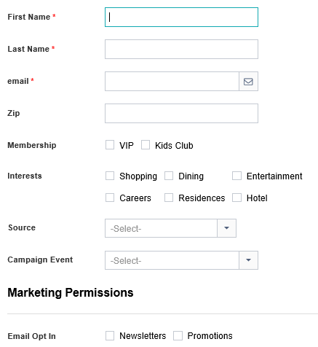

Database Management
Most businesses simply need to answer a few basic questions about how effective their marketing is working but can’t get to the data to provide answers on a consistent basis. Our team of experts will get the data that is needed to make data driven marketing decisions that will improve your roi and continue to maintain critical data so you can continue to improve your marketing efforts.

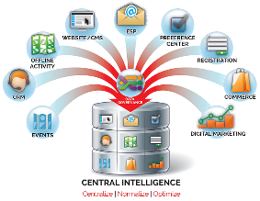
Marketing Analytics
Our customer profiling and response analysis reports will provide valuable insights into your customers to drive better targeting strategies and measure how effective your advertising is working for you so you can make better decisions on how to spend your budget.
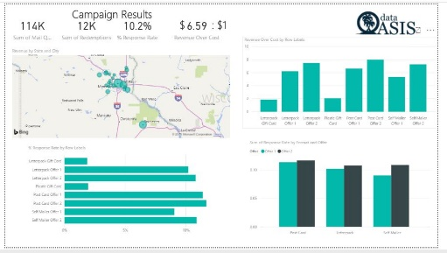

Media Optimization
We use the media channel that will provide the best bang for your buck based on your audience. We can deliver the eyeballs that you need to reach thru proven digital and traditional channels. Our data analysis results will provide the roadmap for selecting the media mix that will generate the best return on your investment.


Data-Drive Direct Response Marketing
We can execute data-driven marketing campaigns in all available media channels that will drive the best performance. Our team of experts will help you with Paid Search, Paid Social, Email Marketing, DRTV, Radio, Outdoor, Direct Mail, Print Media or Event Marketing. We specialize in targeted direct marketing and digital marketing that reaches the right audience at the right time with the right message.

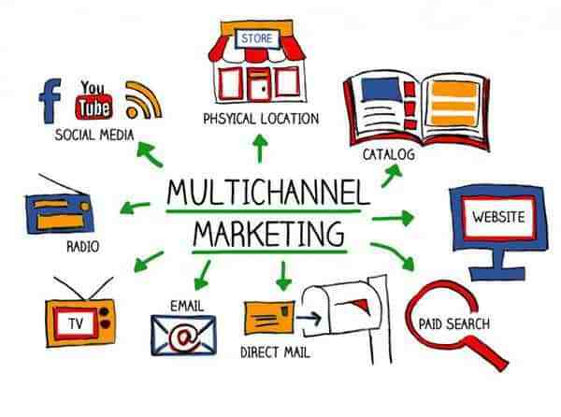
Targeted Marketing Lists
We provide highly targeted marketing lists for any type of marketing campaign that you are interested in. Offering new movers for the home services industry, affluent baby boomers for hearing aid and retirement communities or arrest records for criminal law firms, Data Oasis specializes in providing highly targeted direct mail, email and facebook upload lists that get results.
Our Work
CONVENIENCE STORE
A Convenience Store Chain needed to drive more traffic to stores. The goal of the campaign was to determine if direct mail is a cost-effective medium for increasing store traffic and to kick-start the loyalty marketing program by collecting engaged consumers that can continuously be marketed to. A 3-phase test was established with the idea of testing offer, format and audience to develop a champion program that could be used to effectively drive traffic to stores. A bar-code tracking mechanism was put in place to measure response and build a customer loyalty database for responders. The campaign resulted in identifying the offer and format that resulted in the highest redemption rate (over 10%) and was the most cost-effective at successfully driving store traffic and creating a loyalty database.
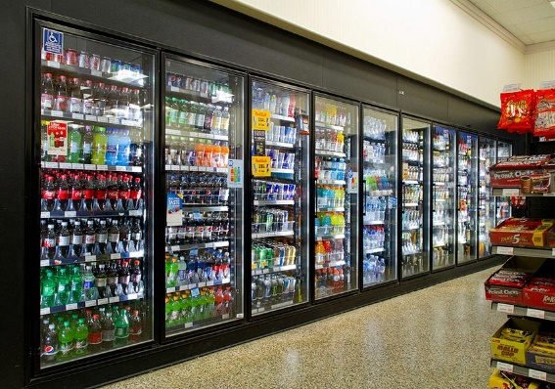

BANKING
A financial services chain needed to generate consistent year over year revenue with less marketing expense. The goal was to profile existing customers by revenue stream to determine most/least profitable and optimize marketing efforts by eliminating targeting to lower performing segments based on profitability and life-time value indicators. A test utilizing Neilsen’s Prizm Lifestyle Segmentation System to cluster similar customers together and measure response of each segment in terms of different types of accounts (money market/checking/cd’s, etc) and test different creative to each audience. Apply same segmentation strategy to business to business acquisition strategy using SIC code clustering/creative strategies. The campaign identified the least profitable segment and reduced marketing expense without impacting revenue impact. Creative was adjusted to each key audience that was more profitable to improve response. Finally, the campaign resulted in significant improvement in B2B efforts by identifying key SIC groups/sales volumes that resulted in the highest response rates.


HIGHER EDUCATION
Business Issue: A higher education institution needed to drive enrollment for Executive MBA program that showed increase over prior year. The goal was to lower the cost per student acquisition by using multiple channels to reach prospects and to develop cost effective prospecting mechanism for acquiring out of market students to on-line programs. A test that utilizeed a combination of on-line and off-line media to drive traffic and measure response was implemented that optimizeed paid social and paid search by measuring effectiveness of campaigns to generate response to high-value events. Targeted email campaigns were used for out of market prospecting and tracking was used to define the best creative/subject line strategy based on response. Highly targeted direct mail program was implemented for the local market audience and response was measured to track effectiveness. The media program resulted in driving traffic to the web site, application fulfillment and final enrollment processing. Media was optimized based on response over time to more effectively utilize marketing budget to increase enrollment applications. Multi-channel program resulted in exceeding targeted class sizes for all major programs at a lower cost per enrollment than previous years.



CONTACT
Form
First Name Last Name Email Comments
Kevin Keenan
954.683.3536

info@dataoasis.com

