RPM ABOUT US SECTION (To be inserted on home page between lead capture and Video)

Raw Power Meals mission is to provide Australians with high quality , fresh , affordable and healthy power meals for the whole family. Our top Chefs are guided by qualified nutritionists to produce the gold standard of ready made pre-packed meals. Trusted By Athletes – Power Food For Everyone!!!
FRESH MEALS DAILY - NUTRITIONALLY BALANCED – MACROS CALCULATED – WE CATER FOR EVERYONE

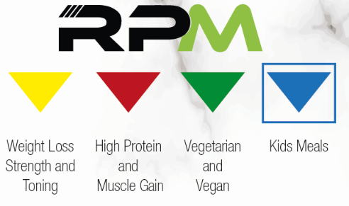

CHOOSE YOUR GOAL CHOOSE YOUR MEALS MAKE IT HAPPEN TODAY

