Top Left Photo:
Of pressure cleaner on trailer

Solutions For:
COVID-19 Infection Control
Building Management
Bin Cleaning & Sanitisation
Garden Maintenance
Common Area Cleaning
Bird waste removal
Mould & Mildew removal
Oil and Grease elimination
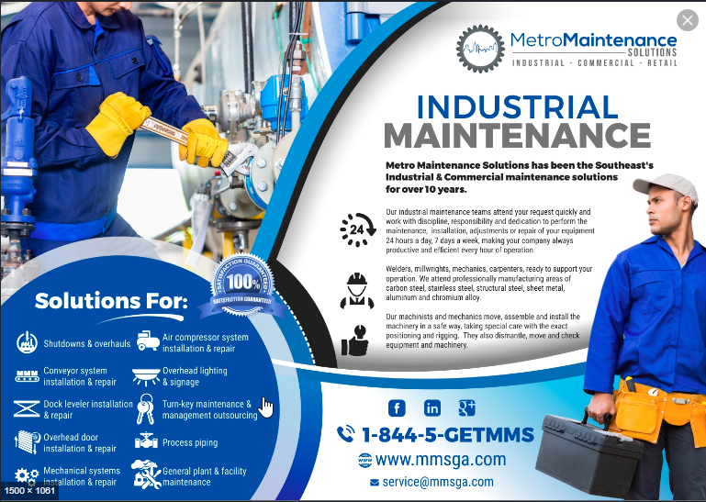
AWS – servicing Southeast’s Commercial & Industrial sector 24/7
We operate 24/7, 7 days a week
SILENT HOT WATER pressure cleaning 150degrees
COVID-19 Trained
PROPERTY
ALL COMMERCIAL &
Aqua Works Logo

