Please see on the next page how I started.

But the style is kind of boring and the green and blue is not what I want. The fuchsia would be ok. Or may be a with a darker green. Behind the company text a big picture of mine or some project across the whole page would be nice. This would be nice to have on every page, except the blog.
I’d like to have of course a lane above “Home, Sample Page…” with FB/Linkedin/XING on the left and phone and mail on the right side.

All in all, my pages are more text-oriented than picture-heavy, because my service does not provide so many own pictures

I need the following subpages:
- subpage for every service, but the should have the same design
- on one service page, where all the online trainings appear, should be the option to submit for the courses
- subpage for every benefit, but the should have the same design
- Subpage for testimonials
- Subpage for team
- Blog

Somewhere should be a place for the latest tweets and blog articles.

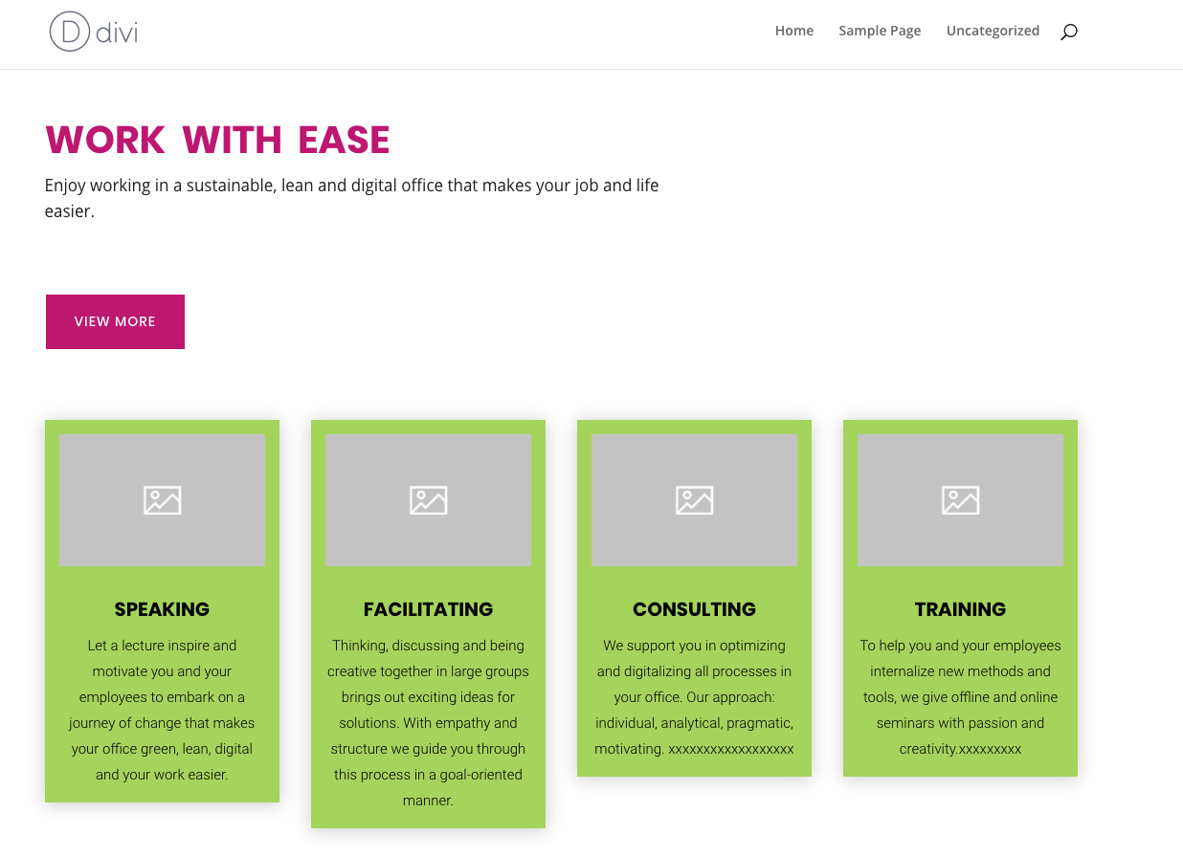

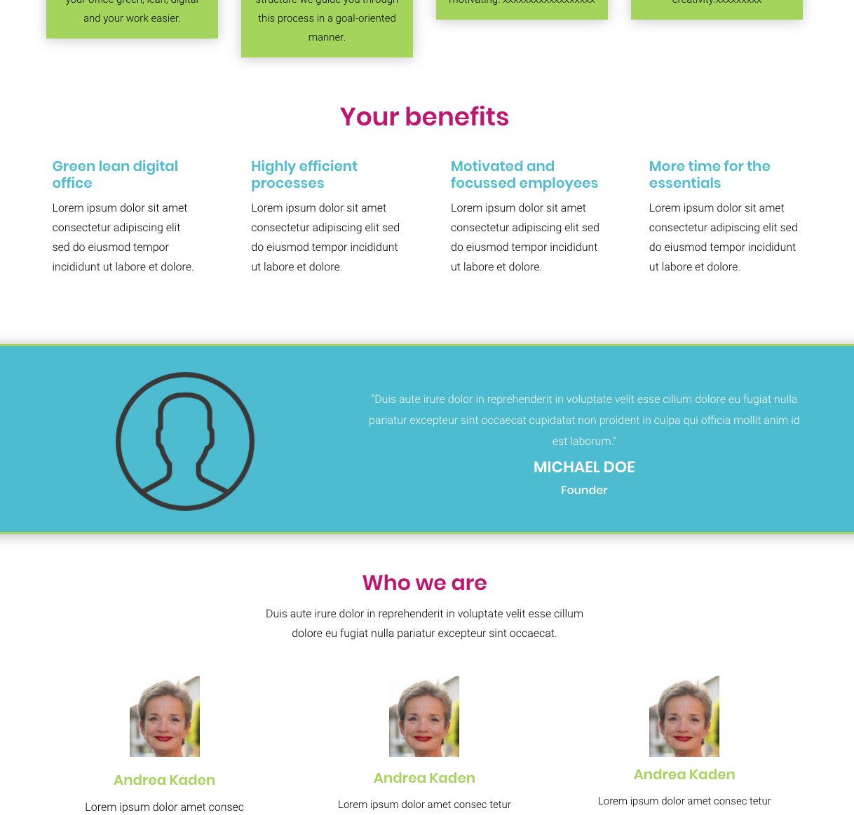

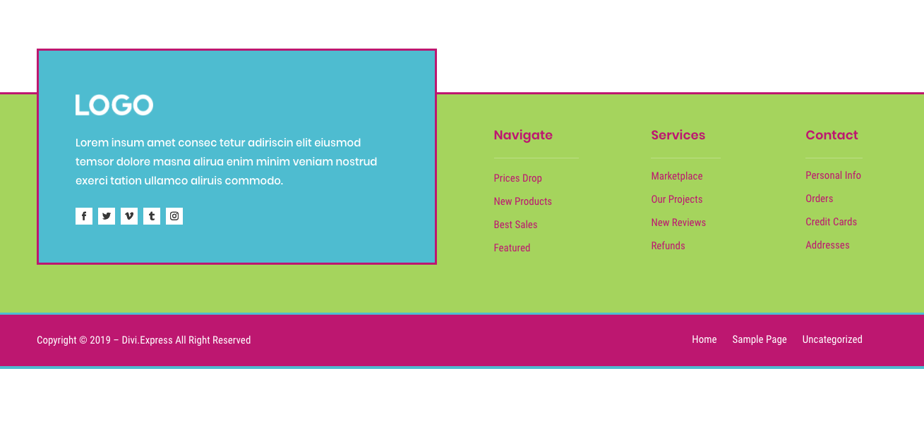
Idea oft the footer, but not with this colours

