CLUB LOGO REVAMP
FWB Sailfish Club

WHAT ARE THE ISSUES WITH OUR PRESENT LOGO?

Present logo:

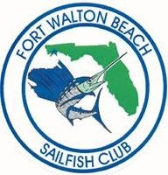

- Biggest issue…….Does not tell our story. What kind of club? What do we do? Who are we?
- Logo is outdated
- Logo has no impact. Doesn’t draw you to it
- Poor quality for reproducing.
- When did the club start?

IMPORTANT: This document is only to give you a feel and understanding for what we would like to accomplish. DO NOT HESITATE to use your own imagination and ideas to capture the essence of what we are trying to accomplish, but with your new vision. We are totally open to new ideas, new layouts, and new configurations (square, round, rectangular, etc….)

ABOUT THE SAILFISH CLUB:

The Fort Walton Beach Sailfish Club is the premier saltwater fishing club on the Gulf Coast of Florida (USA). The Sailfish Club was established in 1972 by a small group of local deep-sea fishing enthusiasts who came together for the enjoyment of sport fishing and for each other’s friendship. This initial group of fishing enthusiasts has grown to over 100 members. The Sailfish Club has become one of the most well thought of and highly regarded angling clubs along Florida’s Gulf Coast.

The Sailfish Club promotes sportsmanship, the conservation of our local fisheries, safe boating, and good fellowship. The conservation of game fish is important to us, because, we want to insure the enjoyment of sport fishing in the Gulf of Mexico for everyone. For today, for tomorrow, and for the future.

​The Sailfish Club is a member of the International Game Fish Association (IGFA), whose rules established the foundation for our club. The International Game Fish Association (IGFA) has recognized our club for its efforts to promote good sportsmanship, and for our adherence to the IGFA principals of game fish conservation. ​

The IGFA rules insure healthy competition and sportsmanship for all our club fishing tournaments.

The fish we pursue:
​

Blue Marlin
White Marlin
Swordfish
Sailfish
Wahoo
Tarpon
Dolphin Fish (Mahi Mahi)
Yellow Fin Tuna
Black Fin Tuna
Cobia
King Mackerel
Red Snapper
Grouper
Amberjack
Redfish (Red Drum)
Speckled Trout
Jack Crevalle
Triggerfish

​The Sailfish Club is a private club composed of local, statewide, and out of state members. A prospective member must be sponsored for membership by an active member. Your membership in the Fort Walton Beach Sailfish Club automatically includes a membership in the Playground Area Boat Club as well.

The Sailfish Club has prospered over the years, because of the devotion and efforts of our members to build the club. These efforts include teaching fishing skills to fellow members, supporting local and statewide conservation efforts, building reef habitat, and enriching our membership in so many other ways.

​The Sailfish Club meets twice a week at the Playground Area Boat Clubhouse in Shalimar. Our membership meetings are on Wednesday evening, and on Friday evenings we have pot luck dinners for members, families, and their guests. There are many additional social events and cookouts throughout the year for our members and their guests. These gatherings are always filled with fun, friendship, and friendly conversation.
​​
​The Sailfish Club regularly brings in expert speakers to the club to share their knowledge of sport fishing, fishing equipment, fish conservation, and other areas of interest to our members.
​
We hope you will join Sailfish Club in protecting and conserving game fish, and the associated saltwater fisheries along our Gulf Coast. As a community, we must work together to enhance their survivability for all to enjoy. ​
​
“Everyone should believe in something. I believe I’ll go fishing…”

Our thoughts regarding the new logo:

We need something that better tells our story. Easy to read, easy to reproduce, and high impact.

Short with a clear message. The message has to fit on the new logo and be visible. Easy to read.

Possible tag line examples for the logo:
- Game Fishing
- Anglers
- Gulf Anglers
- Gulf Fishing
- Fishing the Emerald Coast
- Trolling the Emerald Coast
- Saltwater Sportsman
- Saltwater Fishing Club
- Sport Fishing Club
- Emerald Coast Fishing Club
- Offshore Fishing Club
- Fisherman Who Conserve

Also, we think that if the logo picture was more descriptive, that would help with describing what we do and who we are. Such as one from one of our tournament shirts and the beer cozies from a few years ago. See below.

Here is a good example of what we are talking about…………………………...

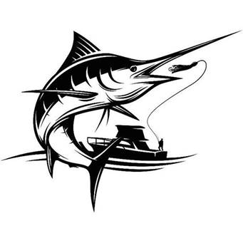
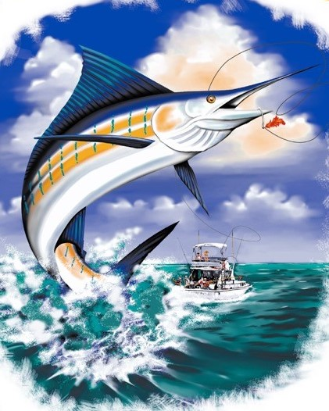

We would like to develop a tag line for our logo that better defines what the club does. Since we are re-doing the logo…………..we think this is critical

Random Thoughts & Ideas:

How about just plain old “fishing”? Something similar to this logo below, but with Sailfish Club across the top and FISHING across the bottom. Since 1972 instead of 1981.

This logo is terrible (example purposes only)…………we are talking more about using the word FISHING and how you could use it on our new logo.
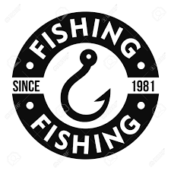

Fishing since 1972………Almost implies that we have been fishing since 1972. “Since 1972” also adds credibility and prominence to the club.

Fishing says it all very short and sweet. Allows you to use larger more noticeable letters. Better visibility.

Maybe Game Fishing instead? Similar in length to Sailfish Club. Saltwater Fishing might be too long.

Sailfish Club
Since 1972
Game Fishing

There is some value in the simplicity of FISHING, especially if the graphics show a saltwater fishing scene.

The word Anglers might be foreign to some people, but does that matter to other anglers? Not sure.
- Anglers
- Gulf Anglers
- Gulf Fishing

We might want to add an additional line below our logo. Have the logo with and without this line for reproducing on different items and different media. Make it fairly prominent depending on the word content of the logo itself:

- Fishing – Sustainability – Conservation
- Sustainability – Conservation

Insert these words in the bad logo below
SAILFISH CLUB - top
SINCE 1972 - middle
GULF ANGLERS, GAME FISHING, or FISHING - bottom

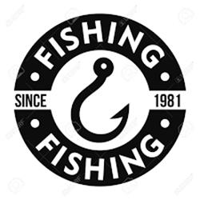
Sustainability – Conservation

IMPORTANT: This document is only to give you a feel and understanding for what we would like to accomplish. DO NOT HESITATE to use your own imagination and ideas to capture the essence of what we are trying to accomplish, but with your new vision. We are totally open to new ideas, new layouts, and new configurations (square, round, rectangular, etc….)

