Key Message and needs to pop off the page

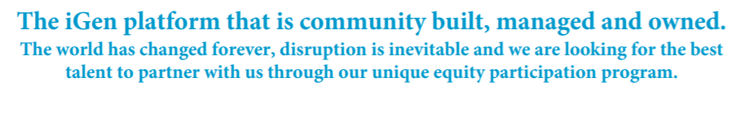
This is a key message and needs to be represented differently and in a much more exciting way. This needs to be redesigned completely
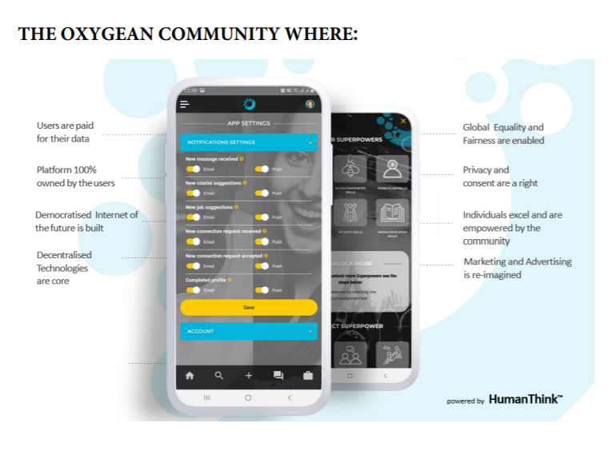

Below is the Why they should do it.

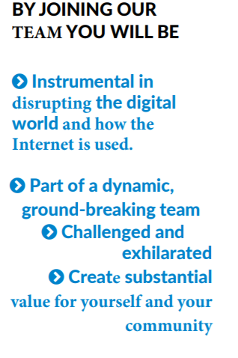

I have attached images from the app that you could use on the ad

