Design brief

Design idea
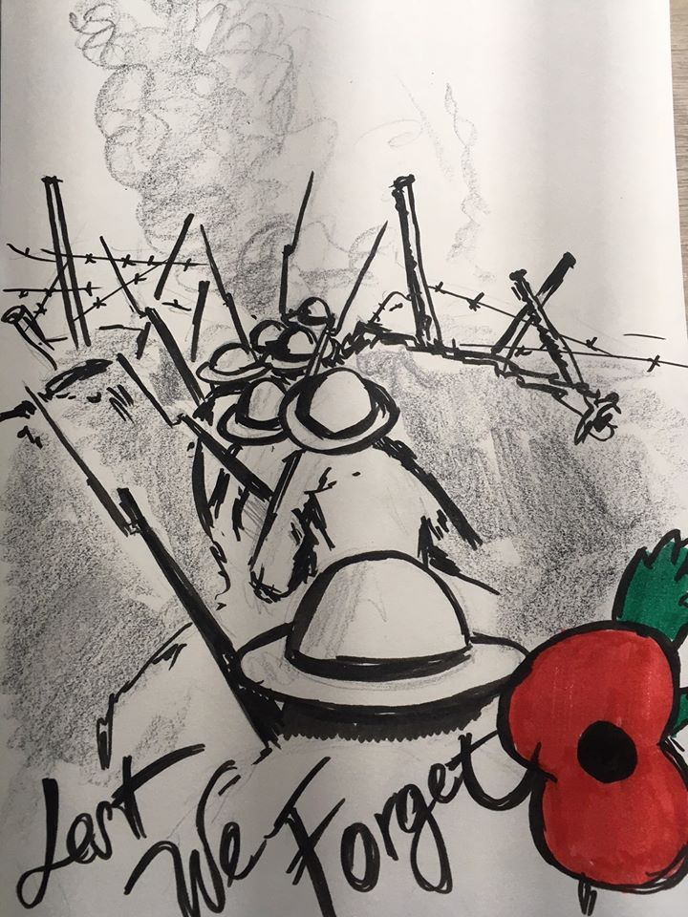

Font
use font of your choice, but something like in the picture is preferred.

Colors
The t-shirt should be grey or some other light color. For graphic, please optimize for up to 3 colors silkscreen print.

Our existing designs for inspiration can be found here: https://www.marsarms.com
The picture should include Mars&Arms Logo in the bottom part or top-part.

