Edgewood Equine Logo Development Brief
Include in the Logo
- Horse, suggestion of nature/ organic
- Business Name “Edgewood Equine”
- Blue/white /green fresh colour palette
Details of our business:
Horse Boarding and training facility based on 20 acres in Campbellville ON, just west of Toronto on the Niagara Escarpment, surrounded by greenbelt and conservation areas. Home to 16 sporthorses and built in 2017 Edgewood is a welcoming barn, full of light, fresh air and goodwill to horses and people. Our indoor and outdoor riding surfaces are regularly maintained with level, consistent footing. We are a low drama facility, the focus is on great care for the horse and a well kept professional environment for training and enjoying your riding.
Our goal is to offer well designed care program and facility with individualised supportive training that allows clients to be present and enjoy time spent with their horse. The training focus at Edgewood is dressage, while ultimately some of our teams show to the most advanced Grand Prix Level our training programs are geared to the goals of each individual horse and rider team and providing support and guidance according to their goals and reaching their personal best. We also train and develop a few young horses on an ongoing basis for eventual showing or resale.
Competitors, M2 Dressage in Waterdown ON , Equestrian Dreams in Campbellville Bronte Creek Equestrian in Carlisle, Sweetgrass Equestrian in Rockwood
Iron Horse in Oakville, Parish Ridge in Burlington
Discuss your industry and market: provide any demographics and psychographics on the markets you serve.
Most of the stables in our area cater to the hunter jumper industry, there are deep and well developed school horse, young rider training and show circuits ( esp trillium) that are a world unto themselves. Many children, school horses, parents and hectic activity are part and parcel of this environment, the focus is mostly on staying on , jumping and ribbons. Most horses that show are leased on an annual basis vs self owned.
While these facilities meet the need of the immediate market and satisfy a huge demand….
…..they miss the needs of the educated adult amateur , rider wanting a more exclusive, quieter environment and the support of knowledgeable peers and a sense of community and an ongoing desire to learn, grow and enjoy their horse. This could be training for the sake of mastering a new movement or technique or working toward a specific show or event. These riders are generally established professionals in their area of expertise and have always been riders or have always held the dream and finally had the opportunity to invest in themselves to learn to ride and have a horse as an adult.
A “Boutique Environment” Edgewood is a facility that is upscale, offers the proper riding arenas, footing, stable environment, turnout and atmosphere to train without being tied into a full training program is challenging to impossible to find in our area, this is our niche.
Style? Image and text, horse to have a dressage influence look, no rider, clean elegant , simple
Three qualities our logo should communicate
- Pleasant, environment, nature, breath of fresh air
- Genuine, authentic, educated
- Simple, refined elegance, not overstated, not snobby
- Horse is the Hero

examples of what you love and hate:
Logo Image | Like | Don’t Like
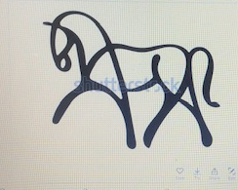 | Simple, elegant, modern, nice movement and flow, suggest dressage horse, easy icon for embroidery and to use multiple ways | No colour element, need something to suggest barn/nature/land
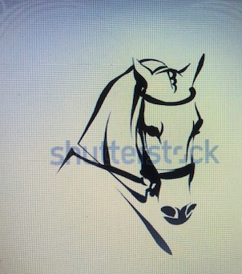 | Elegant lines, beautiful expression , | No colour element
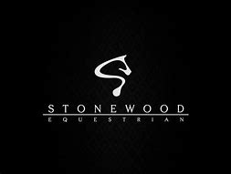 | Simple, elegant, clean , easy elements for embroidery and use multiple ways  Use of weight and scale , horse largest, heaviest , most important, name next most important and other is just background  Shape of horse suggests an “s” but also could be a horse jumping or a horse standing and looking behind | Horse image too generic, no colour
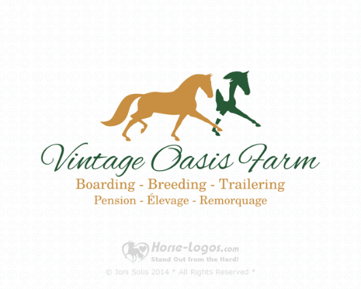 | Clever use of negative space, like how colour is used but still simple/clean elegant,  easy elements for embroidery and use multiple ways | Don’t like this Font, horses are a bit predictable in shape/lines and hand
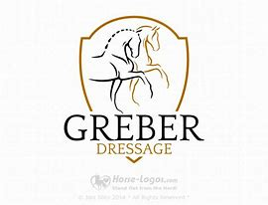 | Simple clean lines, horse images suggest the young or untrained horse to the trained athlete, options to include colour | Don’t love shield element , gives outer definition but too formal , rigid
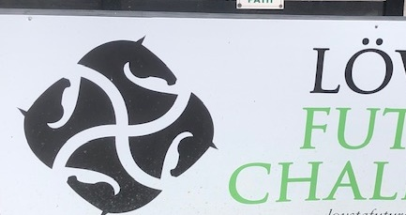 | Interesting use of the horse head, suggest a wheel moving forward, growing, developing  Great for embroidery, screening printing other uses  Use of horse heads defines an interesting outer shape | Hard to identify what the logo represents
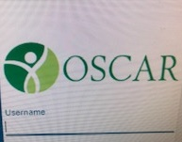 | Use of colour and negative space to create image /idea, yin/yang balance | Not horsey
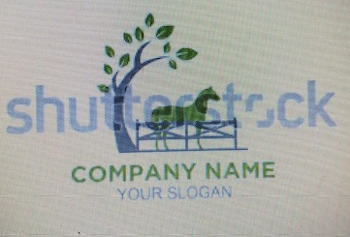 | Includes tree/nature, use of colour | Horse looks too rigid, no fence

