Nutrition information for honey

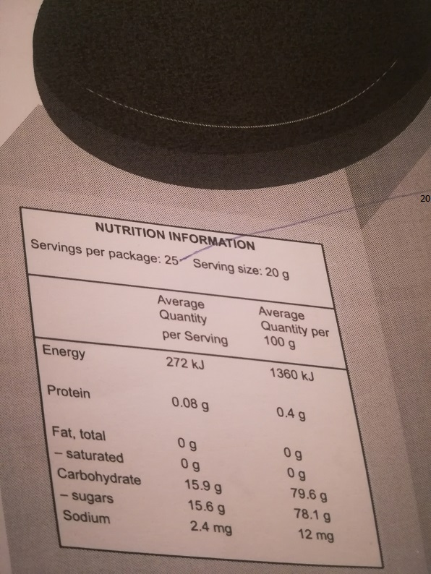
Please change this to 20

