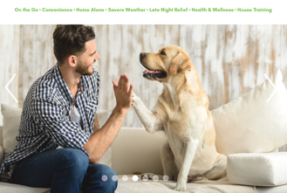
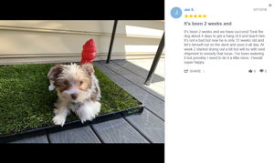
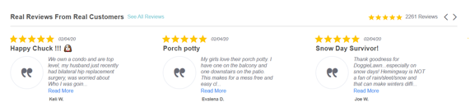
At the top of the page for the different tab options, we would like to have Home, About Us, Benefits & Use, Try Today, and Reviews

Home Page: 6 Components

- Image Slider with benefits shown on either side or top (see example below)


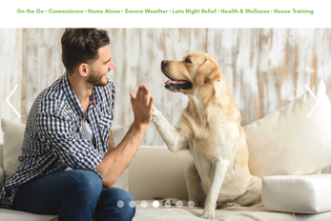

We want the slider photos to correlate with a benefit, the first photo showing someone travelling that matches the “On the Go” benefit with a description of why this product will help them when travelling, the second photo on the slider correlating with the “convenience” benefit and so on.

- Key Features-graphic
  - Natural Grass
  - Odor Control
  - Natural Absorption
  - Interlocking Trays
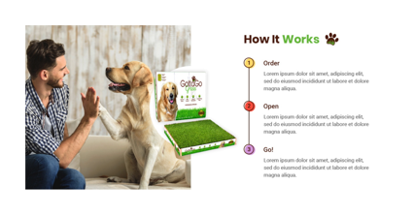
- How it Works
  - We would like a video placeholder next to it.
  - See example to the right

- Reviews
  - With scrollable carousel of reviews.
  - If review clicked on, that individual review will pop up larger
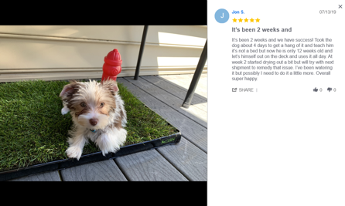
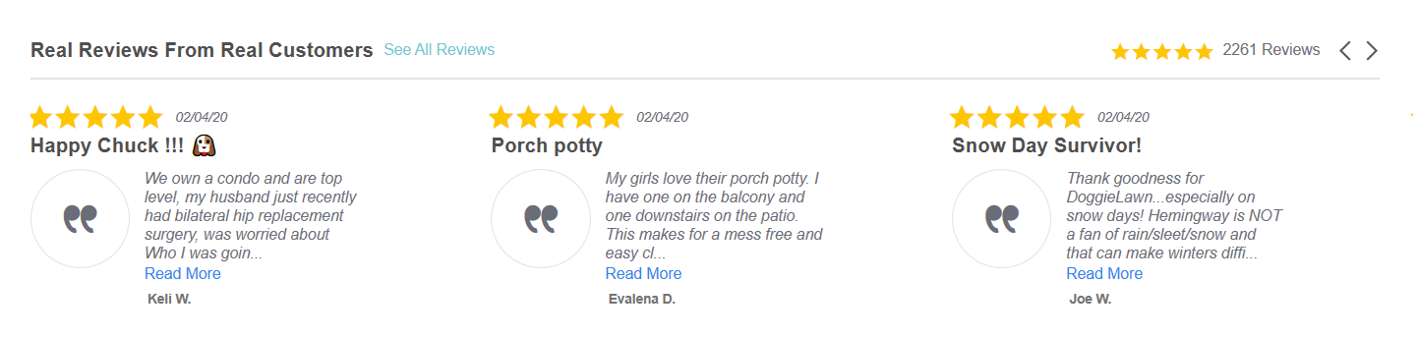
  - See example below
BB
A

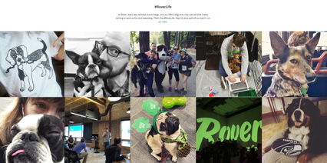
- Community (Pictures in grid)

- Get In touch


About Us Page-2 Components

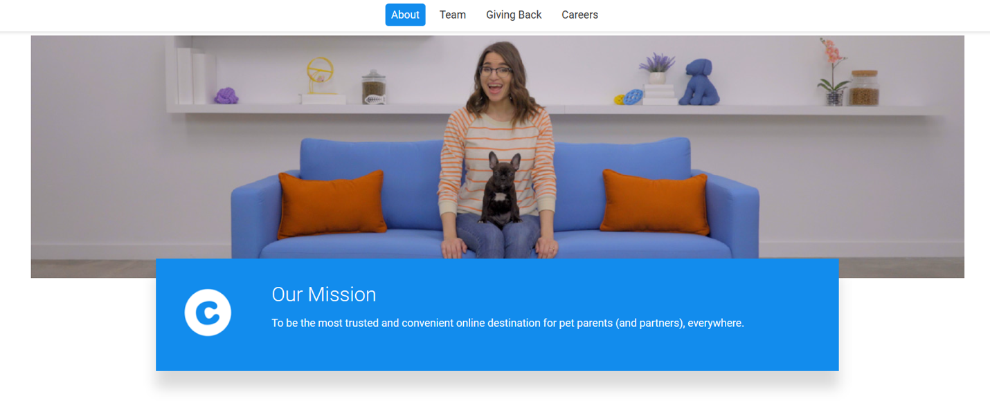
- Within the About Us page we would like different tabs, example below
  - About Us Tabs: About, Team, Press, Careers



- Within About Us-Team Tab
  - A place to feature GGG Team members
B. Does not have to be circles

Benefits & Use Tab:
This is a place to dive further into the benefits featured on the Home Page within the slider.
Benefits: On the Go, Convenience, Home Alone, Severe Weather, Late Night Relief, Health & Wellness, House training

Try Today Tab:
- On this page we would like a button that leads to where it will be sold, Lowe’s and Home Depot
- Buttons will be Logos that will lead to website when clicked

Reviews
Similar to Home Page with scrolling reviews and larger pop up review when individually clicked.

On behalf of the Gotta Go Team, thank you for your hard work.

