UNDER THIS
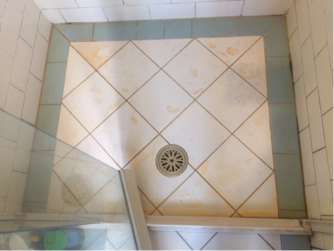
WAS THIS
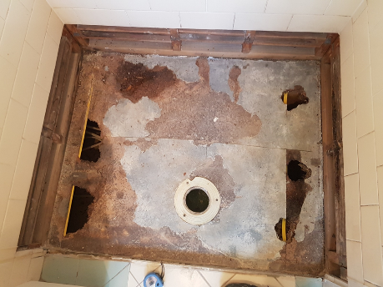


SO WE DID THIS
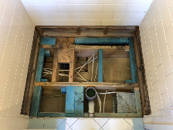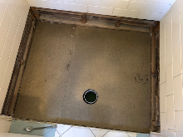
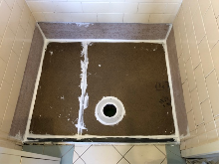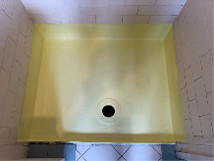
THEN FINISHED LIKE THIS
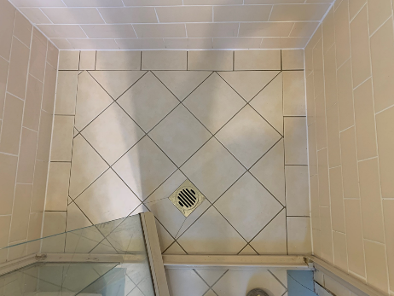
Have an AWESOME Day!
P: 02 9674 4111 E: office@asab.com.au
www.asab.com.au

SO YOU HAVE
1. PEACE OF MIND
- 10 Year Anti-Leakage Warranty
- Est. 2001 (in business longer than warranty)
- Fully licensed & insured
- Experienced (Mgmt has over 50 years exp.)
2. NOTHING TO DO (we do it all)
- we are the ONE STOP SHOP, waterproofing, carpentry, tiling, plumbing, shower screens & repairs + we carry tiles in stock for you (multiple options, not just white)
3. STAY INFORMED
- our office is full time and here to help
- licenced & experienced supervisor
- we keep job photos & keep you up to date by email
10 YEAR
ANTI-LEAKAGE
WARRANTY

