Requirement:
- Please visit current website: https://demo.bitco.link/
- To redesign a survey online website with new layout
- To redesign UI of each question type
- To redesign layout of thank you page when you complete the survey
- Please design based on mobile screen size
- Expected layout content, you can see in the second page below

Please use color tone among these color code: [This is about Mazda automotive brand survey]
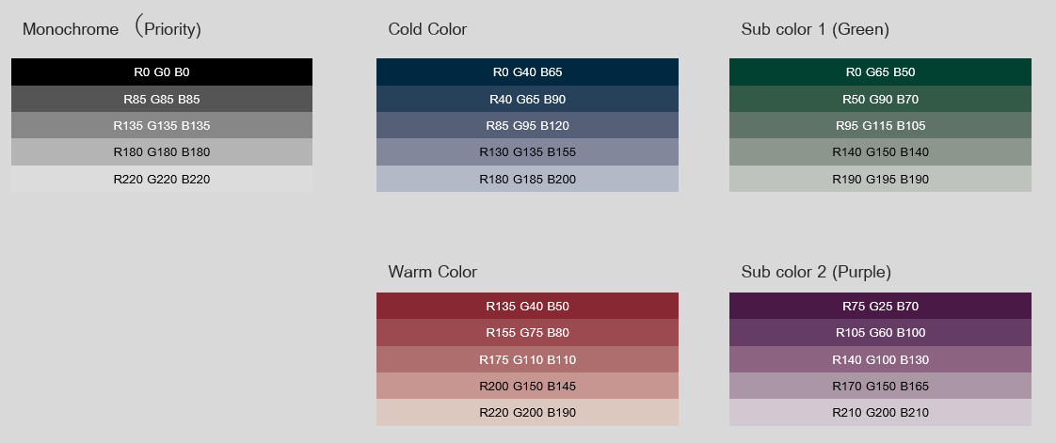

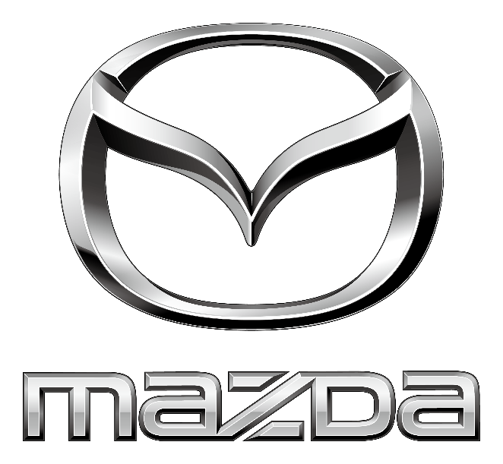

Expected Layout of the webpage [you can change position if you want]

Next
Back
Answer area of each question type
Question Label
Progress Bar
0 – 100%
Client Logo

