SOURCE: https://prowireusa.com/default.aspx#
Website menu
HOME PAGE
Put a slider as per the site on front/main page
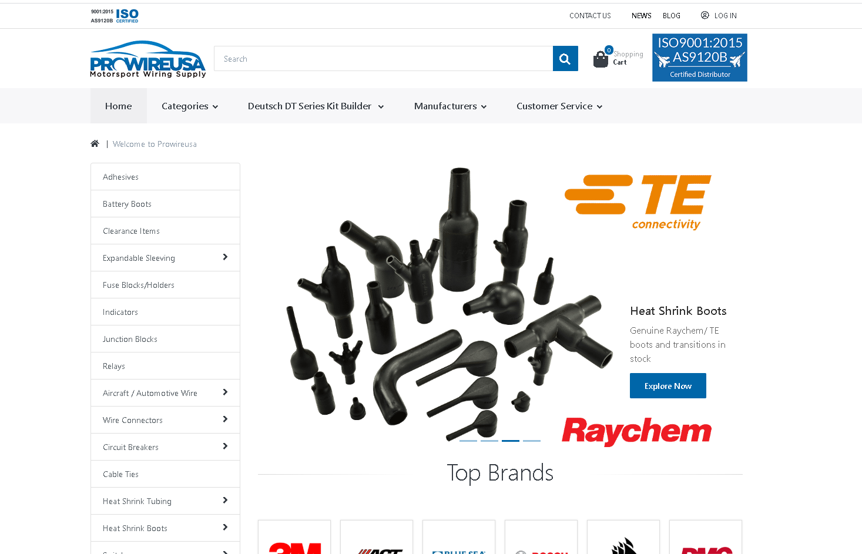

2. Categories menu
Just put some sample product categories
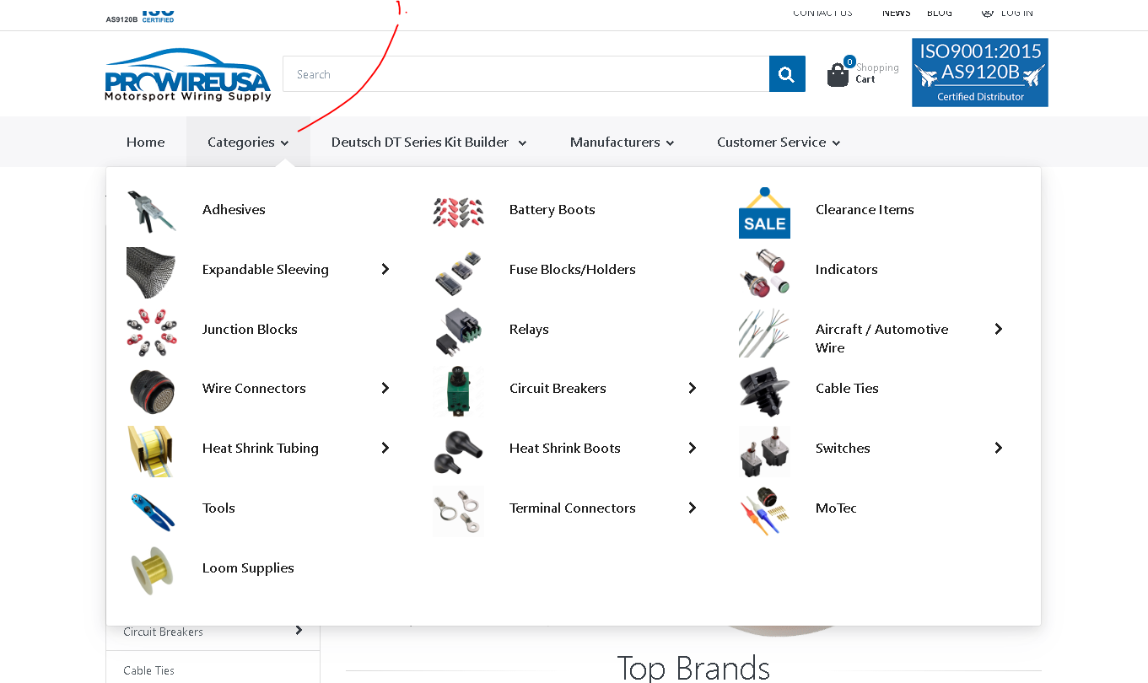

3. Customer service menu
Create the following pages (Your account, FAQS, Returns policy, Shipping info, Contact Us, Privacy policy)

