Request
Name = Red Titanium Engineering. As i will use the logo on letter head, invoices, business card and a car, I think the full three words is best. I am open to mixed colours in the words. I would like an image of a bird within my logo. It can be styled heavily or appear to be a bird. The bird I use is called a 'Pukeko'. It is a New Zealand native, and includes the colours from the colour pallette.

I have attached a word document that includes the color pallette, and the image of the bird that the color palette matches to. It would be nice to have a logo with a pukeko bird in it, however I do not want it to dominate a logo, yet do not want it to be indistinguishable. There are some interesting appraoches in the google link to 'pukeko logo' I added in the file. BUT, please do not copy other logos, as I have had this done before and the logos were from business' within 10 miles from me!

My job is a business consultant in IT. I like the color red as it inspires action. I like the balancing colors of grey, black and blue as i feel it gives me options for business card, car wrapping and website options with text fonts and higlights for print material. I like the Pukeko bird as it is uniquely new zealand, and includes these colors. As an inspiation also, when the bird has young, all the family take responsibility to feed it, and I like that as a value to the brand. It also aligns with the work I do with teams of people helping each other to a common goal.

I am open to your expertise in design and suggestion from what I have shared here.

Name: Red Titanium Engineering

Color Pallette:
Bicycles Winter
This "Bicycles Winter" graphic has 5 dominated colors, which include Cool Grey, Dark Gunmetal, Gainsboro, Dark Imperial Blue and International Orange (Engineering). It makes so beautiful color combination inspired from this image.
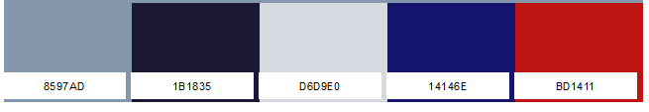
https://www.schemecolor.com/bicycles-winter.php
Converter from Hex color to RGB
https://www.colorhexa.com/bd1144
8597AD = 133 151 173
1B1835 = 27 24 53
D6D9E0 = 214 217 224
14146E = 20 20 110
BD1411 = 189 17 68

Image and color inspiration:
New Zealand Bird called a ‘Pukeko’
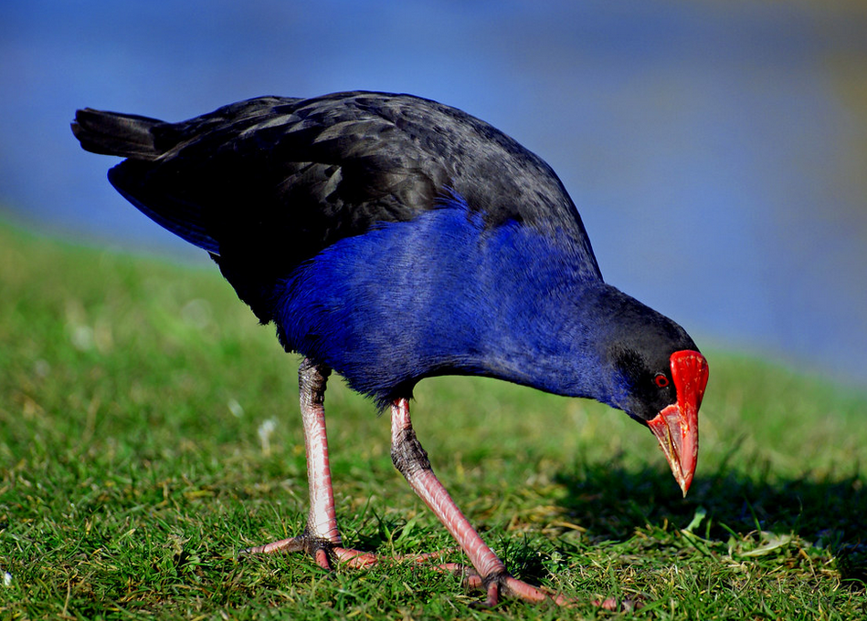
https://www.flickr.com/photos/volvob12b/11284335596
Google images here
Existing Pukeko logos

