Revised Ford Hutman Website Revisions v3, March 3

Add 5 photos to scroll – PRSA Screen/ Nasdaq outside/ Rach Fox Business/ Rach Interviewing / Fortune Stage

Revise ‘Capabilities’ in sidebar to Expertise

About Rachel Ford Hutman (please add Ford to my name)

(Revised copy below)
Rachel Ford Hutman is a global health industry connector and creative problem solver. She has worked on some of the world's biggest therapies and medical technologies of all time, including the first RNAi therapy (Alnylam’s ONPATTRO), the first therapy for Duchenne Muscular Dystrophy (Sarepta’s EXONDYS 51), the first technology in the world to personalize insulin 24 hours a day (Medtronic’s MiniMed 670G) and IBM's AI launch (Watson). She has counseled (need a space between ‘has counseled’) some of the most well-known health/ technology organizations and developed communications strategies for the world's biggest brands (Johnson & Johnson, Medtronic, IBM, Best Buy, Takeda, Sanofi, Shire, Brigham & Women’s, NHS, MIT), but she is most proud of her work telling patient stories.

Photos – add a different pic in the smaller photo area titled Award Pic (it is a different photo than this one – I am holding a microphone).

##

Ford Hutman Media Expertise (please replace capabilities with expertise)
Provides senior level support for leading pharma/medtech/ healthcare companies at all stages of development (remove Ford Hutman Media at the start of the sentence)

##

(Add Quote Section)

(Quote section copy.)
“If you have the chance to work with Rachel, I suggest you take it. Not only does she have an exceptional understanding of the healthtech industry and endless media connections, but she brings an indomitable attitude that is optimistic, fun and determined. I’ve worked with a ton of PR consultants in my career and she is a rockstar.”

Ted Tanner
Global CTO, IBM Watson Health (I would like both his titles both on separate lines)
Co-founder of PokitDok

Add photo next to the quote titled Xmed Conf

##

(Coverage section/ no title) (Please use logos in place of names of outlets. All photos added to brief). Please confirm all of the logos will link to the below.

Revise Entrepreneur Logo - Workplace Wellness Isn't Just for Big Corporations
It should just be Entrepreneur – right now showing Entrepreneur India

NPR logo - Nearly 1 in 5 Americans Says Pain Often Interferes With Daily Life

WebMD - What is AI?

News-Medical - Artificial Intelligence (AI) in Cancer Care

Fortune – Want a Better Health System? You Need A.I. (And Here’s Why)

Fox Business News– How AI is Improving Care

CNN Money – Disrupting IBM Technology Now Matching Cancer Patients to Clinical Trials

Fast Company - IBM Says New Chip Can Filter Blood For Signs Of Cancer

CNBC – Alnylam CEO on Drug Prices

STAT - When a Nobel Prize brings a shower of hype: the roller coaster ride of RNAi

Forbes - A Gene Therapy Appears To Replace Missing Protein In Muscular Dystrophy Patients

##

(Add a new Quote Section – Add quote on the left and photo titled Ian on the right)
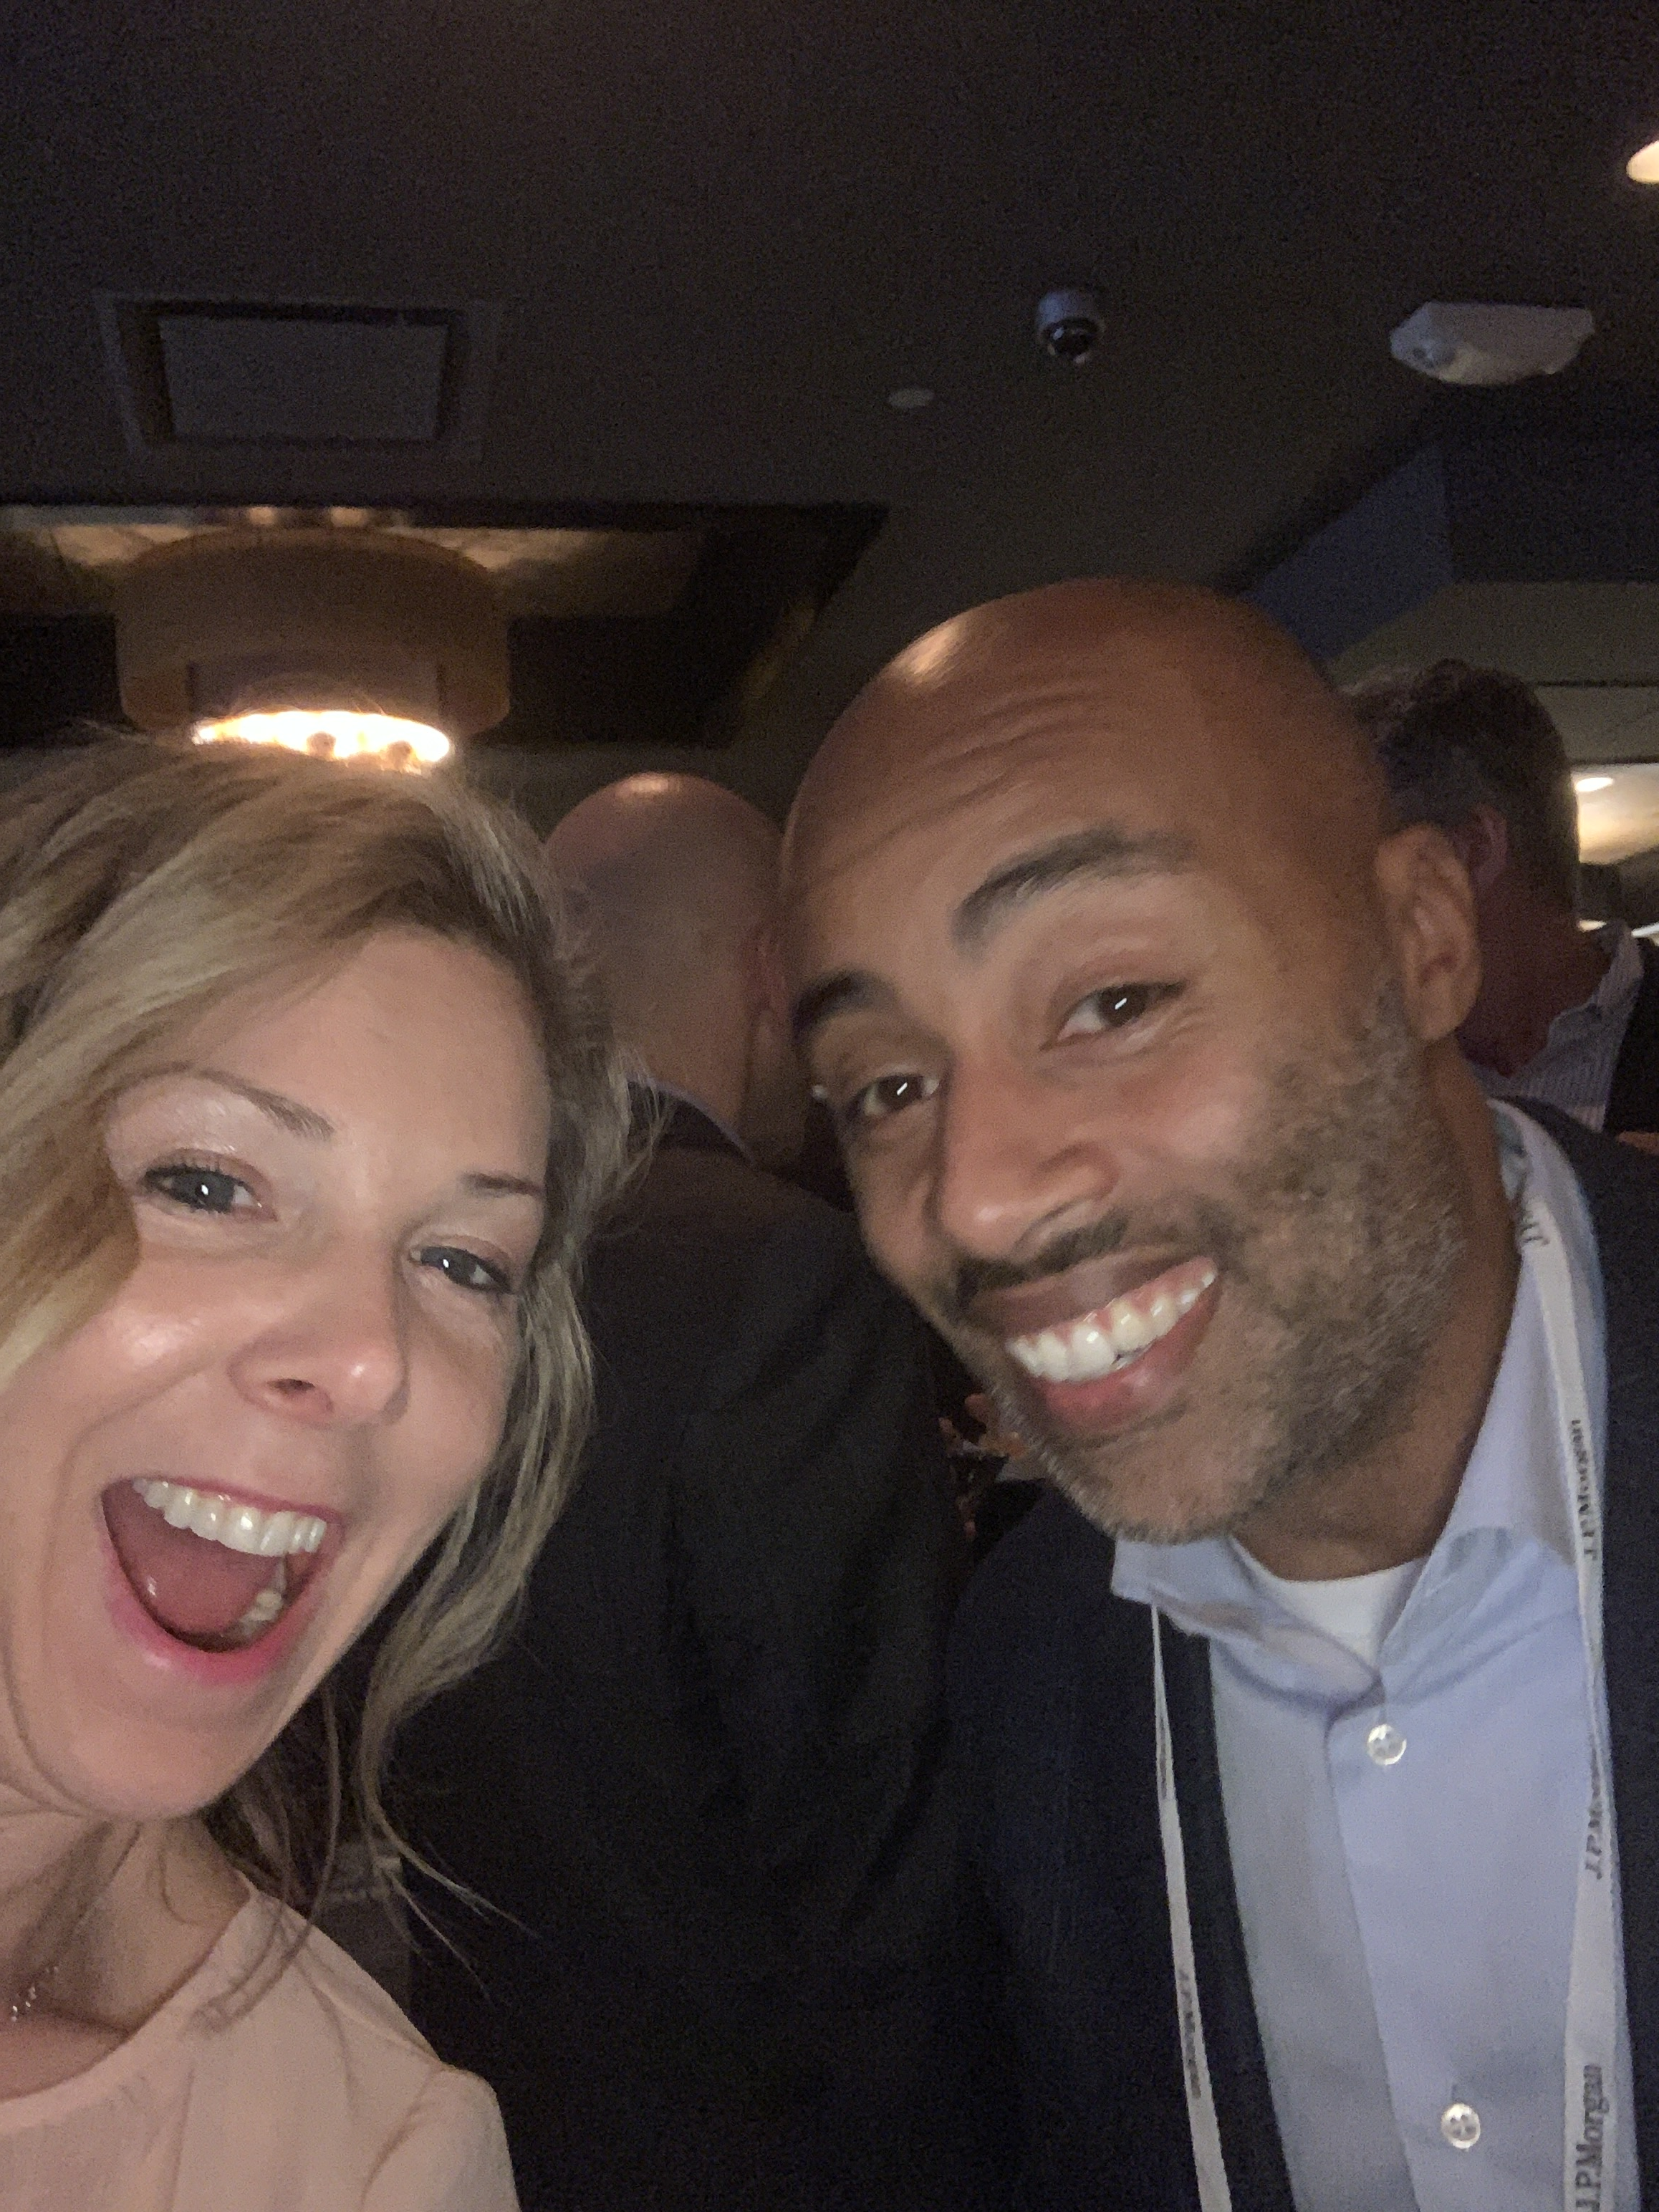
"I call her ‘Sunshine’ but that doesn't mean she'll always just agree with you. We've gone toe-to-toe on PR strategy a number of times, which I appreciate. Developing the first therapy to treat a rare disease was challenging and she helped us with all phases of comms - from narrative development to media strategy for our FDA approval and R&D Day. She has a good blend of PR and investor relations experience and can bridge the two seamlessly."

Ian Estepan
Senior Vice President, Chief of Staff and Corporate Affairs
Sarepta Therapeutics

##

(Contact Section)
Contact LOGO (please add the white out Ford Hutman logo after Contact)

Contact (header/ slightly larger font)
Remove my phone number. Review email to be info@fordhutmanmedia.com

##
Copyright 2020, Ford Hutman Media. All Rights Reserved.

END OF SITE

**

Read More Drop Down Copy (please confirm this copy is NOT a part of the site and will be a pop up under the ‘Read More’ in the bio section above.)

Rachel excels at working with the media to bring health stories to life while making them accessible to stakeholders. She worked as a journalist before transitioning to communications and has special insight into working with the media. With 15-years of communications experience, she is consistently leveraging her long-standing relationships with global agenda-setting reporters across a range of outlets from CNBC, BBC, YahooFinance!, Al Jazeera, Bloomberg, Reuters, Financial Times, Fast Company, TIME Wired, Forbes, Business Insider, WSJ, NYTs, and key health trades like Fierce, Modern Healthcare, Becker's, Digital Health Journal, GenomeWeb, BioWorld, Drug Discovery Today and many more. Rachel also has investor and analyst relations experience (Section 32, Third Rock Ventures, Foundation Medicine, T2 Biosystems, IBM, Sophiris Bio, Trovagene) that adds to her ability to highlight market dynamics at play.

Named PRSA's PR Professional of the Year in 2011 for her published research on stakeholder engagement, Rachel has built a reputation for her energy, creativity and humor. She received her MA in communications and media studies at SDSU and her BA in English/ History at UMBC. When she isn’t networking at a healthcare conference, you can find her surfing, running marathons or playing soccer with her son.

