Product Label Brief – Natural Deodorant
This brief is for the development of a product label for a natural deodorant product that we are creating. The product will be in a black kraft recyclable jar – as pictured. The requirement is for a sticker label that will be applied to the package and will complete the following:
- Display the necessary product information (listed below)
- Align with the Lone Kauri brand and colours (see www.lonekauri.com)
- Provide some sort of seal on the kraft jar to stop the lid coming off (while still being easy to open the lid – the entire sticker should not wrap around lid and base)
- I am open to suggestions on whether there should be one or two stickers (e.g. logo on top, product labels on the side)
- All designs should consider efficiency of labelling products in a manufacturing environment
- Designs should cater for different scents of deodorant (e.g. naming or colour etc)
- Name?
- The designer should be able to provide advice on types of labels to be used for effectiveness, printing, while considering environmental nature of the product.
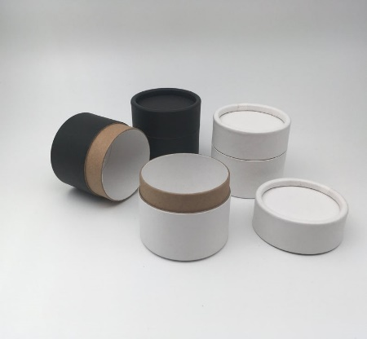
Requirements
- Colours should link to brand – see logo at website
- Include
  - Name [by Lone Kauri?]
  - Natural Deodorant
  - Flavour (specific colour variation to label?)
  - Size - 60g
  - Bar code (to be supplied later – please use a
  - Potentially icons – Handmade, Natural, Zero Waste, Aluminium free, Made in NZ
Visit us: lonekauri.com
Follow Us: lonekauri_nz (Instagram icon)
Directions
[Name] is a luscious deodorant paste that contains no nasty chemicals and neutralises odour naturally. Massage a small amount under your arms for all day protection. Store in a cool place out of direct sunlight. Do not apply to broken skin. If irritation occurs discontinue use. Please recycle.
Ingredients
Arrowroot powder, baking soda, coconut oil, shea butter, sweet almond oil, diatomaceous earth, essential oils, [bees wax]
[XX] cents of every purchase go towards Kauri Tree restoration.
Same examples of product designs that I like.
