SITE TEXT:

Remarkably Different DevOps
Built from the ground up specifically to empower Salesforce development, Flosum's flawless version control and robust CI/CD capabilities and push error-free releases to production at blazing fast speeds.

The #1 Rated App for Release Management
Don't take our word for it, our 5-star reviews on Salesforce Appexchange & G2 speak for themselves.

Best In Class Git Integration
Harness the power of Git, without the pain points. Flosum provides high performance integration with all native Salesforce apps including Salesforce DX.

*INFOGRAPHIC WITH ALL INTEGRATION CAPABILITIES* - here is our integration list: https://app.box.com/s/8xrfw7tsskggd2cd8mhmp4c6vu9sokoi

Truly All-Native Solution
High Performance Conflict Resolution, Code Merge, Branch Management, Pull Request, and Org Synchronization. All out of the box with 100% of functionality occurring on the Force.com platform. No need for Git, and little to no training required.

*Highlighted Statistics*
98.2% of Flosum users state that the Native Version Control system is "extremely productive"
96.3% of experienced Git users find Flosum’s Version Control to be more productive when compared to Git

Uncomplicated Enterprise Level Software, Trusted by Salesforce
Flosum is loved by the largest brands around the world. And it's the only DevOps solution used by Salesforce themselves.

INSERT LOGOS, MAKE THE SALESFORCE LOGO FIRST – see screenshot of the rest of our logos: https://gyazo.com/36047c887f5c97f3926c9e831ccbdd1a

Built for admins
Admins are awesome. And Flosum empowers them to do more. From merging their own changes and comparing profiles, to creating deployments, Flosum levels the playing field, making DevOps (or should we start calling it AdminOps) accessible to the entire team.

Loved by Developers
We give developers the tools they need, in the ways they’ve always wanted. Our powerful version control, code review features and sandbox synchronization capabilities improve collaboration and save developers hundreds of hours of time.

Unbreakable Security
The only solution on the market which does not have access to your code or metadata. Meets all compliance requirements, making it a perfect fit for Financial, Heathcare and Government institutions.

- Flosum Security Bounty Program
As part of Flosum's commitment to security, we invite developers to report any found issues with our solution. We make it a priority to resolve confirmed issues as quickly as possible in order to best protect customers and offer public recognition for those who bring valid concerns to our attention.

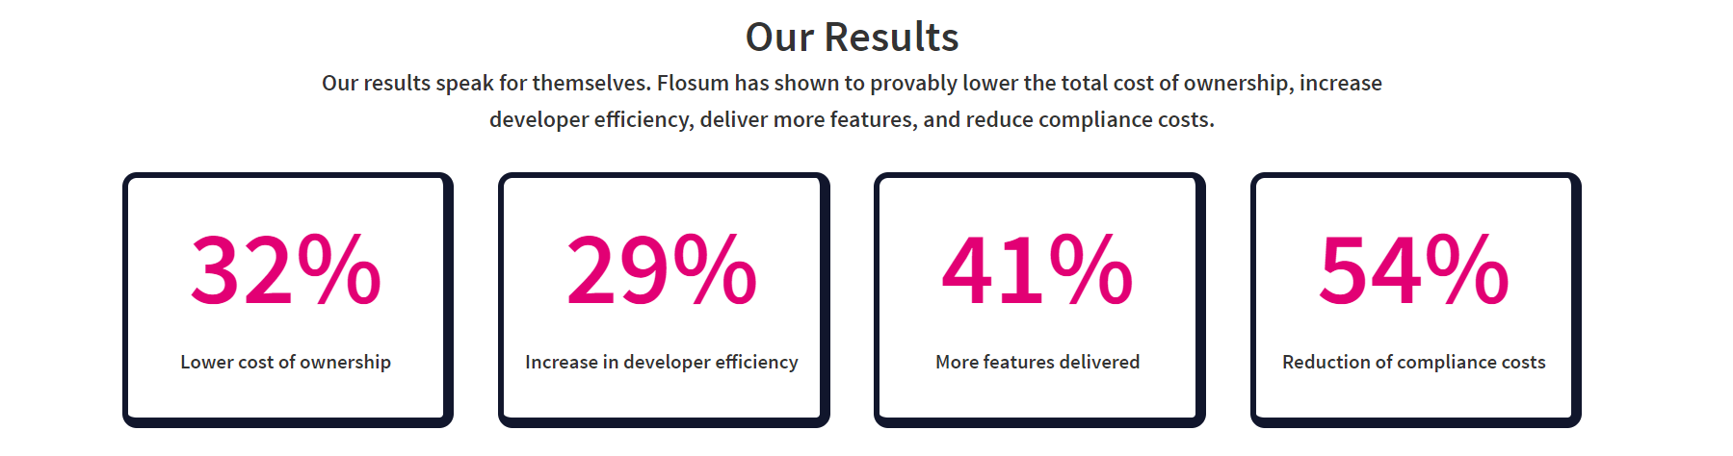
*utilize the same results above, not same design

