Brand Identity Design Brief for

Chatswood Partners
We sell business and properties

Company profile
- Who are you?
Chatswood Partners, your trusted local agent, we sell business and properties

- What do you do?
We sell business, buy business, and grow business for our vendors and buyers

We sell commercial properties and lease and manage your commercial properties

We connect vendors with Chinese Buyers

- Where are your customers based?
Focus on Local customers in Sydney

- How are you seen (or how do you want to be seen) in the market place?
- We are new to the market, our strength is connecting local vendor with Chinese buyers
- We are not competing with anyone, only compete with ourselves, we is aimed to become the best version of ourselves
- Our local small business owners
- We are aiming to be the leading experts in our local area

Logo meaning deliver: Trust, Authority, Quality and Professional and Reliable
Leading experts in the industry

- Where do you want to go?
What are the mid and long-term goals for the business, and how will you achieve them? For example:

- Turnover is going to $500,000 plus in next three years
- I will have number of brokers in the team, and building sales support and marketing team
- We will focus on our strength, to help Chinese buyers and immigration buyers to find qualified listings and help our local vendors connect with Chinese buyers

- What’s the personality of your company?
- Trust, reliable and knowledgeable advisor
- We are professionals, knowledgeable, detail orientation advisor
- We put our clients first

Trust, Authority, Quality and Professional and Reliable
Leading experts in the industry

- Who are your competitors?
https://linkbusiness.com.au
http://www.sbx.com.au
https://www.xcllusive.com.au
https://www.vbaaustralia.com.au
https://forwardbusiness.com.au
https://allbizsales.com/au/
https://sinosmart.com.au

The difference between our business with competitors, we will provide not just selling and buying business, but also provide service to grow the business.

We also provide commercial property investment service to our clients

We focus on local, and understand local and offer our clients best service

Project Objectives
- What do you want to achieve with this project?
We would like to grow our team and our knowledge and help clients to fulfil their dream and grow their wealth.

- Who’s the target audience and what do we need to focus on?
We are focusing on Chinese Investors and first business buyer and, and looking for business and properties investment

- What does the brand need to be used on, and what other issues do we need to consider that relate to this project?
The brand will be used in name card, website, social media and email and letterhead and any future marketing campaign and material

Sample of Logo I like, and Prefer to see Creative c, as initial of Chatswood

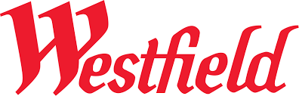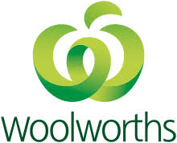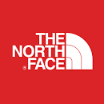



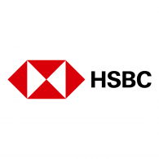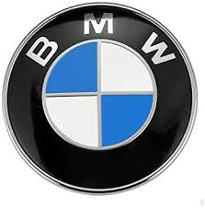
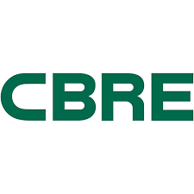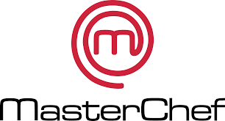
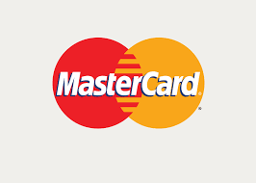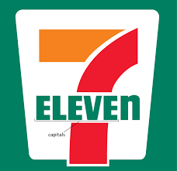

Some of contemporary fonts you might be consider to use

ake a look at
Franklin Gothic
Palatino (Apple font)

And then go to:
https://www.creativeboom.com/resources/top-20-fonts-that-will-be-popular-with-designers-in-2019/

And look at:
Euclid
Supria Sans
Como
GT America
Pitch

Go to
https://www.shillingtoneducation.com/blog/top-20-fonts-2020/

And look at:
Ambit
Futuera
Visuelt
Sweet Sans
Brandon Grotesque

Color you might consider, but not limited to below

Year of 2020

PANTONE 19-4052 Classic Blue

Year of 2019

PANTONE 16-1546 Living Coral
PANTONE 19-1662
Samba

Very like logo and Color sample

