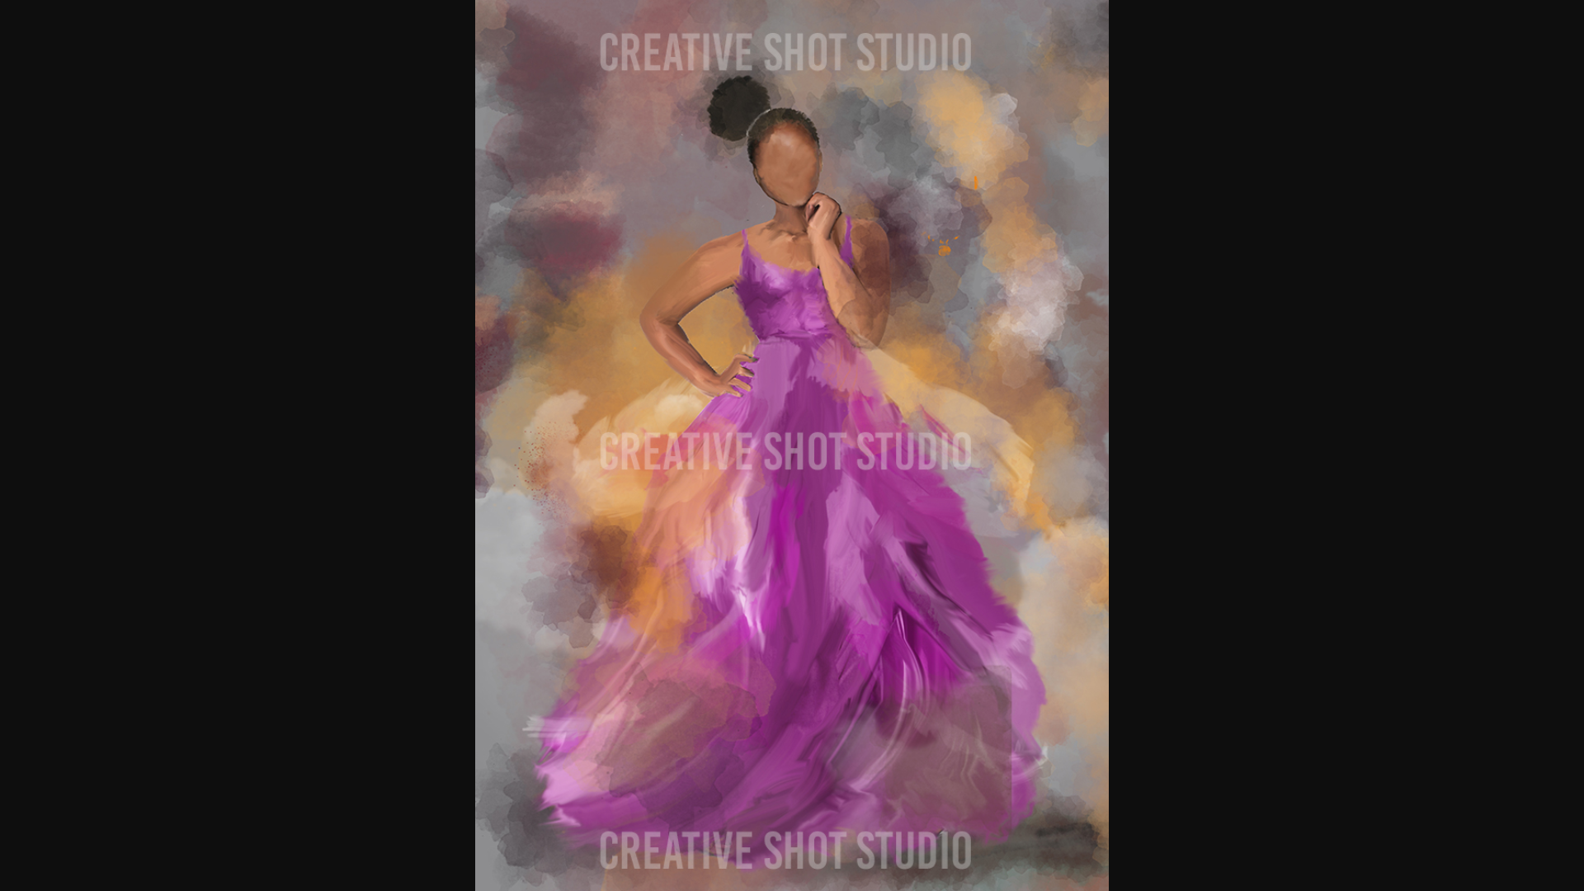
Please remove shadow from arm-thanks!
Please clean up her hairline…not sure if it’s a shadow or what, it’s dark blob at her hairline AND on the side of her face-Thanks!

…And please change her hairstyle too, I think it makes her look older as well…I’ve included the picture below to give you an idea for possible styles (-:

Please change her hairstyle…I’ve included a picture below just for ideas/as a visual-Thanks!
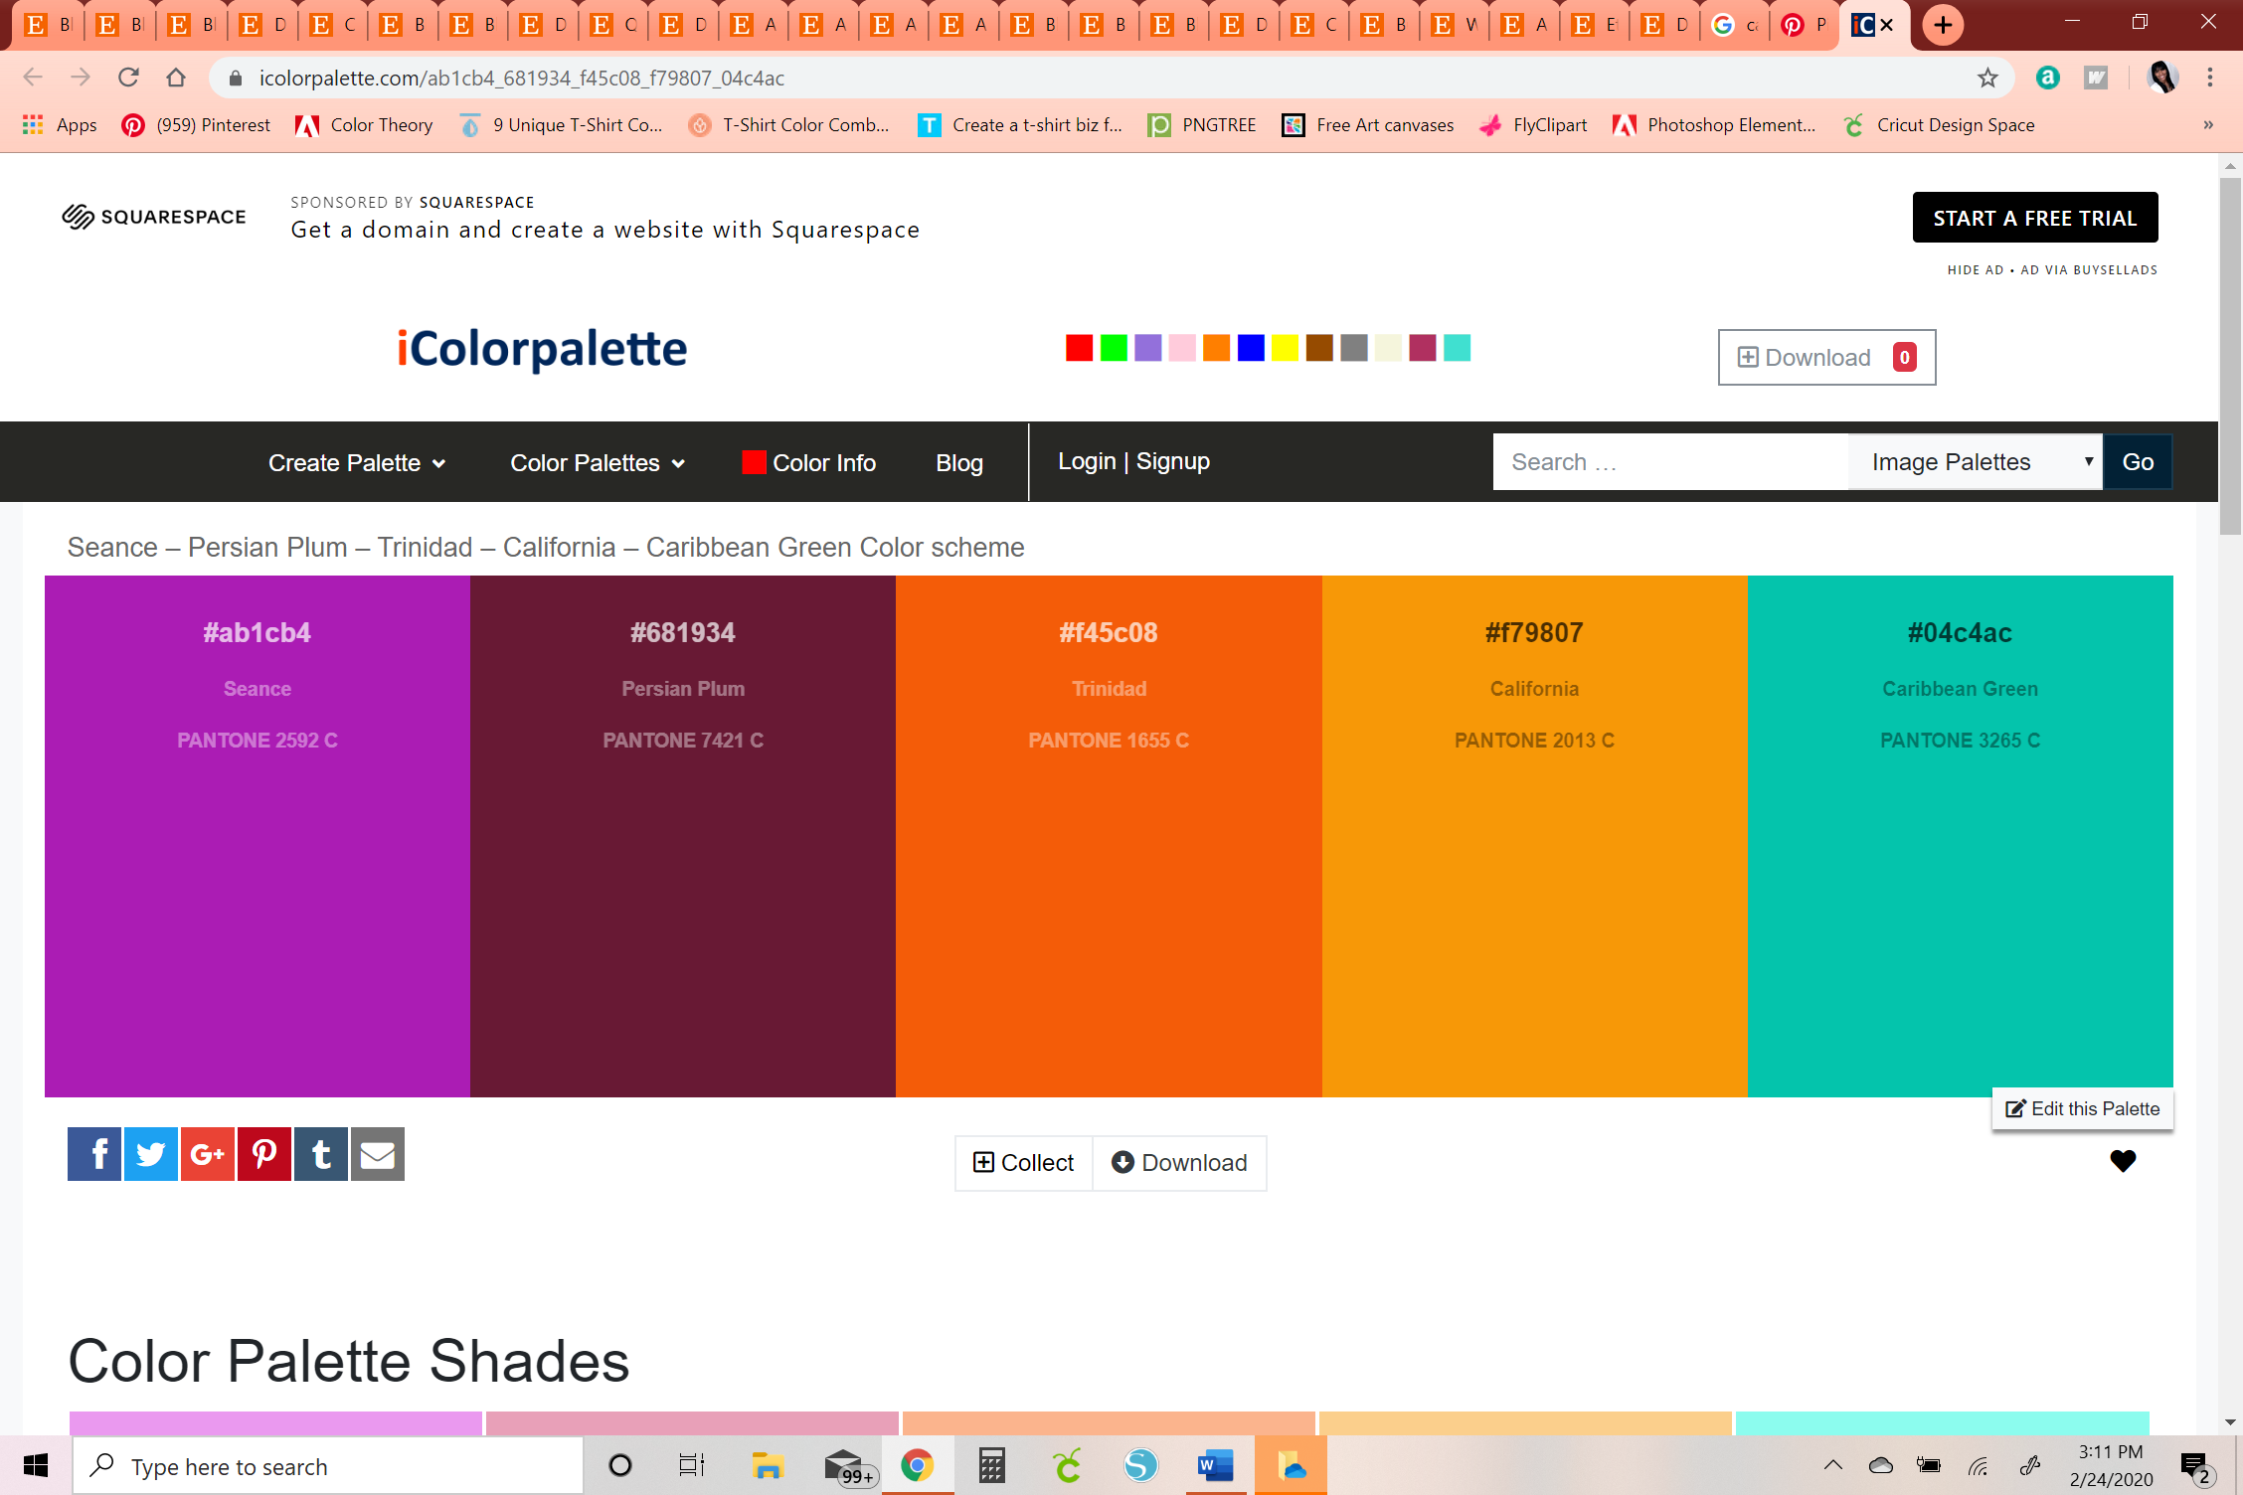
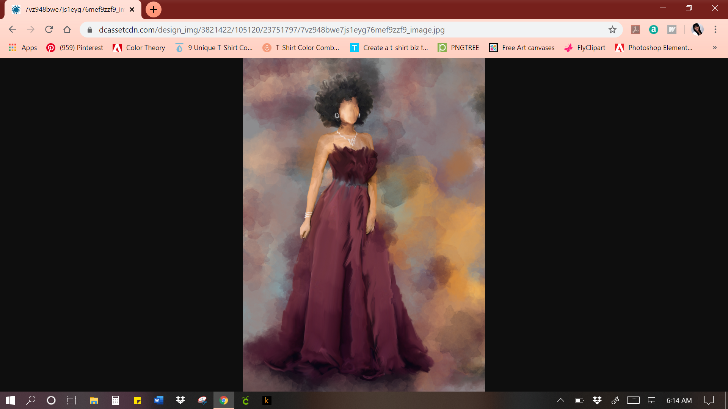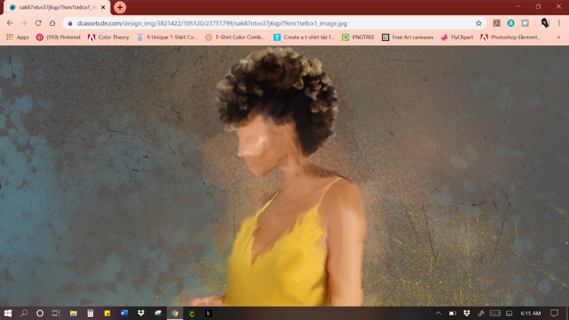
Please fix her face because she should not have a nose and I should not be able to see facial features.
And please remove the dark shadow off the back of her neck-thanks!
Please change her hairstyle, it makes her look old…so I’ve included a picture below just for ideas/as a visual for you
And lastly, remove her jewelry, it’s a little too dressy-Thanks!
And
I don’t care for the belt or the top part of this dress (it looks like it’s made from feathers or something). However, the style/make of the dress is reallyyy nice, so if you could just fix the upper part AND change the color to a pretty Caribbean colored orange that’d be great please!!
HAIRSTYLE CONCEPTS
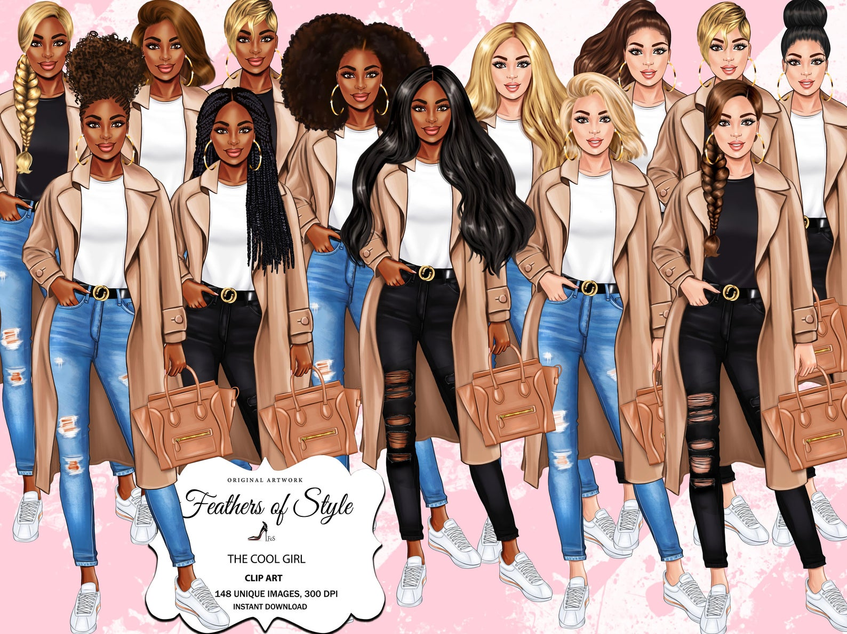


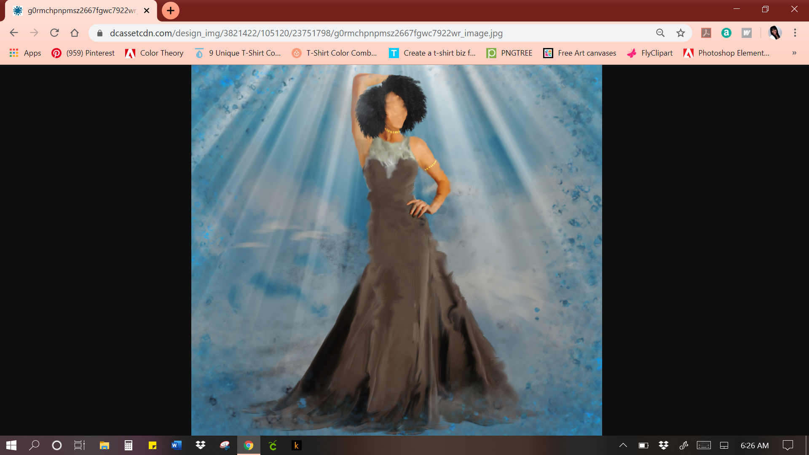
#31C92E
Please make her dress one solid/smooth color/design…I don’t like the feathered look at the top-Thanks (-:
Lastly, please change the color of her dress to a pretty and bright Caribbean lime green-Thanks!
I love her!!! Just please clean up the blur on her face as well as the black hair marks/strokes framing her face please
Also, please smooth out her arm, it looks like it’s missing some stokes and like it’s a different color than her wrist/hand-Thanks!
Please remove the blue specks/ shadow from off arm-thanks!

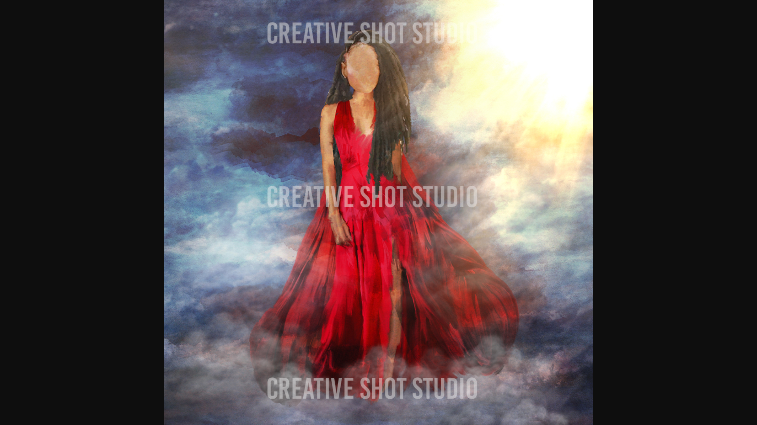
Please blur her face just a little bit because if you look closely you can see slightly the layer where her eyes, nose and mouth were-thanks!
Please remove this color stain/mark off her thigh-thanks!

Please turn and blend this one red line/ stroke into her skin tone color…Thanks!

Please remove the shadow off her hand because it’s making her hand look scary/skeleton-like-Lol!

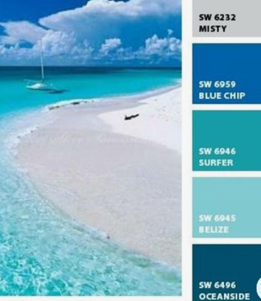
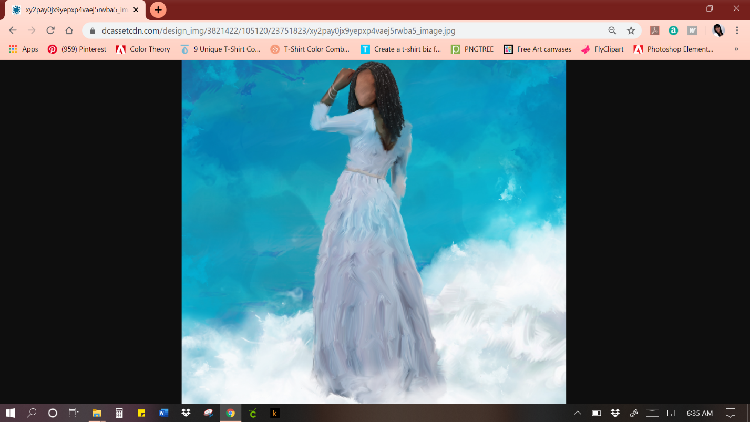
Is it possible to instead make her dress a blend of type of colors you used for her background because there the EXACT colors in a beautiful ocean!
She’s absolutely BEAUTIFUL…but her hand looks reallyyy weird to me…it kind of looks like it’s just stuck on her dress sleeve and doesn’t quite match the skin texture or tone of her face-Lol!
I’m not sure what this HUGE black shadow is under her hair/on her back but please fix it-Thanks SO much!
Please blend this dark area in with her skin tone

