Website platform:
It has to be a webshop where I can easily adjust things myself, so I wonder what the best theme and platform is for the webshop. would you like to think about this?

WEBSITE COLORS:
the website must have a neutral color and I want some details to be edited with blue and yellow (colors of vibropac), is that possible?

things that should be on the website:
he points websites:
- Possibility of choosing different languages
- Newsletter subscription
- Dropdown under categories
- The search menu: "I am looking for"
- Products on the home page alike (in our case think different categories)
- Well-arranged menu on the side with which they go to the different categories
- Mobile responsive
- Shopping basket at the top of the header
- State social media channels on the website
- Coockie popup bar
- Benefits on the page
- All photos with a white background, are beautiful and well-arranged
- Reviews from people who have already purchased products from us
- Chat Function on the website ?? People can ask questions here
- Can order on the product page and on the overview page Check example: https://www.tools2go.nl/automotive-gereedschappen/koelsysteem-verwarming-en-airconditioning
- Trustpilot or something in that trend needs to be added
- Footer cups: frequently asked questions, privacy, general terms and conditions, returns and warranty, shipping etc etc
- Check account content (krattenboer.nl) (confirmation email)
- About us"
- Cup with Video?
- We send with (zalando site at the bottom)
- Related products at every product page
- Last viewed (HBM)
- Photo of someone on the website
- Pop up (business / private) so you don't have to log in and you keep it easier. Check: https://www.groenhart.nl/
- Chamber of Commerce and VAT number of course
- Link to the catalog (so that they can download it)
- Featured or Most sold collection above
- and of course pages for different collections

example websites:
- https://www.hbm-machines.com/?gclid=EAIaIQobChMI-pOGmOnL5wIVSOR3Ch3UrwWjEAAYASAAEgI71fD_BwE
- https://www.automotive-line.nl/speciaal-gereedschap.html
- https://www.datona.nl/

the categories that should appear on the website
the different cups that I want on the website are in the blue bar and are written with white font.

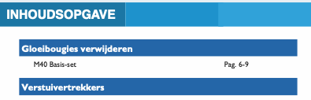

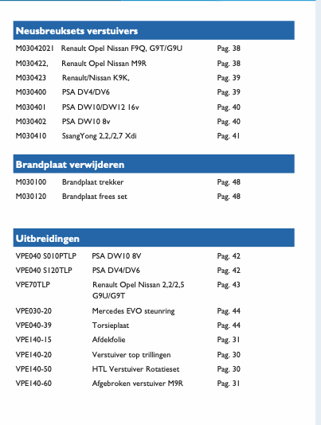
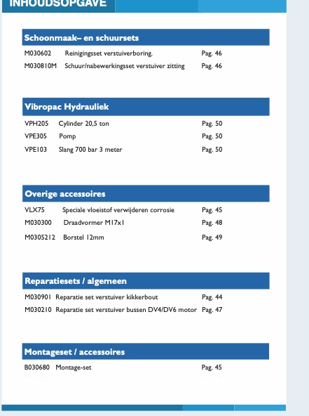
is there anything you need more information about?

