
Unification of Treatments and Interventions for Tinnitus Patients

Rationale and Objectives
Tinnitus consists of the perception of a phantom sound including the patient’s reaction to it. Tinnitus remains a scientific and clinical enigma of immensely high prevalence and socio-economic burden.
The overall aim of the UNITI project is to deliver a predictive computational model based on existing and longitudinal data attempting to address the question, which tinnitus treatment approach is optimal for a specific patient group based on specific parameters.
Clinical, epidemiological, medical, genetic and audiological data, including signals reflecting ear-brain communication, will be analysed from existing databases. Predictive factors for different patient groups will be extracted and their prognostic relevance will be validated in a randomized controlled trial (RCT) in which different groups of patients will undergo a combination of therapies targeting both auditory and central nervous.

Please redesign the following figure:
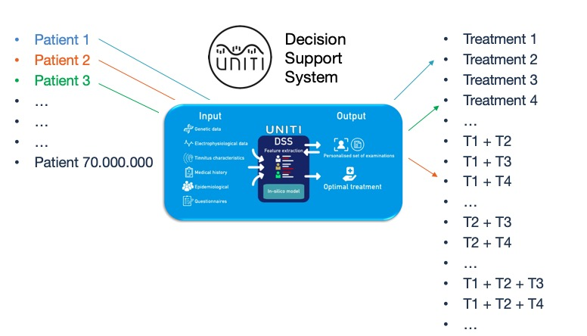

Please redesign the following figure:
Methodology
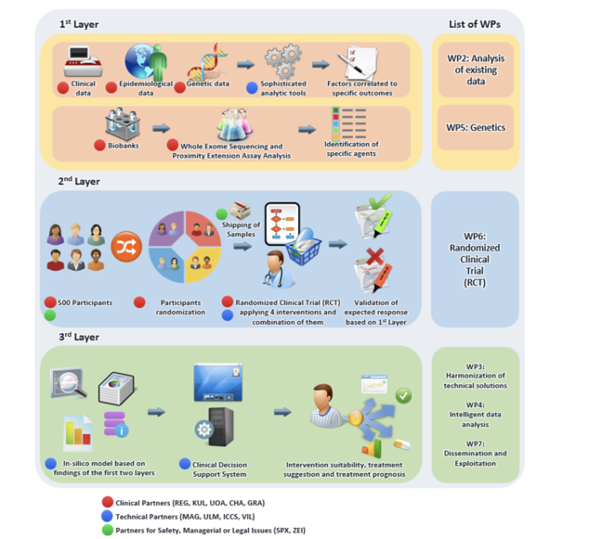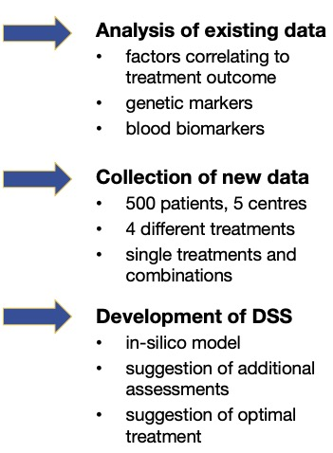

Consortium
High resolution Logos of the partners (1, 2, 3, 4… 13) / please see attached photos (logos).

Contact
Web: https://uniti.tinnitusresearch.net
Twitter: @uniti_project
Instagram: UNITI_Project
Facebook: unitiproject
LinkedIn: http://www.linkedin.com/in/uniti-project

Key facts:
Starting date: 1/1/2020
Project Duration: 39 months
EU contribution: € 5 989 343,75:
13 partners including 5 tinnitus centers
Project coordinator: Winfried Schlee (winfried.schlee@gmail.com)

The following should be the footer of the poster:


This project has received funding from the European Union's Horizon 2020 research and innovation programme under grant agreement No 848261

