Robust Features. MiSWITCH takes full advantage of the SIP network architecture to deliver a comprehensive set of Class 5 and IP-Centrex calling features in a format that is flexible, efficient and future friendly. Rest assured that your platform is future proof – as technology and markets continue to evolve, new features will be added as application servers that are managed by the platform’s robust SIP Session Control stack.
Scalability. As a fully managed service, MiSWITCH lets you focus on your business without the pain that typically accompanies growth. Whether you have a handful of customers or thousands, MiSWITCH will deliver the same rock solid performance, day in and day out.
Reliability. Our seasoned management team knows what its like to lose sleep because of network downtime, and we don’t like it any more than you do. As a result with have engineered reliability into every aspect of our network and offer 99.999 service level guarantees for all mission critical functions.
Redundancy. The MiSWITCH platform is a geographically redundant infrastructure-as-a-service offering that is delivered from InterNAP’s industry leading colocation facilities in New York and Dallas. When you combine InterNAP’s route optimizing P-NAP technology with our seamless failover using active-active application servers, our network architecture guarantees the highest uptime levels possible.
Pricing. Our per seat pricing allows you to pay-as-you-grow with no capital expenses and linear, predictable operating expenses.
Telco. MiSWITCH is a neutral platform vendor. As such, you have the flexibility to use your own PSTN termination providers with our BYOT options. However, you will always have access to competitively priced prepaid DIDs and PSTN termination service, using our top tier carrier network. Our Telco portal is a fully automated tool that allows you to order and manage your DIDs and prepaid account.

Most high-availability or n+1 redundancy schemes rely on a primary and failover node. In contrast, the n-Share system is Always Available. That means that we provide identical service across multiple locations in real-time. With seamless and transparent failover between nodes, service disruptions are avoided because customer connections are automatically transferred to any nodes available.
So, a voicemail can be left on a Dallas feature server, and retrieved on the New York server immediately, even if the Dallas server is no longer available. It also means that feature options (such as call-forwarding or other * codes) take effect across all servers immediately.
As network traffic grows, MiSWITCH adds capacity by deploying additional n-Share nodes. Newly added nodes are added to the n-Share mesh and automatically become available to share call processing tasks across all nodes dynamically and with zero downtime. This means that we can expand to accommodate Reseller growth with zero impact on the availability of services to end users.
Where other high-availability schemes require the use of active and standby servers (with the standby servers left idle in readiness for a problem) n-Share creates efficiencies by dynamically distributing load across all available servers. This means that load can be dynamically shared across all connected nodes based on geographic distance from the user. Especially in cases where media-anchoring is required, this optimizes quality of service by ensuring voice and video payload will take the shortest path between the sender and receiver.
Mobile workers are now using SIP mobility clients (such as the PBX Fone mobile client) running over 3G and 4G wireless networks, where network conditions are often unpredictable. As a result, the ability to maximize quality of service in a scalable and reliable way is becoming more important than ever. On that front, MiSWITCH has you covered.

User Features
- Account Codes
- ANI/CLI Customizations
- Anonymous Call Rejection
- Authentication by Digest
- Busy Lamp Field
- Call Forwarding
  - Call Forwarding Always
  - Call Forwarding Busy
  - Call Forwarding No Answer
  - Call Forwarding Not Reachable
  - Find Me (multiple numbers)
  - Sync with Server
- Call Logs (Inbound and Outbound)
- Call Monitoring
  - Automatic Recording
  - Supervising Mode
  - Silent Monitoring
- Call Notify
- Call Pick Up
  - Call Pick Up Department
  - Call Pick Up Domain
  - Directed Call Pickup
- Call Recording
- Call Return
- Call Status (Real-time in User Portal)
- Call Transfer
  - Attended Transfer
  - Blind Transfer
  - Intercom Transfer
  - Transfer to Voicemail
- Call Waiting
- Calling Line ID Delivery Blocking
- Calling Name Retrieval
- CDRs
- Charge or Billing Number
- Client Call Control (API and User Portal)
- Conferencing (Multi-Way Calling)
  - Convene Conference
  - Invite Attendees
  - Multiple Conference Rooms
  - Scheduled/Instant Conference
  - Web-based Setup
- Device Auto Provisioning
- Direct Inward Dialing
- Directed Call Park
- Directed Call Pickup
- Diversion Inhibitor
- Do Not Disturb
  - Sync with Server
- Extension Dialing
- External Calling Line ID Delivery

- Hunt Groups
- In-Call Service Activation
- Instant Messaging (via XMPP or SIP SIMPLE)
- Intercom
- Internal Calling Line ID Delivery
- Last Number Redial
- Message Waiting Indicator
- Music-On-Hold
  - System Default Music-on-Hold
  - Personalized Music-on-Hold
- Phone Status
- Presence
- Privacy
- Selective Call Acceptance
- Selective Call Rejection
- Simultaneous Ring
- Shared Call Appearance
- Three-Way Call
- Two-Stage Dialing
- Video Telephony
- Voicemail
  - Default Greetings
  - Customizable Greetings
  - Name Recording
  - Email Notification
  - Voicemail Forwarding
  - Forwarding to Email
  - User Portal (View, Save Delete)
  - Voice Messaging Group
  - Voice Messaging Call Back
- Web User Portal
  - Contact List with Presence
  - Click to Call
  - Inbound Call Handling Rules
  - Screen Pops
  - Messaging

Group Features
- ACD
- Auto Attendants
  - Personal Auto Attendants
  - Scheduled Auto Attendant
  - Chained Auto Attendants
- Barge In
- Business Trunking
- Call Intercept
- Call Park
  - Directed
  - Dynamic
- Calling Group ID Deliver
- Configurable Extension Dialing
- Configurable Feature Codes
- Configurable Directories
- Device Inventory
- Department Support
- Group Announcements
- Group Custom Ringback
- Group Instant Messaging
- Hot Desking
- Hoteling
- Hunt Groups
- Instant Group Call
- Listen In
- Office Manager Portal (Web portal)
  - Active Calls
  - Auto Attendant Designer
  - Call Records
  - Call Statistics
  - Conference Bridge Configuration
  - Device provisiong
  - Moves, Adds, Changes
  - Music on Hold Upload
  - Queue Management
  - Voicemail Management
- Night Mode
- Paging
- Simultaneous Ring (group)

System Features
- Brandable Portals
  - All User Levels
  - Configurable Permissions
  - Custom Domains
  - Secure
- Custom Integrations

  - Salesforce Adapter
  - Virtual Office Control Panel
  - Hospitality and Hotel Systems (PMS)
  - Click-to-Call from WordPress and other CMS
- API
  - Access all System Funtions
  - Call Control
  - Configurable OAuth Permissions
  - Even Subscriptions (webhook)
  - Mature and Well Documented
- Fault Tolerant
  - Active-Active Architecture
  - Geo-distributed
  - Highly Scalable
  - Rolling and Hitless upgrades
- Security and Fraud Detection
  - Auto Block Failed Registrations
  - Auto Block SIP Port Scanning
  - Auto Block Promiscuous SIP Devices
  - Velocity Filter for Bad Digits
- Device Provisioning
  - Customized Directories
  - Domain and Device Overrides
  - MAC Management
  - Remotely Triggered Updates
  - Supports Major SIP Phones
  - Zero Touch Device Configuration
- Regulatory Compliance
  - 911 Emergency Calling Solution
  - CALEA (lawful intercept)

End User Portal

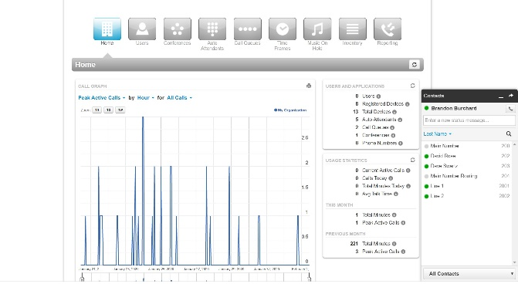

Fax to Fax ATA
The MiSWITCH Fax to Fax (Internet Fax from end-user’s fax machine) service provides reliable faxing over the Internet.
t.38 and Internet Faxing
t.38 the ITU recommended standard for sending and receiving faxes over the Internet, was designed to send raw data over networks for fax transmissions. In theory, this should work fine. The reality, as anyone that has tested t.38 over the public Internet can attest, is at best, unreliable. Jitter, packet loss and PCM Clock sync issues often cause these faxes to fail and the longer the fax, the more likelihood of failure. For businesses that rely on fax as an important way to communicate with their customers and business partners, it is clearly a costly, frustrating and unacceptable solution.
MiSWITCH takes the t.38 out of Internet Faxing
With the MiSWITCH Fax ATA solution, end-users never need to worry about packet loss, jitter or PCM Clock sync issues creating fax failures. Our solution does not utilize t.38 at the end-user’s location. Rather, our ATA (Analog Telephone Adapter) has proprietary software that receives fax transmissions from the end user’s fax machine locally, and then transmits it to our servers using HTTPS. This process is not affected by jitter or packet loss and works perfectly well over any type of Internet connection.

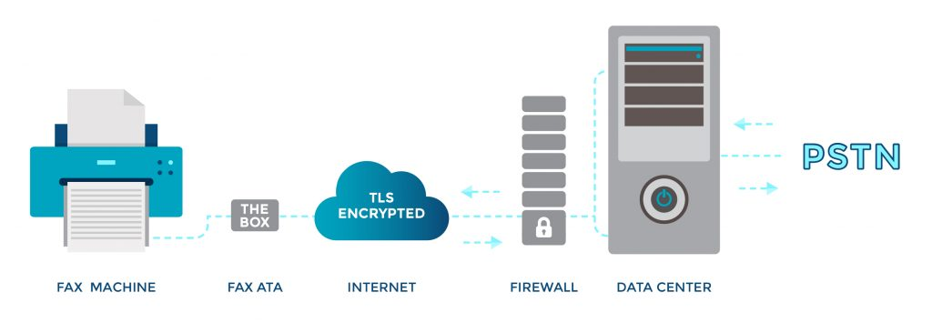
Incoming faxes, destined for the end user’s fax machine, work in the opposite direction. Incoming faxes are first received in at our servers, and then then transmitted to the end user’s ATA securely, before being delivered to the end user’s fax machine. Incoming faxes can also be delivered to the end user’s email. If the end user’s fax machine or ATA is off-line or unable to receive, faxes can queue until the ATA and fax machine becomes available available. Senders never get a busy signal and end users never miss a fax!
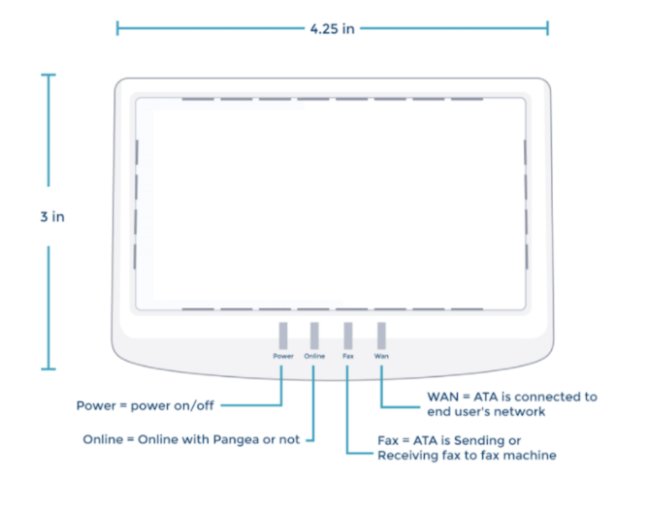

Benefits of the MiSWITCH Fax ATA

  - Transparency: Clients may continue to fax as they always have
  - Plug and Play
  - Low-cost Fax ATA
  - Small packaging for low-cost shipping
  - Secure. All data transfer is TLS encrypted

The MiSWITCH platform leverages industry standard SIP to provide innovative and integrated telephony and UC services. Because the capabilities of our systems have been exposed through RESTful application programming interfaces, you can leverage all of the features of our platform and control every aspect of call flow, media handling and even business logic.
MiSWITCH promotes and encourages resellers to create innovative, revenue-generating applications that harness the power and flexibility of the Voice API.
Examples of applications that been built to date include:
- Amazon Alexa Skills
- Specialized Call Center applications
- DID Ordering and Management portal
- CDR (Call Detail Record) Automation
- Custom IVR (interactive voice response) systems
- Smartphone applications that implement Mobile PBX functions
- Integration with CRM and Billing systems

