BANNU AROGYADA SEVA SOCIETY

ESTD Dec 2013

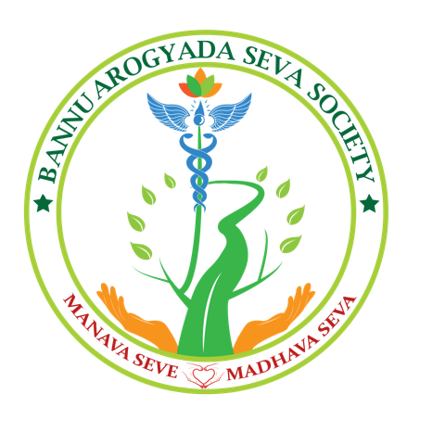

DELIVERING HEALTH CARE AND EDUCATION TO THE UNDERSERVED WITH CARE, COMPASSION AND COMMITMENT

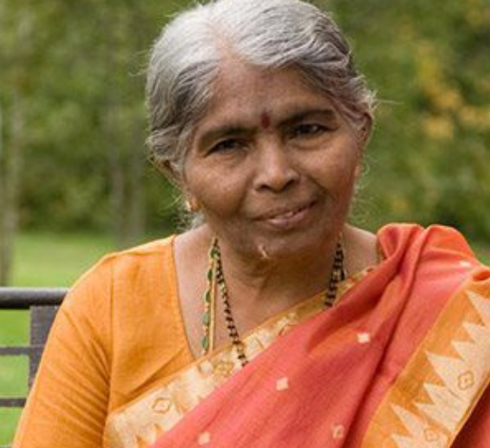
VEERAMALLA PADMAJA (BANNU) B.Sc BZC

The story behind the name "Bannu"

The name Bannu is that of Dr. Charanjit Reddy’s sweet mother, to whom he owes his passion to serve rural areas and the kids with intellectual disabilities. She always wanted to serve the health care needs of the poor in tribal areas, and is always an inspiring figure.

About the Founder

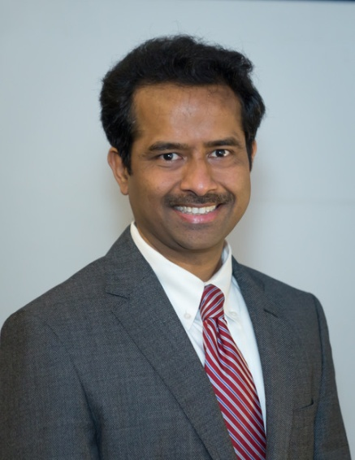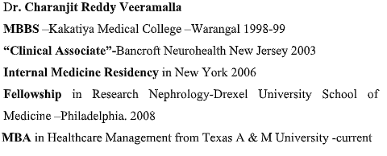

Dr.Charanjit Reddy has been working as an internist in several hospitals in the United States of America successfully since 2006. Apart from Dr. Reddy practicing as a full time physician he also manages efficiently all of his establishments in USA as well as in India remotely from the United States of America. He is actively involved in all aspects of his establishments in ways such as policy making, hiring of staff, financial management, promoting and marketing, periodic evaluations, and annual reports.
Introduction:

Bannu is a nonprofit organization registered in India in Dec,2013 as well as registered as “Bannu INC” in US in Sep, 2011 founded by Dr.Charanjith Reddy.

An organization that strives to make positive and lasting contributions in rural areas of India, particularly within the fields of Health and Education.

Our ongoing current projects:

- Bannu Neuro Health and Rehabilitation Institute- only institute for MR children & adults

- Bannu Garments - a self employment program to support parents of MR children

- Bannu Charitable Hospital in a tribal forest area

- Bannu Health Camps & Mobile clinics

- Helping babies breathe programme (HBBP) - training program (completed)

- Donating medical supplies to underserved hospitals

- Community HEALTH awareness programs

- Clinical rotation for medical students

Brief overview of each project:

- Bannu Neuro Health & Rehabilitation Institute:

A school for intellectually disabled children and rehabilitation institute for adults providing facilities speech therapy, Social play groups, Physical, occupational and speech therapy, Sensory integration, Behavior therapy, Goal and objective development, Social Work-Support, Individual and group counseling, Supports for transitioning to school, Life skills & vocational training,

Computer lab with E-learning tools, door to door free transportation. As well as we promote and encourage children to take active participation in sports and cultural activities, we organise regular field trips and knowledgeable outings.
Currently the school has around 110 children attending daily and 36 full time staff , having its own campus in 1 acre area.

IMPACT:

Statistics showing Students Enrolled since inception

Year | Student Enrollment
2013 | 10
2014 | 50
2015 | 70
2016 | 90
2017 | 100
2018 | 125
2019 | 125

Statistics showing awards bagged by students in sports
Students participation in sports | 50
 | District level | State Level
Gold Medals | 23 | 02
Silver Medals | 23 | 05
Bronze Medal | 35 | 08

Statistics of the school and other services provided :

Particulars | No.
Students Enrolled | 125
Drop outs | 13
Parents meeting s organized | Every 2nd and 4th Saturday
Parents counseling sessions | 17
Parent Participation | 65%
Field trips | 40
Outings | 23
Health check-up camps | 05
Niramaya Health Cards | 30 cards per year
Sadharam Certificates | 80
Health cards | 120
Bus pass | 70 cards per year
Train pass | 30

Statistics showing students participation in cultural events

Cultural Events participated | 37
Disability Day | Since inception of School
Father Jarom Birthday Celebrations | Since inception of School
Annual Day celebrations | Since inception of School
Jyothi Reddy Cultural Meet | 01
Flash Mob | 01
26th Day Parade in Police HO | 01
Khel India | 01
Vocational stalls | 08
Kadiyam Foundation Celebrations | 02
Other respective celebrations | Monthly

Statistics showing achievement in children

 | Enrolled | Improved/Achieved/Graduated
Hyperactive students | 38 | 12
Vocational students | 37 | 10
Personal skills | 52 | 41
Social Skills | 45 | 34
Occupational Skills | 28 | 28
Recreational Skills | 18 | 12
Self – Grooming Skills | 63 | 47
Basic Academic skills | 35 | 35

Parent Participation and Employment
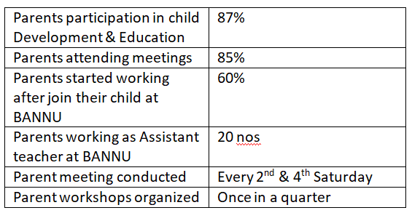
- BANNU GARMENTS:

Bannu Garments was established to promote employment for our own students and parents of the children enrolled in our school. Wherein they are trained in trailering .

Impact:
No. of mothers trained - 25
No. of adults with intellectual disabilities trained and employed - 05
No. of uniforms stitched & sold - more than 10000

- BANNU CHARITABLE HOSPITAL:

A 16 bedded critical access hospital established in Dec, 2015 in a very remote medically and economically underserved area catering to tribal people capturing villages and mandels of Mulgu District. We provide subsidized or free health care and our services include - Operation theater, Pharmacy, Ultrasound, 2D Eco, Tiffa & Gyn –Non Gyn scans, X-ray, diagnostic lab and ambulance. Currently adding 5 specialty services –Cardiology, ENT, Radiology, Gynecology-Infertility, Physiotherapy .

There are 2 full time doctors, 6 Consultant Doctors and about 18 full time staff with a future goal to make Bannu Charitable Hospital a 50 bed 6 subspeciality facility.

Impact:

No. of IN-Patients treated | 17000
No. of OUT-Patients treated | 110000
No. of diagnostic tests done | 273000
No. Radiologic tests done | 115500
Ambulance rides/transfers | 350
No. of surgeries Conducted | 430
No. of Cardiac patients seen – 2D Ecos done | 30
No. of Physiotherapy Patients visiting | 40
No. of Tiffas & GYN/Non GYN scans | 2000
No. of ENT patients seen | 200
No. of X rays | 5500
No. of Lab tests done | 25000

- Helping babies breathe programme:

A 2 days certification workshop on “Neonatal Resuscitation techniques” in partnership with PROJECT CURE (USA based NGO ) & AMERICAN ASSOCIATION OF PEDIATRICS. It is a hands on training program for doctors and nurses working in rural Government health facilities in Telangana India, conducted by United States physicians and trainers.

HBB training programs -2 days workshop | Participants /beneficiaries
Eturnagaram 2016 and 2017 | 65+50
Bhupalpally 2016 and 2017 | 65+50
Osmania Govt hospital 2016 & 2017 | 65+50

- Bannu Health camps and mobile clinics

We conduct regular free health camps with 4-8 speciality doctors and other associated medical staff like pharmacist, nurses, medical technicians and assistants. As well as several mobile clinics with a doctor ,pharmacist, nurse and lab technician. We organize these camps in much interior areas surrounding our hospital.

IMPACT

Mega health camps
Details | No. of patients
No. of Mega Health Camps conducted | 35
No. of patients seen per each camp | 500-1000 total average 31400
No. of diagnostic labs done during each camps | 1500-2000 total average 66000
Medicine freely dispensed | USD 5000 to 8000 (INR 3 lakhs to 5 lakhs  )..total around USD 154000 (INR 88 lakhs )
No. of patients screen with cervical cancer in each camp | 15-20

Mobile clinics

Details | No. of patients
No. of Mobile clinics conducted | 60
No. of patients seen per camp | 60 total of 3600
No. of diagnostic labs done during camps | 1000 total of 50000
Medicine freely dispersed | USD 30,000 (INR 20 Lakhs )

- Donating medical supplies to underserved hospitals:
In partnership with PROJECT CURE USA we basically collect medical equipment and surgical supplies from USA health care facilities and donate to Government and NGO run Hospitals serving underserved population in India.

IMPACT

One 40ft container worth USD 2,50,000 (INR 1.5 crore) in the year 2016 was donated to hospitals in Bhupalpally and Warangal District.
One 40ft container worth USD 3,00,000 (INR 2 Crore) in the year 2018 December was donated to Osmania Government hospital.

- Community health awareness programme

We periodically conduct medical education and training programs for local health care workers, anganwadi workers (Anganwadi is a type of rural child care centre in India. They were started by the Indian government in 1975 as part of the Integrated Child Development Services program to combat child hunger and malnutrition. Anganwadi means "courtyard shelter" in Indian languages.)

Also awareness programs through antenatal clinics for pregnant women, periodic thyroid camps and anemia workup and treatment in and around Eturnagaram as well as cancer screening camps

- Clinical rotation for medical students/ medical volunteers

We provide hands on clinical experience, medical education and training to medical and nursing students locally and internationally with a future goal to make it more organised and structured programme. We also have medical volunteers consisting of practicing doctors and nurses.

Impact:

Particulars | No. of participants
No. of students participated | 04 (each of 4 weeks duration)
No. of doctors & Nurses | 04

