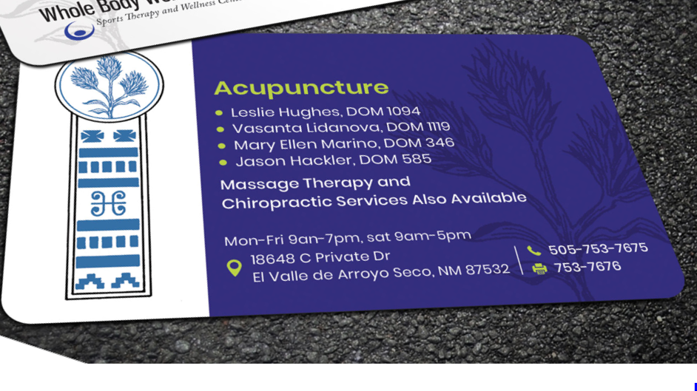

This is good with the Acupuncture being alone on the front of the card. We need the same for Massage Therapy and Chiropractic Care…and we’d like to use the phrase Chiropractic Care and Massage Therapy instead of Massage Therapist. See below:
Massage Therapy

Kartar Kaur Khalsa, LMT 378
Hal Dyer, LMT 6329
Denise Janelle, LMT 8743

Acupuncture and Chiropractic Care Also Available

Chiropractic Care

Robin Glass, DC 782
Jay Bunker, DC 2081
Nikki Schwartz, DC 1017

Acupuncture and Chiropractic Care Also Available

Fax number needs area code 505-753-7676
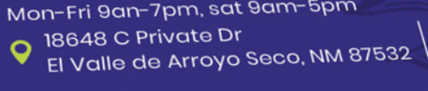

Please change El Valle de Arroyo Seco to Espanola. Sorry about this…We live in a place with confusing geography.
Sat needs capitol S.

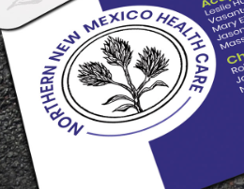
This on the front of the card. We really like the feel of the circle as it somewhat matches the Whole Body Wellness logo -



The below was submitted by someone else. We really like….could this be modified to work on the back of our card? The yellow wouldn’t look very good on top of white, so we might need a different color background than white?



If that doesn’t seem possible, then the below with black Indian paintbrush like in the circle.



