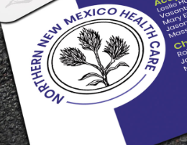
This on the front of the card. We really like the feel of the circle as it somewhat matches the Whole Body Wellness logo -

