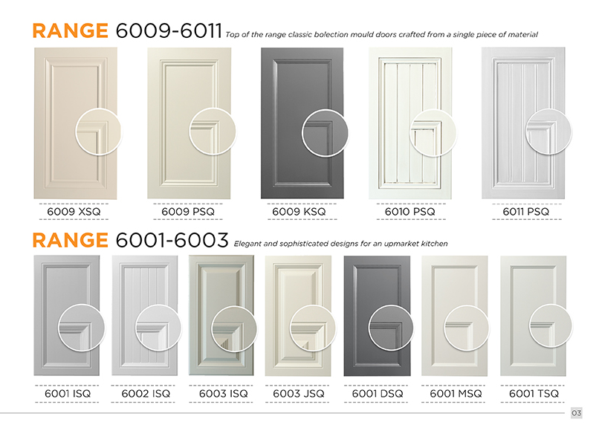
Brochure edits 30/04/20
Page 3:
- Please add 6008PSQ to the top row first image with the close up. Change the title to range 6008-6011.
- I have included new copies of 6009KSQ photo, you may change this as it may be better quality
- Please move the close ups in range 6001-6003 up to the blue line. I want to see more of the design 6003ISQ and 6003JSQ.
- I have included a new photo of 6001DSQ that you could use, the quality is better.

Page 4:
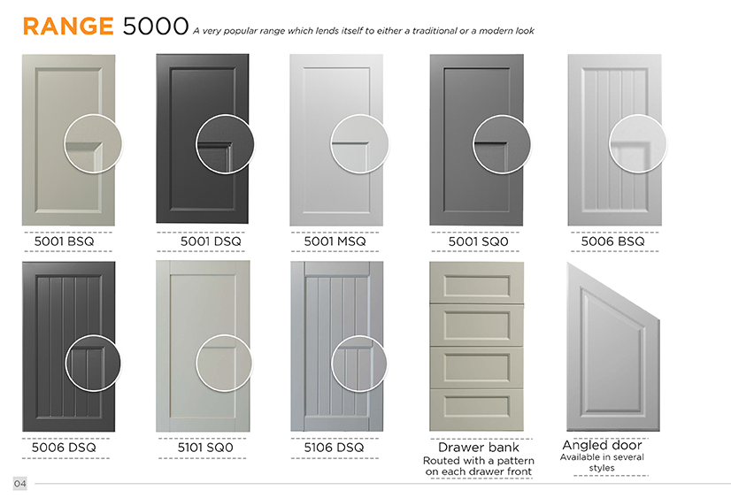
- Change the angled door photo with the one I just uploaded.
- Top row: Move all the close ups, up towards the line. They are too far down the bottom can’t can’t see the close up clearly.
- 5006BSQ close up is blurry, please fix.
- Move the close ups in the bottom row down to the blue line.

Page 5:
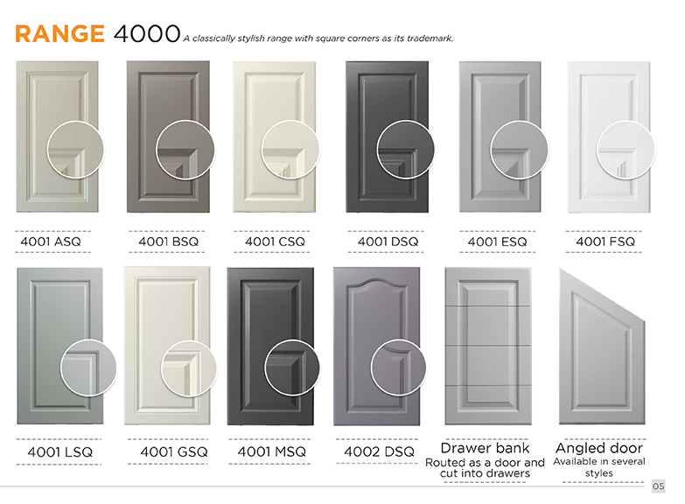
- Change 4001GSQ to 4001HSQ
- Put 4001GSQ photos into the bottom row, 4001GSQ, 4001HSQ, 4001LSQ, 4001MSQ and 4002DSQ
- Move close ups on top row up range 4000 up to match the row on range 5000 page 3
- Move close ups in bottom row down to match the row on range 5000 page 3
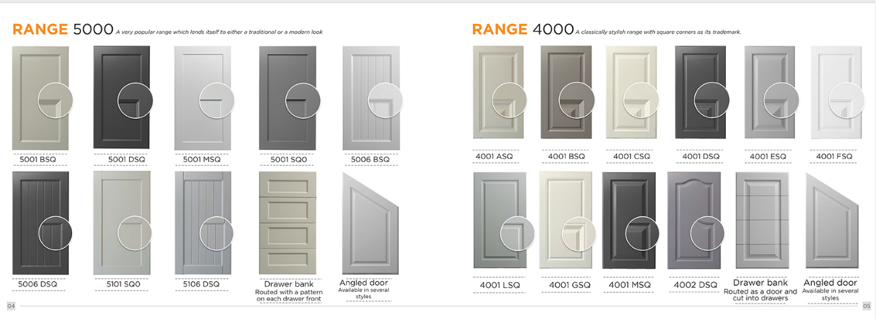

Page 6:
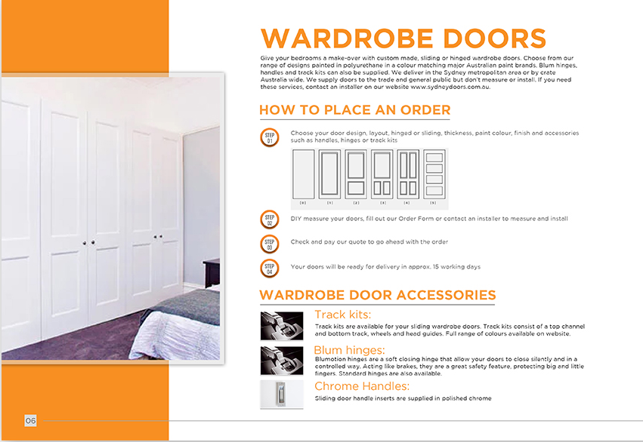
- Replace the Track Kits photo with the bottom track photo uploaded
- Plus the font size of the text of the steps in Wardrobe Doors: How to Place an Order are still too small, they should be same size as the text of the steps in Kitchen Doors How to place an order.

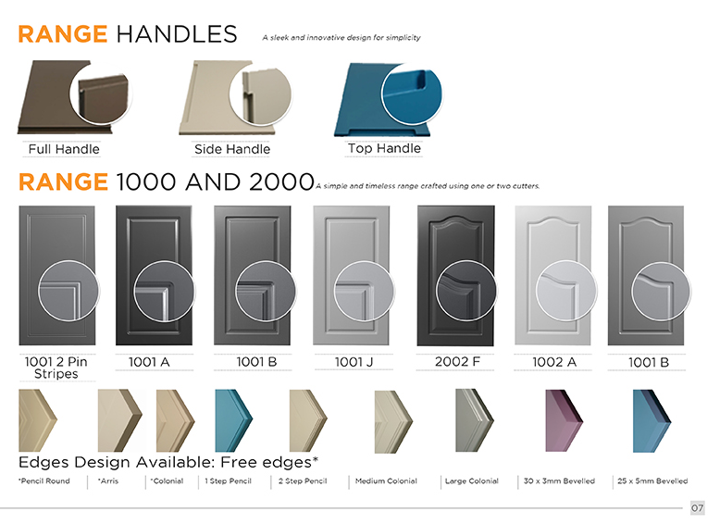
Page 7:

- Please remove all doors in the range handles and add new photos in the order
Full handle, Shark Nose, Side Handle, Top Handle and Z Handle ( you may need to change the hues as it will be all white)
- The edges have uneven spacing between them. Make the names of the edges bigger.

Page 8:
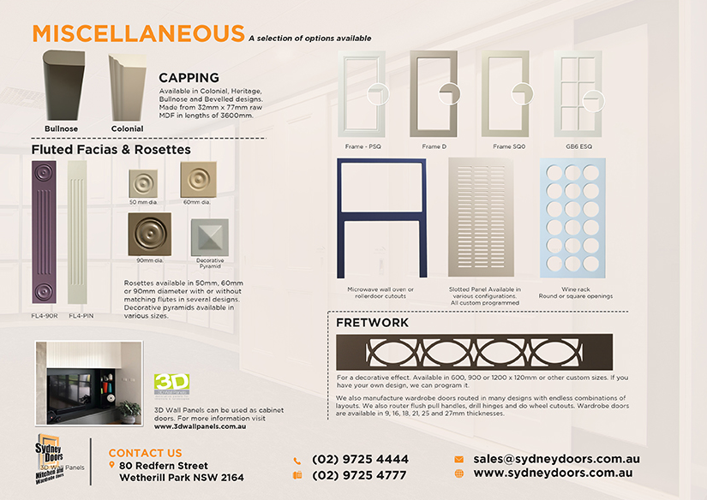
- Add Heritage, Dental and Bevelled Capping photos under the capping section.
- - Add new Frames (Frame X, Frame Double Arc 1 & Frame Double Arc 2).
- Make the frames larger and enlarge the close up making sure they are aligned.
- Make fretwork smaller

