Brochure edit 10/8/20
Front page:
We have requested for the vents in the ceiling to be removed. For some reason it’s added back in this edit. The edit prior to this posted had no vents in the ceiling as seen attached below. Can you please remove this vent like how it was before, we only asked for the stickers to be removed in the last edit.
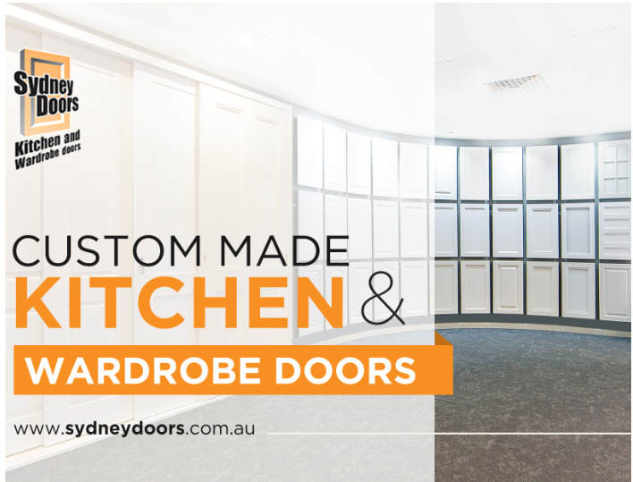

- When editing out the vent in the ceiling, please ensure that the first brown door is not in edited back into the door line up.
- The logo on the front page seems a little blurry compared to the heading. Can you check this?

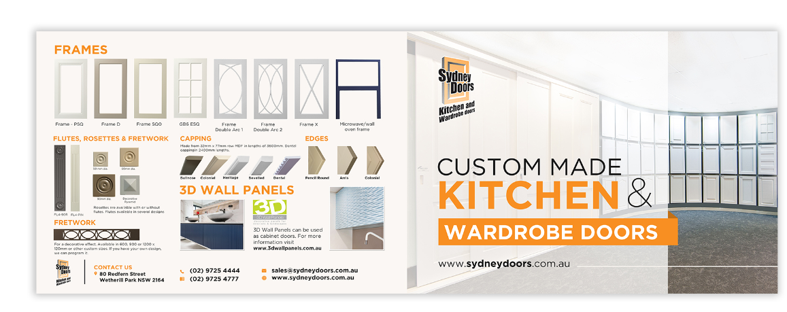

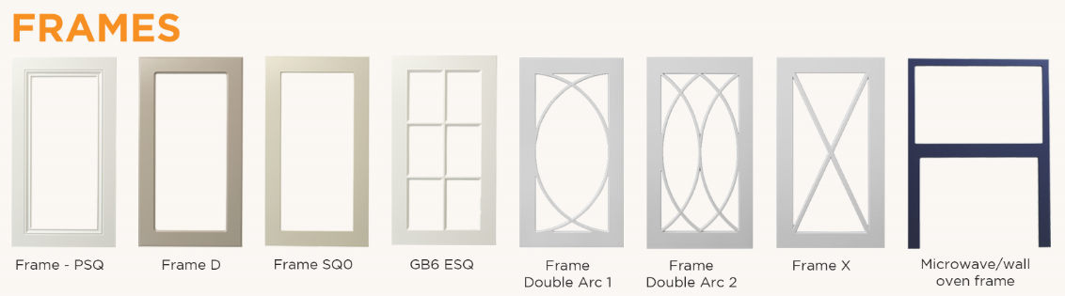
- Please align the doors. As you can see GB6 ESQ is higher than the rest.
- CAPPING: In the text, add a space between the words “capping” and “in”. This has been requested before.
- Make the ends of the capping square, not on an angle (especially the first 2). Example below:

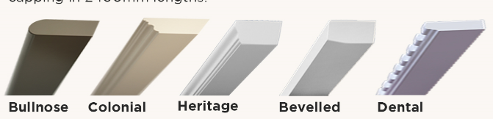

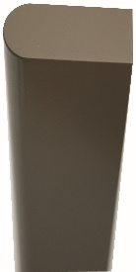

Instead of stretching it out, please make the ends straight like the photo to the left.

Page 06:
- Wardrobe image appears to be low resolution. Replace with high resolution image. Photo attached.
- Make the font size on the text below the Wardrobe door Accessories the same size as the text below the WARDROBE DOORS heading.

Page 07:
- Range Handles: There are strange crop marks around the outside of all handle doors. The resolution on the close ups appears to be low resulting in a wavy line along the top of the Z handle closeup etc.

