Sydney Doors Brochure Changes
Please keep the front cover as is, we love the design!

Page 2: Information page with before and after pictures. Heading: Kitchen and Wardrobe Doors
- Keep before and after pictures on the right. The top images need to say ‘before and after’ not before and before
- Please photoshop the middle cursor out of the second before and after image so it looks like the first one.
- Move the heading ‘New kitchen doors= a quick and cost effective kitchen renovation’ underneath the first photo on the right
- Move the heading ‘New wardrobe doors= an instant bedroom makeover’ under the second photo on the right.
- The left hand half of the page will contain text and icon as stated:
“Kitchen renovations and bedroom makeovers are quick and cost-efficient when you simply replace the doors and panels. It saves you thousands while improving the value of your home.”
Under this paragraph include all the icons and text you have used in the mock up.
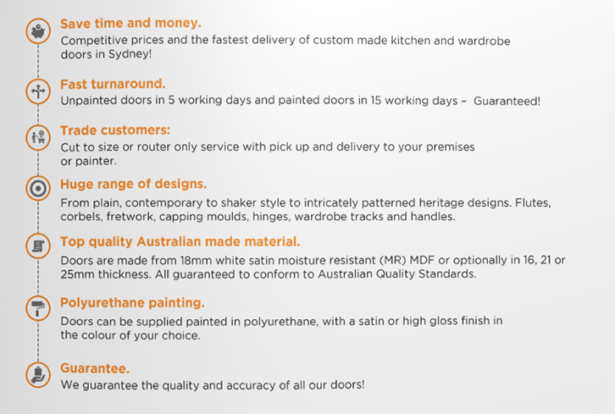
The icons and text will have to be smaller as they have to fit on the first inside cover page.
Save time and money
Competitive prices and fast delivery of custom made kitchen and wardrobe doors Australia wide.

Fast turnaround
Unpainted doors (to trade only) in approximately 5 working days and painted doors in approximately 15 working days. (Delete the word “Guaranteed!”)

Delivery
We deliver Australia wide.

Move the heading: “Trade customers” to between the heading “Polyurethane” and “Guarantee”.

Huge range of designs
Choose from plain, shaker style or intricately patterned heritage designs, even custom designs and angled doors.

Add- Hardware and decorative
We supply Blum soft closing hinges, door handles and wardrobe track kits. Flutes, corbels, capping and fretwork.

Top quality Australian made material: (text as is)

Polyurethane painting
Doors are painted in polyurethane to match most Australian paint brands in your choice of satin, matt, semi or high gloss finish. Doors can be supplied raw to trade only.

Trade customers
(Text as is)

Guarantee
(Text as is)

Please note: All doors need to be photoshopped to a shade of a different shade of white colour.
Page 3: Range 6009-6011 Top of the range classic bolection mould doors crafted from a single piece of material (Please refer to old brochure for layout reference)

(Left to right) Make this the top half of the page
6009XSQ
6009PSQ
6009KSQ
6010PSQ
6011PSQ
Insert line ________________ to divide the page in 2
Range 6001-6003 Elegant and sophisticated design for an upmarket kitchen (Please refer to old brochure for layout reference)
(Left to right) Make this the bottom half of the page

6001ISQ
6002ISQ
6003ISQ
6003JSQ
6001DSQ
6001MSQ

(If there is some white space left over, please leave for now as we may need to add more things later on)

