Page 8:
- Make “Frame Double Arc 2” the same width as the other frames. This is still too wide
- Change the 3D image to the one I have uploaded of the Greenhills beach
- Slotted panels- “Available…” needs to start on a new line
- Delete the 3D Wall panel text over the Sydney Door logo



Page 3
Can you please fix the shadowing on the right of this door. No other door has a black line on the right hand side of the door
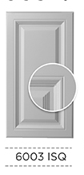

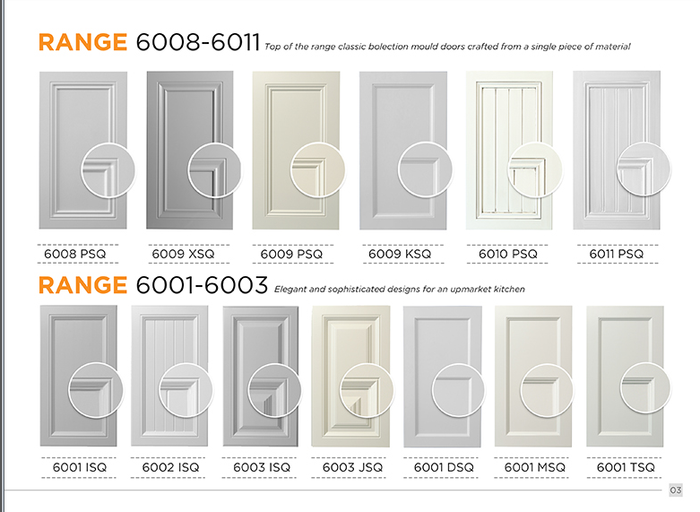
- 6001TSQ circle is not the same size as the rest, please make it bigger.
Page 4 and 5
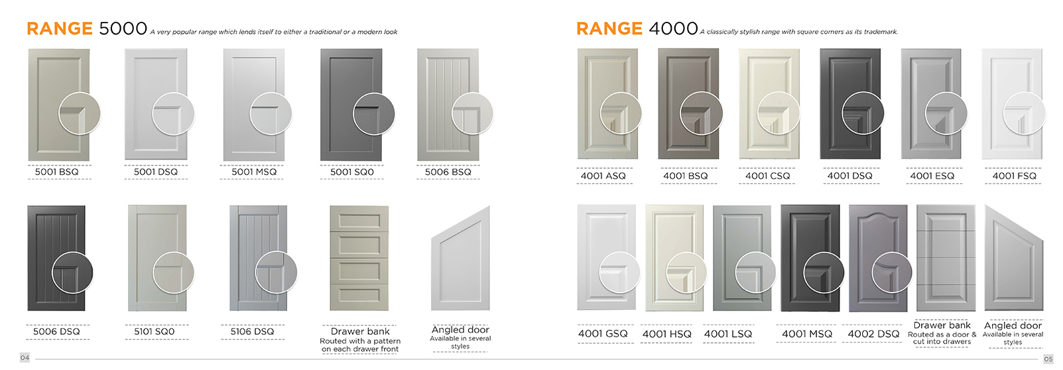
- The size of the circles are not the same on both pages. Some are still too small. Please make sure they are all aligned to the blue line.
- Move the close up of 4001CSQ out of the door slightly to match all the other doors in on that page

Page 7:
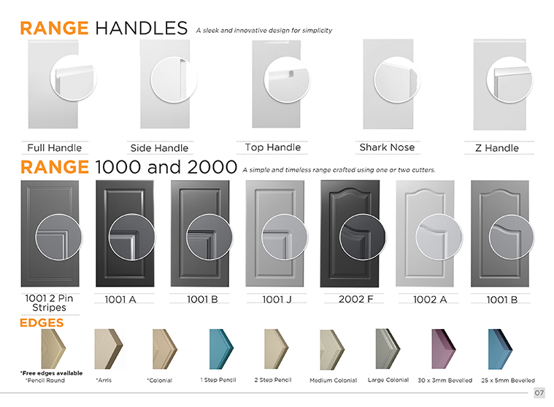- The handle range close ups are all different sizes. Please fix so they are all the same size and within the blue lines
- Range Handles: Put the close ups on the left hand side of the door, so the “side handle“ is visible. The close up of the Top handle is cut off on the left hand side.

- Rotate the shark nose close up 180 degrees so they edge is at the bottom since this is commonly a top door
- Fix the close up of range 1000 and 1002, some circles are smaller than others

Range 1000 and 2000: Close up circles are not equally spaced, some overlap the right hand side of the door more than others. E.g. the 1002 A overlaps a lot and the 1001 A doesn’t overlap at all.. Please also check all other ranges and draw vertical lines on any others.

Delete the word “stripes” from the design 1001 2 Pin (so it fits on one line)

Edges: Text should read: “Free edges available with a design” (Add “with a design”)

