Brochure Edits 2/6/20
Page 8:
- Remove all Frame Close ups
- Make the capping and fretwork heading orange
- The decorative pyramid needs to line up with the 60mm diameter rosette. You need to fix the spacing for the rosettes because it looks very odd at the moment.
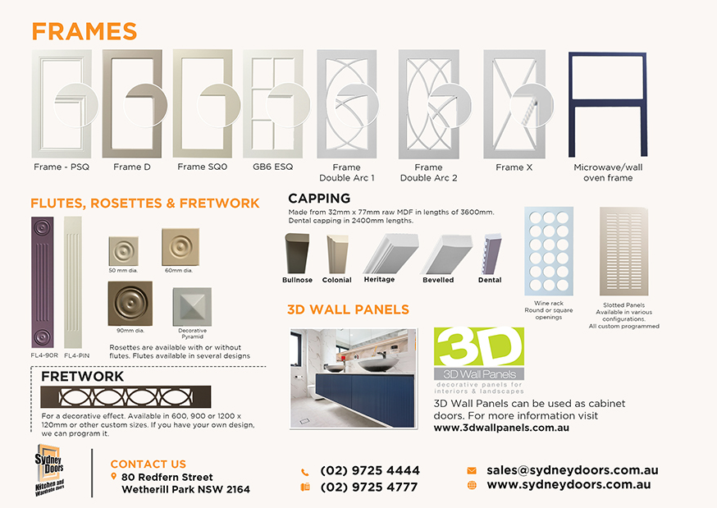

ATTENTION: Please read all the instructions carefully before sending me back your edit. Every single edit document I have asked for the close ups to be fixed and lined up properly. The circles on the doors are not the same across all ranges. It is not the same measurement, some overhang outside the door more than others. Please FIX for all ranges.

Page 3:
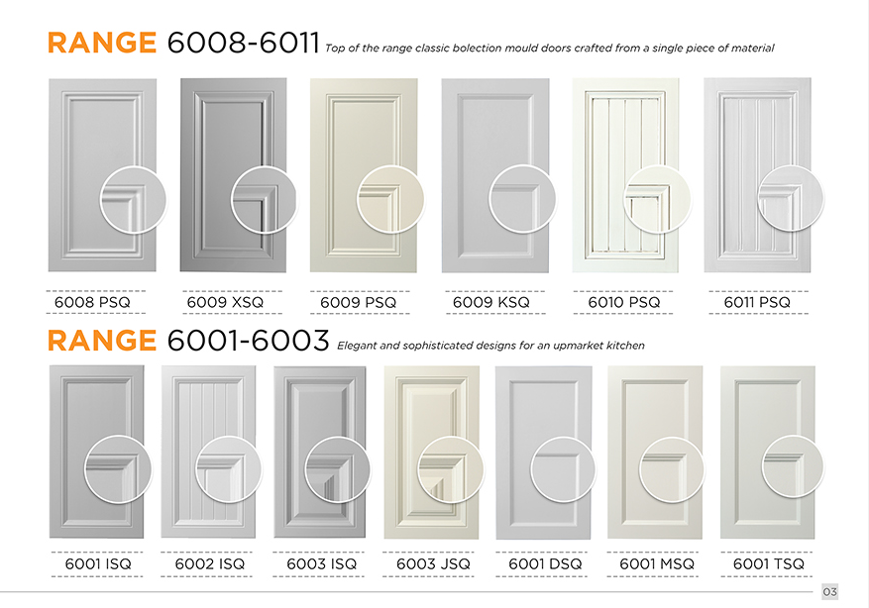
- 6001MSQ close up is sitting inside the door unlike the others which have some overlap
- The close up of 6009XSQ is in line with the door in the back. See below: 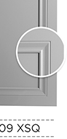
However doors 6009PSQ, 6009KSQ, 6010PSQ are out of line. Please see the photos. All doors should line up.
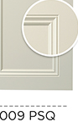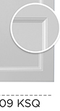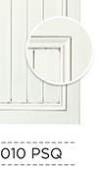

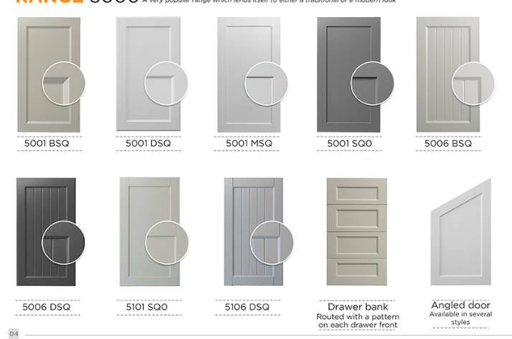
- Line up 5006BSQ and angled door
- Flip the angle door to the right so it looks like the door on page 5.

Page 6:
Take out the underline of ‘how to place an order’ and under ‘wardrobe door accessories’
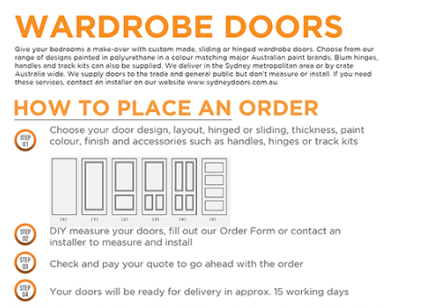
Why is the text under the heading so squished but all the text below isn’t.
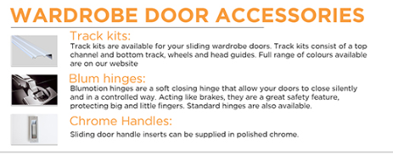
The text of the track kit and blum hinges is also so squished but chrome handles has good spacing. Can you make sure everything is uniform.

Page 7:
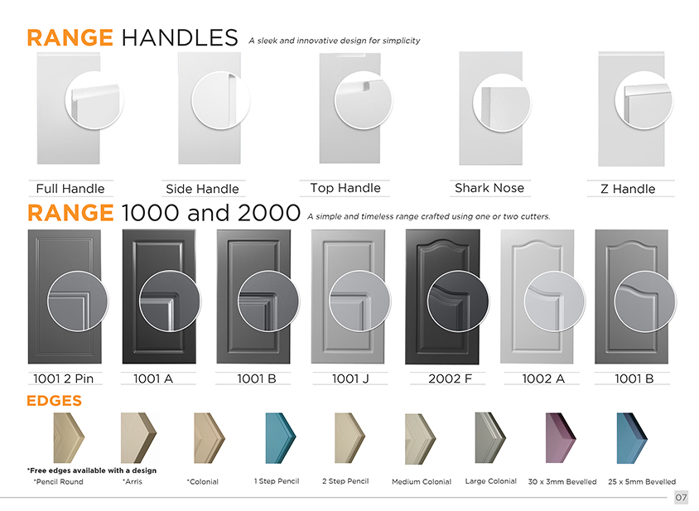
- Can you make the handle doors larger please
- Flip the side handle door left so the handle is on the left side and keep rhe close up on the right
- Shark nose handle close up- Where is the handle? It’s showing the edge of the door, it needs to be the handle pointing down
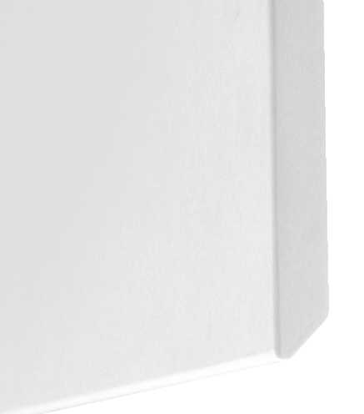
- Range 1000 and 2000: Close up circles are not equally spaced, some overlap the right hand side of the door more than others. E.g. the 1002 A overlaps a lot and the 1001 A doesn’t overlap at all.. Please also check all other ranges and draw vertical lines on any others.

