Brochure Edits 26/6/20
Back page:
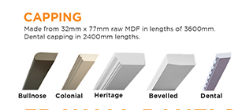

- Bullnose and colonial capping is still smaller in width in comparison to Heritage and Bevelled. Can you please make the bullnose and colonial larger so they are the same in width. As seen on the blue line, the widths are all different.
- The angle of the Dental is not at the same angle as the other designs.


- Align “Flutes” heading to the same height as “Capping” and “Edges” heading.
Increase the space between text and “Fretwork” heading.
- Heading too widely spaced



Can you please crop the image on page 8 to look like the right. Show more of the cabinets, not the sink.


This text should not be our instructions that we sent you. Change to the old text as shown below:


Page 3:
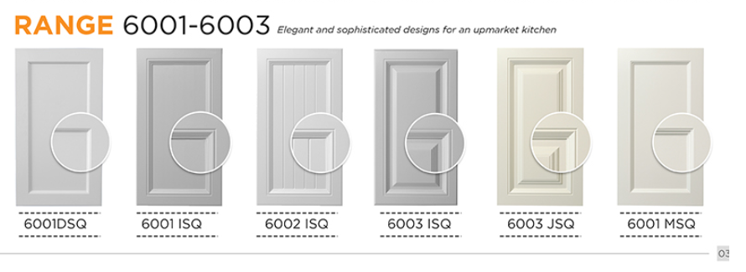
- The space between 6003ISQ and 6003 JSQ is larger than the others. Please make it even between all the doors.

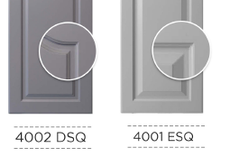Circle position on 4002 DSQ sticks out less than 4001 ESQ, circle position should be the same on ALL DESIGNS!
Fix 6001 DSQ circle position and insert a space between 6001 and DSQ.

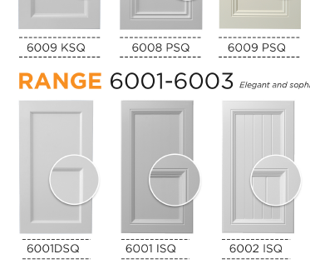Dotted line at 6009 KSQ is in alignment with the door, but 6001 ISQ and 6002 ISQ the dotted line is shorter. Make dotted line align with the left and right edge of the doors on ALL DESIGNS.
Top dotted line is thicker than the dotted line below. Use this thickness for all designs

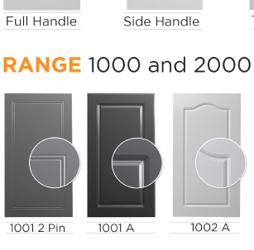
Use dotted line above and below design name/code for HANDLES and RANGE 1000 and 2000.

Front page:

This is the correct crop:


