Brochure Edits 14/04/20
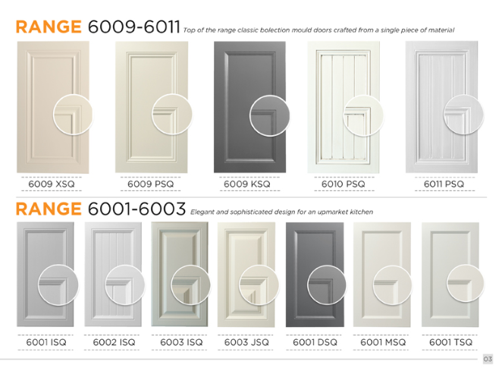
Page 3:
Please ensure that the top of the door design aligns with the line I have drawn.
- 6009KSQ, 6001DSQ, 6001MSW and 6001TSQ is still too low

Page 4:
- Remove the close up circle for the drawer fronts and angle doors
- Please move 5001MSQ, 5001SQ0 and 5006BSQ slightly up in the close up circle
- Range 4000 and 5000 remove bolding on “drawer bank” and “angled doors” texts. Remove comma (,) at end of Range 5000 drawer fronts text.

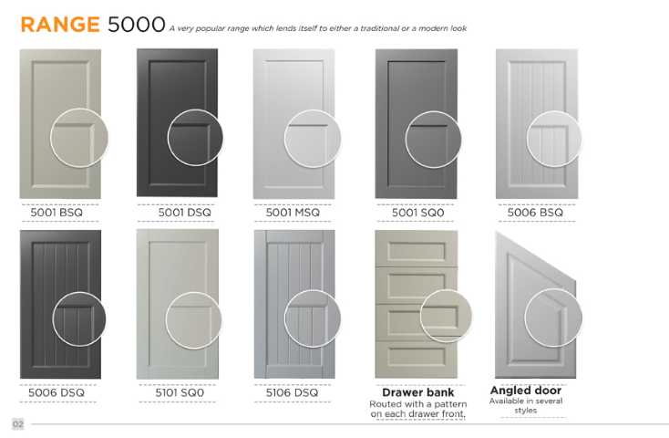
Page 5:
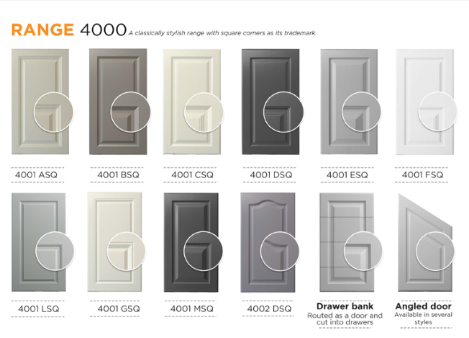
- Remove the close up for drawer bank and angled door
- Please move up the close ups for: 4001BSQ, 4001CSQ, 4001DSQ, 4001ESQ and 4001FSQ
- Please move down the close up of 4001GSQ and 4001MSQ
Page 6:
- Wardrobe door accessories should be an orange header like how to place an order
- Please re-add the heading Track Kits under that for the first accessory
- I think the title should just be ‘Wardrobe Doors’
- Wardrobe page: How to place an order steps: use the same font and font size as for the Kitchen doors order steps on page 2.
- Wardrobe door accessories: remove space between “accessories” and “:”
- Remove bolding on “Wardrobe accessories”, “Blum hinges” and “Chrome handles”. Make these headings orange and make text grey, not black.

Page 7:
- Please change the colour of these doors to the theme we’ve been using for this brochure
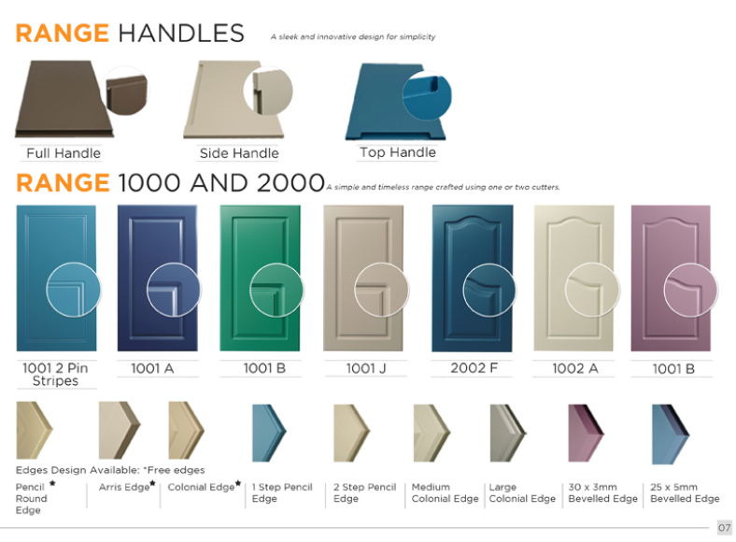
- Please add * not a star for the free edges so it matches what we have indicated at the top. A reminder the free edges that need the * is Pencil round edge, arris edge and colonial edge
- Please move up the close up for 1001B, 1001J, 2002F, 1002A and 1001B

