Brochure Edits 15/6/20
Page 8:
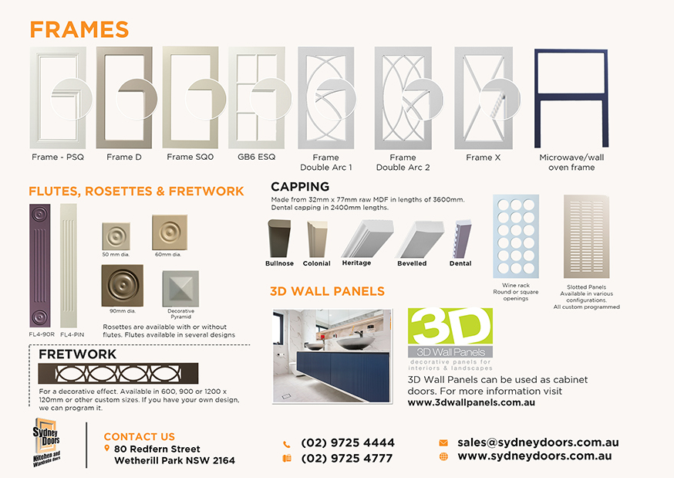
2
1
3. Delete dotted line
- Align (move up) “FLUTES, ROSETTES & FRETWORK” headline in line with the orange “CAPPING” headline.
- Increase size of “3D WALL PANELS” headline to the same size as “FRAMES” headline and move images and text up.
- Delete dotted line around FRETWORK

ATTENTION: Please read all the instructions carefully. Complete all corrections before sending back your edit. If this is not done, at this stage, we will make a complaint! We have asked for the same edits many times but you have not done them as requested. Every single edit document I have asked for the close ups to be fixed and lined up properly. The circles on the doors are not the same across all ranges. It is not the same measurement, some overhang outside the door more than others. Please FIX for all ranges.

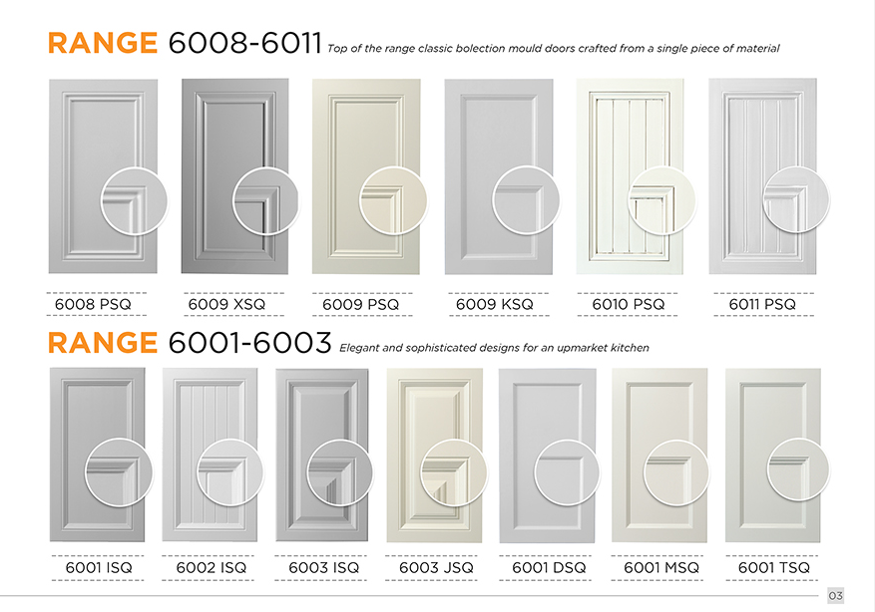
Page 3:
Circle overhangs door by correct amount
Circle doesn’t overhang door

- CHECK ALL CLOSE UP CIRCLES ON ALL RANGES SO THEY HAVE THE SAME AMOUNT OF OVERHANG!!!!!
- Example: 6010PSQ close up circle is overhanging past the door edge – this is the correct amount of overhang. All other circles have a different amount of overhang. 6001 MSQ close up circle has no overhang. MAKE ALL CIRCLES IN ALL RANGES OVERHANG THE SAME!!!!

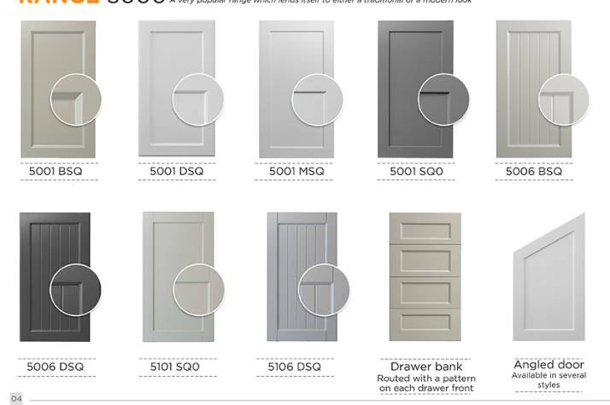
- Line up 5006BSQ and angled door

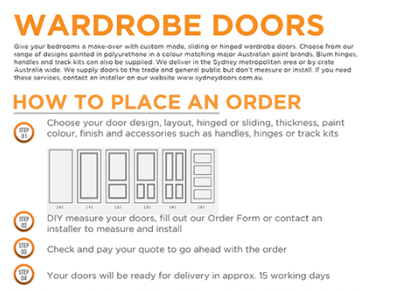
Increase space here
Increase space here

Page 7:
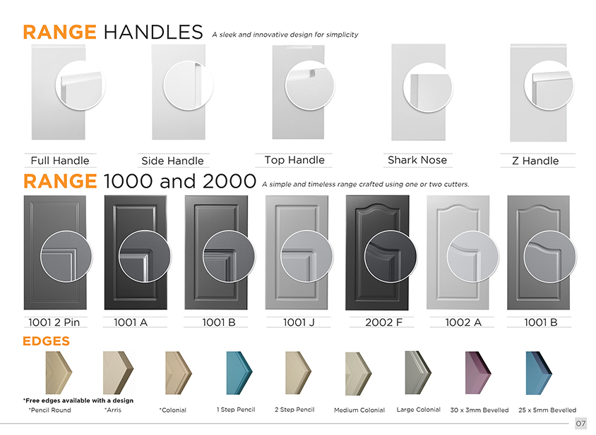
See note next page
Decrease space
Increase space
- Mirror image the Side Handle door so that the handle shows on the left hand side, keeping the close up circle where it is.
- See shark nose close up in circle below
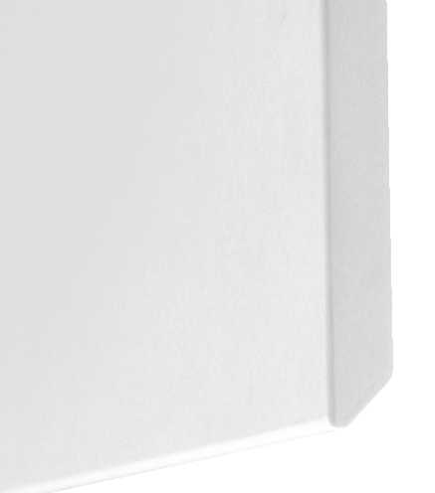Shark Nose close up like this
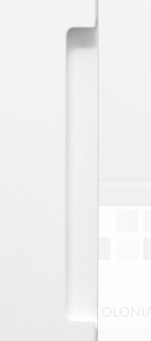
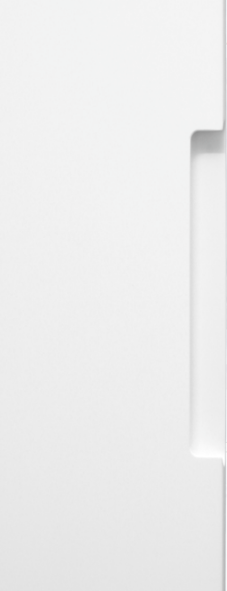

Show SIDE HANDLE door with handle on the left hand side and close up circle on right side.

