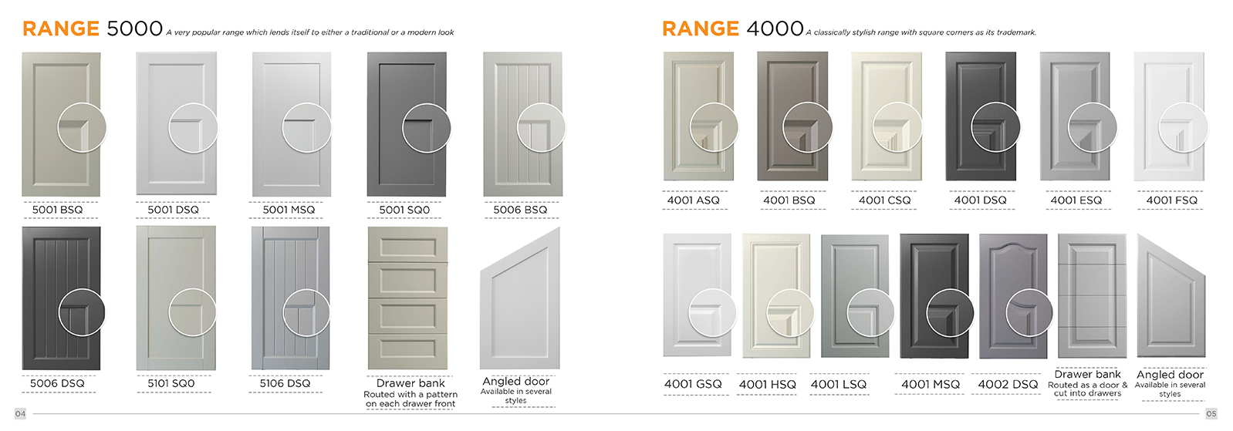
Page 4 and 5:
- The doors are not aligned across both pages. Move range 4000 doors up to the line to match range 5000

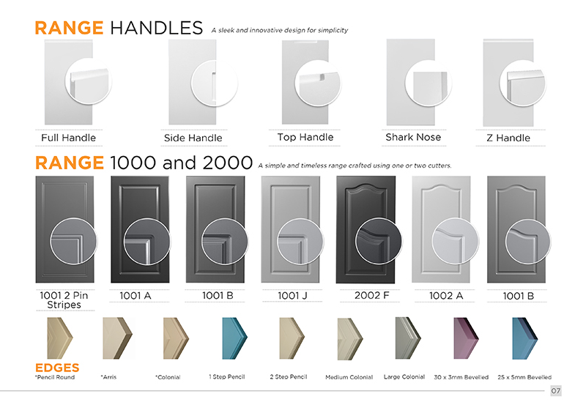
Page 7:

- Make the doors in the handle range larger

- The Shark nose close up is wrong. Please use the close up that was uploaded.
- Side Handle close up is not a close up. Move all circles to the left of the doors on the Range Handles

- Range 1000 and 2000. Align all close ups: some circles are further past the edge of the door than others. Also align the position of the profile inside the close up circles so that the right hand side of the design is the same width.

- The ‘Edges’ heading needs to be above the edge photos, not under. Add “*Free edges available with a design” below “*Pencil round”:

Page 8:
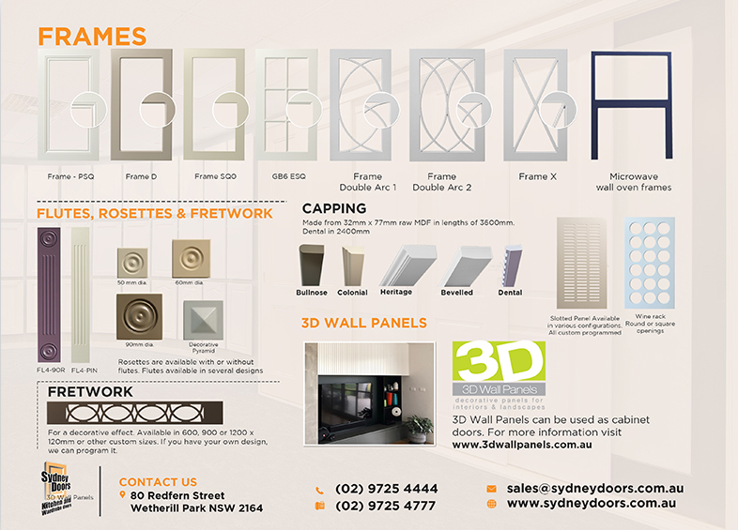
- The background colour on this page does not match the front page. Please change the colour to be the same as the lighter overlay on the front page. Delete the background image.
- Increase the space below the “Frames” heading
- Increase the size of the captions below the frames to be the same size as Frame X (the first 4 captions and “Microwave..” are smaller font). Centre all caption text below each image (Frame Double Arc 1 and 2 are not centred). Delete the ‘s’ and add “/” on Microwave/wall oven frame(s).
- Frame double arc 2 is wider than the rest, make it the same size
- Increase the close up circles to match the size of the circles in the other ranges
- Delete dotted line above “Flutes..” heading
- Capping: change “Dental in 2400mm” to “Dental capping in 2400mm lengths.”
- Move the Slotted panel and wine rack up. Add an ‘s’ to Slotted panels.
- Increase the size of the 3D WALL PANELS heading. Change image to Greenhills Beach image to be supplied.
- Delete text over the Sydney Doors logo

Page 06:
Increase the size of the text on the Wardrobe doors steps to match the size of the text on page 02 as below:
Make this font size larger!! To match the text below!!
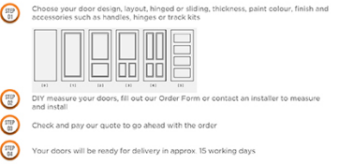
Above font size to be the same font size as below:
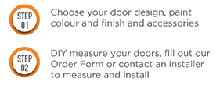
- Change step 3 text to: “Check and pay your…” (not our)
- Track Kits: change the last sentence to: “Full range of colours available are on our website”
- Chrome Handle: change text to: “Sliding door handle inserts can be supplied in polished chrome.”

