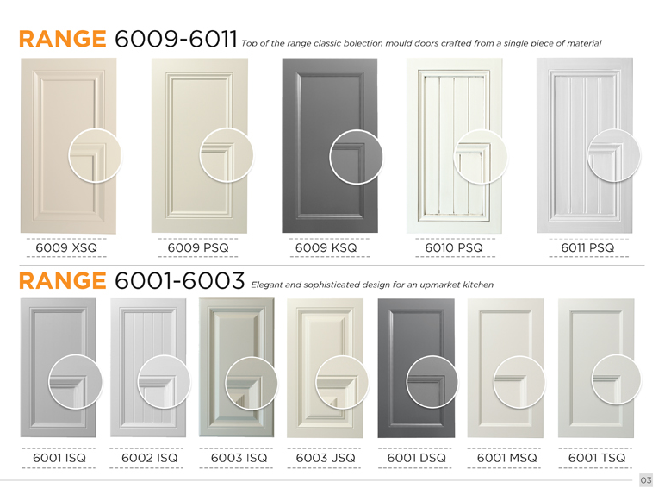
Page 3:
- Delete the horizontal line separating the range 6009-6011 and 6001-6003 as the other pages don’t have this
- Add an ‘s’ to the word ‘design’ in the Range 6001-6003 description.
- Range headings font size should be uniform throughout the brochure.
- Top and bottom of doors not in alignment in most ranges.

Page 4 and 5:
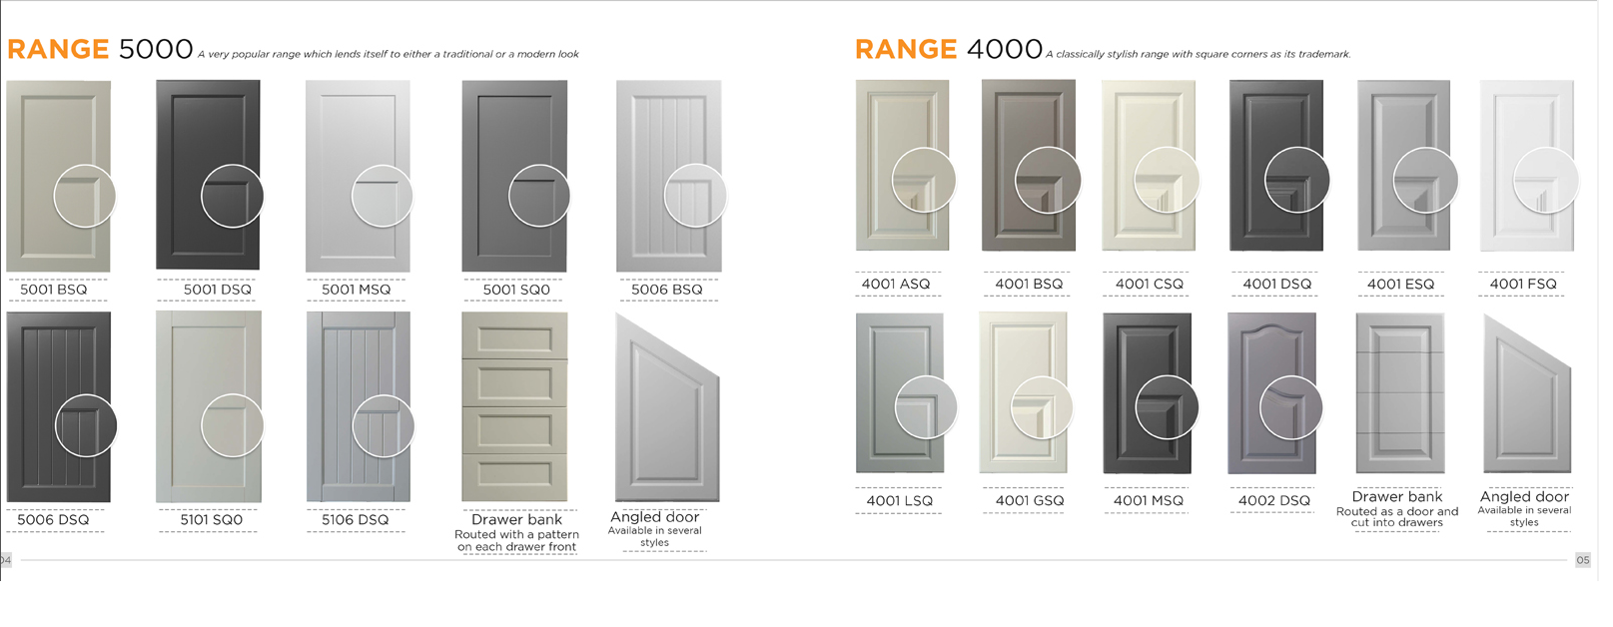

- The circles between page 4 and 5 are different size. Range 4000 close up circles have so much space . It needs to be moved up and to the right to fill up more room in the circle.
- The bottom line of range 4000 doors do not line up with bottom row of range 5000 doors
- The doors are different sizes, please see if you can make range 4000 doors bigger. Make them same size as range 5000 doors
- Move 5001DSQ, 5001MSQ, 5001SQ0 and 5006BSQ up in line

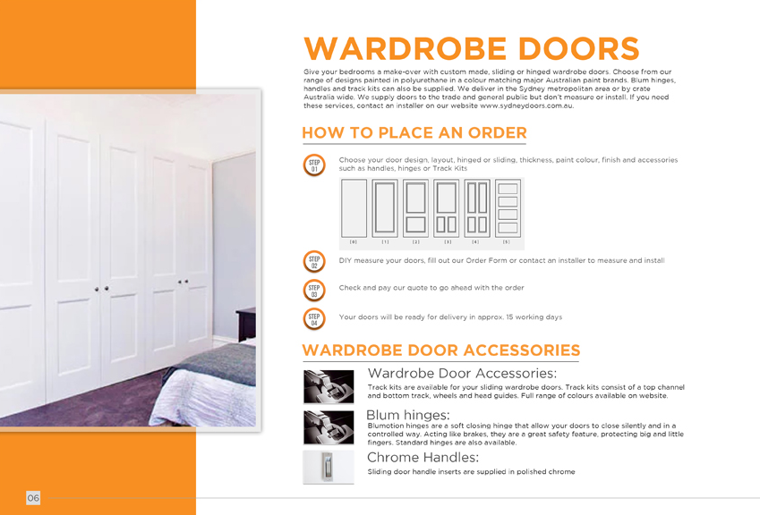
Page 6:
- In step 1, track kits should not have capital T. Should be ‘track kits’
- Under wardrobe door accessories, first heading should be ‘Track kits’ not ‘wardrobe door accessories’
- Chrome handles not Chrome Handles
- Wardrobe Doors Steps font size doesn’t match the Kitchen Doors Steps font size.
- Are the text and headings grey on the Wardrobe door accessories? It seemed odd looking.

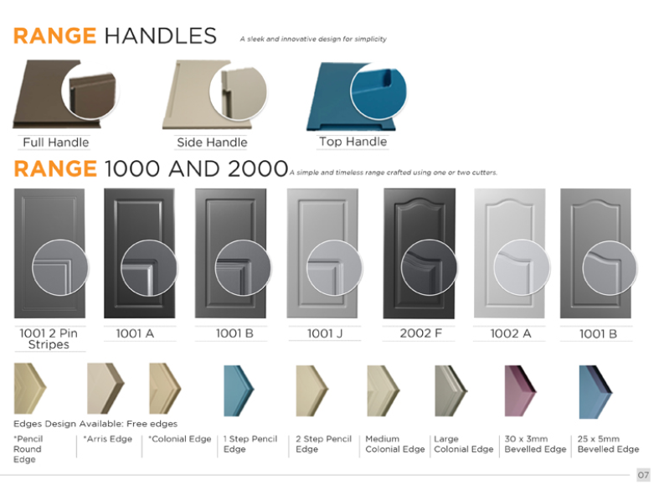
Page 7:

- Theres no asterisk on Free edges at the bottom, please place Free edges *
- Please delete all the word edge and fit the edge names on one line only to make more room for new door photos
Should read:
Pencil round , Arris , Colonial, 1 step pencil etc

Shift the edges down after making space and the doors down

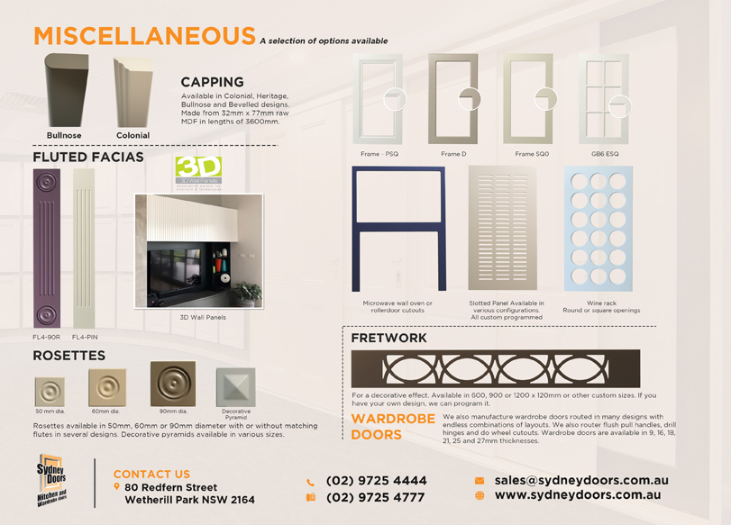
Page 8:

- Delete the wardrobe doors heading and text in the bottom right
- You forgot to add text next to the 3D Wall Panels Logo: “3D Wall Panels can be used as cabinet doors. For more information visit www.3dwallpanels.com.au”
- Please swap the positions of the 3D Wall logo and picture with the Rosettes pictures and text
- Change heading to Fluted Facias & Rosettes

